**2. Crystal structure [10 L]**

Types of Solids: Isotropy and Anisotropy, Laws of crystallography: Law of constancy of interfacial angles, Law of rational indices, Law of crystal symmetry, Weiss indices and Miller indices, Crystal Structure: Parameters of the Unit Cells, Cubic Unit Cells: Three Types of Cubic Unit Cells, Calculation of Mass of the Unit Cell, Methods of Crystal structure analysis: Laue method and Braggs method: Derivation of Bragg’s equation, Determination of crystal structure of NaCl by Bragg’s method, X ray analysis of NaCl crystal system, Calculation of d and λ for a crystal system, Numerical.

**The solid state:**

Introduction:

The main three types of matters are solid, liquid and gas. The solid state of matter is characterized by strong interparticle Forces of attraction. They have definite shape and volume.

Types of solids:

There are two types of solids, i) crystalline solids and ii) amorphous solids.

i) crystalline solids have regular shape because a regularity and periodicity in the arrangement of constituent particles. They have sharp melting points. All crystalline substances except those having cubic structure are anisotropic. Ice, salts as NaCl, metals are examples of crystalline solids.

ii) Amorphous Solids:Amorphous solids do nothave regular shape, the constituent of particles are randomly arranged. They don’t have sharp melting point and they are isotropic. Glass, Plastic, rubber, starch, gum etc are few examples of amorphous solids.

Isomorphism and Polymorphism:

i) Isomorphism: two or more substances having the ssame crystal structure are said to be isomorphism. for example, i) NaF and MgO ii) NaNO3 and CaCO3

ii) Polymorphism:

A single substance that exists in two or more forms or crystalline structures are called as polymorphism. For example: calcite and aragonite are two forms of calcium carbonate. Polymorphism occurring in elements is called allotropy.

Crystallography:

**Crystallography** is the branch of science that deals with the arrangement and bonding of atoms in crystalline solids and with the geometric structure of crystal lattices. The geometrical crystallography deals with the outward special arrangement of crystal planes and geometric shapes of the crystals. This is based on three fundamental laws,

i) Laws of constancy of interfacial angles.

ii) Laws of rationality of indices and

iii) the law of symmetry.

i) Laws of constancy of interfacial angles: This law states that angle between adjacent corresponding faces is inter facial angles of the crystal of a particular substance is always constant inspite of different shapes and sizes and mode of growth of crystal. The size and shape of crystal depend upon the conditions of crystallisation. This law is also known as Steno's Law.

ii) Laws of rationality of indices: This law states that the ratio of intercepts of different faces of a crystal with the three axes are constant and can be expressed by rational numbers that the intercepts of any face of a crystal along the crystallographic axes are either equal to unit intercepts (i.e., intercepts made by unit cell) a, b, c or some simple whole number multiples of them e.g., na, n' b, n''c, where n, n' and n'' are simple whole numbers. The whole numbers n, n' and n'' are called Weiss indices. This law was given by Hauy.

iii) The law of symmetry: According to this law, all crystals of a substance have the same elements of symmetry is plane of symmetry, axis of symmetry and centre of symmetry.

Crystal Systems:

A Crystal System refers to one of the many classes of crystals, space groups, and lattices. In crystallography terms, lattice system and crystal, the system are associated with each other with a slight difference. Based on their point groups crystals and space groups are divided into seven crystal systems.

The Seven Crystal Systems is an approach for classification depending upon their lattice and atomic structure. The atomic lattice is a series of atoms that are organized in a symmetrical pattern. With the help of the lattice, it is possible to determine the appearance and physical properties of the stone. It is possible to identify to which crystal system they belong to. In a Cubic System crystals are said to represent the element earth. They are Seven Crystal Systems and are stated below with illustrated examples.

The Seven Crystal Systems:

1. Cubic System:

All three angles intersect at right angles and are of equal length. Crystal shapes of a cubic system based on inner structure (square) include octahedron, cube, and Hexaciscoherdron. Example: Silver, Garnet, Gold, and Diamond.

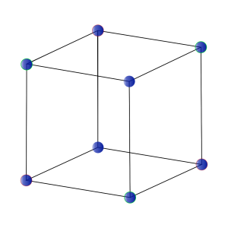

Cubic System

2.Tetragonal Systems:

It consists of three axes. The main axis varies in length; it can either be short or long. The two-axis lie in the same plane and are of the same length. Based on the rectangular inner structure the shapes of crystal in tetragonal include double and eight-sided pyramids, four-sided prism, trapezohedrons, and pyrite.

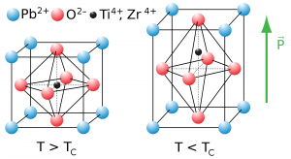

Perovskite – Tetragonal Systems

3. Orthorhombic System:

It comprises three axes and is at right angles to each other. There are different lengths. Based on their Rhombic structure the orthorhombic system includes various crystal shapes namely pyramids, double pyramids, rhombic pyramids, and pinacoids. Some common orthorhombic crystals include Topaz, Tanzanite, Iolite, Zoisite, Danburite and more.

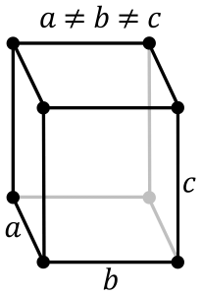

Orthorhombic System

4. Monoclinic System:

It comprises three axes where two are at right angles to each other, and the third axis is inclined. All three axes are of different length. Based on the inner structure the monoclinic system includes Basal pinacoids and prisms with inclined end faces. Some examples include Diopside, Petalite, Kunzite, Gywvpsum, Hiddenite, Howlite, Vivianite and more.

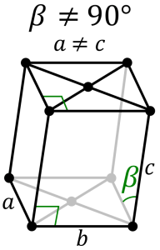

Monoclinic System

5. Trigonal System:

Angles and axis in a trigonal system are similar to Hexagonal Systems. At the base of a hexagonal system (ross-section of a prism), there will be six sides. In the trigonal system (base cross-section) there will be three sides. Crystal shapes in a trigonal system include three-sided pyramids, Scalenohedral and Rhombohedra. Some typical examples include Ruby, Quartz, Calcite, Agate, Jasper, Tiger’s Eyes and more.

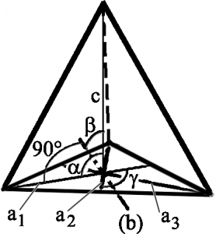

Trigonal/Pyramidal System

6. Hexagonal System:

It comprises four axes. Among them, three axes are of the same length and are on one plane. They intersect each other at an angle of sixty degrees. The fourth axis intersects other axes at right angles. Crystal shapes of hexagonal systems include Double Pyramids, Double-Sided Pyramids, and Four-Sided Pyramids. Example: Beryl, Cancrinite, Apatite, Sugilite, etc.

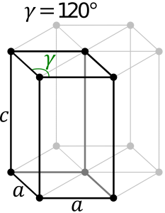

Hexagonal System

7. Triclinic System:

All three axes are inclined towards each other, and they are of the same length. Based on the three inclined angles the various forms of crystals are in the paired faces. Some standard Triclinic Systems include Labradorite, Amazonite, Kyanite, Rhodonite, Aventurine Feldspar, and Turquoise.

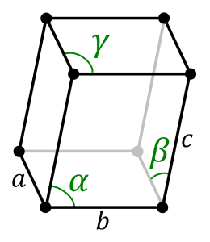

The Bravias Lattices and Structure of Crystals: