**K. T. S. P. MANDALS**

**HUTATMA RAJGURU MAHAVIDYALAYA,**

**RAJGURUNAGAR, TA. KHED, DIST. PUNE 410505**

**T.Y. B.SC. CHEMISTRY - SEM II**

**CBCS PATTERN AS PER NEW SYLLABUS**

**SUBJECT - PHYSICAL CHEMISTRY CH-601 CHAPTER NO. 3** **Nuclear Chemistry**

**PART - V**

**BY**

**DR. SUNITA JADHAV**

**The energy released in a nuclear reaction:**

Einstein's Equation (Mass & Energy relationship)

According to Albert Einstein's famous energy and mass convertible equation, it is

**E = mc2**...............................(1)

Where, E = energy, m = mass & c = velocity of light (3 x 108 m/s)

In the nuclear reactions, there is a change in the mass of the nuclide (Δm) along with the release large amount of energy, ΔE.

Equation (1) may be written as, **ΔE = Δmc2**------------------(2)

Substitute, c = velocity of light (3 x 1010 cm/s) in the equation (2), we get

ΔE = Δm x (3 x1010)2

**ΔE (ergs) = Δm (grams) x 9 x1020**---------------------(3)

*Thus, 1 erg = 2.39 × 10– 11 kcal*

*9 x 1010 ergs =?? (2.151 x 1010)*

From Equation (3),

**ΔE (kcal) = (2.151 x 1010) x Δm (grams) ------------- (4)**

The mass of the products (daughter nuclide) in a nuclear reaction is less than that of the reactants (parent nuclide). The energy is calculated from the mass difference between parent and daughter nuclide. As a result, we can compute the amount of energy released in a nuclear reaction using equation (4).

For example;

**+ ------------🡪 + + Energy**

**2.13553u 3.016049u 4.001506u 1.008665u**

The atomic mass difference between parent and daughter nuclide is

5.029602 u – 5.010171 u = 0.019431u

Δm = 0.019431u

Using equation (4),

ΔE (kcal) = (2.151 x 1010) x Δm (grams)

ΔE = (2.151 x 1010) x 0.019431

ΔE = 417960810

**ΔE = 4.18 x 108 kcal**

**Mass Defect:**

The sum of the masses of neutrons (mn) and protons (mp) forming a nucleus is more than the actual mass of the nucleus. This difference of masses is known as mass defect.

**Δm = m -m’**  (m = Theoretical mass, m**’** = Actual mass)

Mass defect (Δm) = (mass of protons + mass of neutrons) - Experimental mass of nucleus

**Δm = [Z mp + (A -Z) mn] – m’**

***The difference between the experimental & calculated masses of the nucleus is called the Mass defect.***

**For Example:**

Deuteron (2H), It consists of one proton and one neutron. Its mass may be calculated as:

mass of the proton = 1 × 1.007276

mass of the neutron = 1 × 1.008665

= 2.015941 u

m = 2.015941u, m’ = 2.014202 u.

**Δm = m - m’**

= 2.015941 – 2.014202

= 0.001739 u

This is the mass defect of the deuterium nucleus.

**Nuclear Binding Energy:**

The atomic nucleus comprises protons & neutrons, which are tightly packed together in a small space. Although there are strong repulsive interactions between the protons in the nucleus, it does not break apart because the nucleons are held together by powerful forces (fig. 3.18).

***The energy that binds the nucleons (protons and neutrons) together in the nucleus is nuclear binding energy. Or. The energy required to break the nucleus into its isolated nucleons is binding energy.***

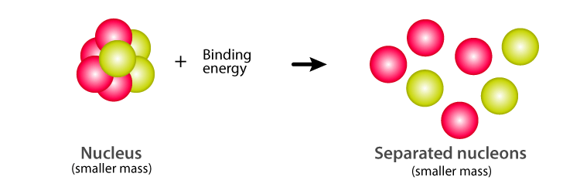

**Fig. 3.18 :Nuclear binding energy**

**Calculation of binding energy:**

The binding energy (B.E) of a nucleus may be calculated from the mass defect by using Einstein's mass-energy relationship equation,

**ΔE = Δm x c2 (ergs)**

Equivalence of energy and atomic mass unit (amu);

1 amu = $\frac{1}{12}$ x 12 **g/mole** (mass of 12C)

1 amu = g

1 amu = g

**1 amu = 1.66 x 10-24 g**

Basically, Binding Energy can be calculated in eV or MeV.

*1 eV = 1.6 x 10-12 ergs (eV = electron volt, MeV = Mega electron volt)*

*= 1.6 x 10-19 joules*

*1 MeV = 1.6 x 10-6 ergs*

*= 1.6 x 10-13 joules*

If the mass expressed in the atomic mass unit (amu), then B.E. in MeV is calculated by using the equation, (1 amu = 931 MeV)

**B.E. = Δm × 931 MeV**

**Binding energy per nucleon or average (mean) binding energy:**

1. ***The average binding energy is the ratio of binding energy to the number of protons and neutrons (mass number) of a nucleus.***
2. It can be expressed as,

**B.E per nucleon ($\overline{E}$)= $\frac{Δm × 931 MeV}{number of protons+number of neutrons}$**

$\overline{E}$**= $\frac{Δm × 931 MeV}{A}$**

1. When the nucleon's binding energy is greater, the nucleus's more stable, the curve of Binding energy per nucleon with mass number as shown in fig. 3.19.

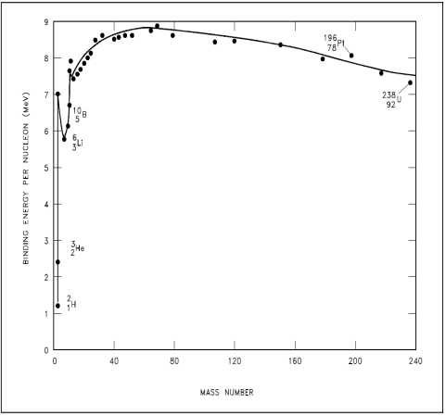

**Fig. 3.19 :The curve of Binding energy per nucleon Vs. mass number**

**Problem 1:**

Calculate mass defect, binding energy, and average binding energy for ${}_{26}^{56}{Fe}$ with atomic mass 55.975 amu. (mp=1.0078 amu, mn = 1.0086 amu).

**Solution:**

Given: ${}_{26}^{56}{Fe}$, A = no. of protons + no. of neutrons, Z = atomic number = number of protons

A = 56, Z = 26, m**’** = actual mass = 55.975 amu, mp=1.0078 amu, mn = 1.0086 amu

Δm =?, E (B.E) = ?, $\overline{E}$ =?

1. ***Mass defect (Δm) = m – m’***

m (theoretical mass) = Z x mp + (A-Z) x mn

= 26 x 1.0078 + (56-26) x 1.0086

= 56.4698 amu

Δm= m – m’

= 56.4698 amu - 55.975 amu

= 0.4858 amu

1. ***B.E = Δm × 931 MeV***

B.E = 0.4858 amu x 931 MeV

B.E = 452.2798 MeV

1. Average binding energy $(\overline{E})$**= $\frac{Δm × 931 MeV}{A}$ = $\frac{E}{A}$**

= $\frac{452.2798}{56}$

$\overline{E}$**= 8.076 MeV**

**Problem 2:**

Calculate binding energy per nucleon for ${}_{28}^{60}{Ni}$ with atomic mass 59.935528 amu. (mp=1.007825 amu, mn = 1.008665 amu).

**Solution:**

Given: ${}_{28}^{60}{Ni}$, A = no. of protons + no. of neutrons, Z = atomic number = number of protons

A = 60, Z = 28, m**’** = actual mass = 59.935528 amu, mp=1.007825 amu, mn = 1.008665 amu

Δm= ?, E (B.E) = ?, $\overline{E}$ =?

1. ***Mass defect (Δm) = m – m’***

m (theoretical mass) = Z x mp + (A-Z) x mn

= 28 x 1.007825 + (60-28) x 1.008665

= 60.49638 amu

Δm= m – m’

= 60.49638 amu – 59.935528 amu

= 0.560852 amu

1. ***B.E. = Δm × 931 MeV***

B.E = 0.560852 amu x 931 MeV

B.E = 522.153212 MeV

1. Average binding energy $(\overline{E})$**= $\frac{Δm × 931 MeV}{A}$ = $\frac{E}{A}$**

= $\frac{522.153212}{60}$

$\overline{E}$**= 8.7026 MeV**

**Problem 3:**

Calculate mass defect and binding energy for ${}_{27}^{59}{Co}$ with atomic mass 58.9518 amu. (mp=1.0078 amu, mn = 1.0086 amu).

**Solution:**

Given: ${}_{27}^{59}{Co}$, A = no. of protons + no. of neutrons, Z = atomic number = number of protons

A = 59, Z = 27, m**’** = actual mass = 58.9518 amu, mp=1.0078 amu, mn = 1.0086 amu

Δm =? and E (B.E) =?

1. ***Mass defect (Δm) = m – m’***

m (theoretical mass) = Z x mp + (A-Z) x mn

= 27 x 1.0078 + (59-27) x 1.0086

= 59.4858 amu

Δm= m – m’

= 59.4858 amu - 58.9518 amu

= 0.534 amu

1. ***B.E. = Δm × 931 MeV***

B.E = 0.534 amu x 931 MeV

**B.E = 497.15 MeV**

**Some applications of radioisotopes as tracers:**

1. **Tracer in studying chemical Investigation:**

In a molecule, the atom of one element is replaced either by its radioactive isotope, the characteristics property of the isotope, act as a labeled using which the path of the element can be traced, in the series of transformation, leading to the chemical reaction. The labeled element is called the "tracer element." Some of the following examples are given below.

1. ***Esterification:***
2. Consider the following reaction,

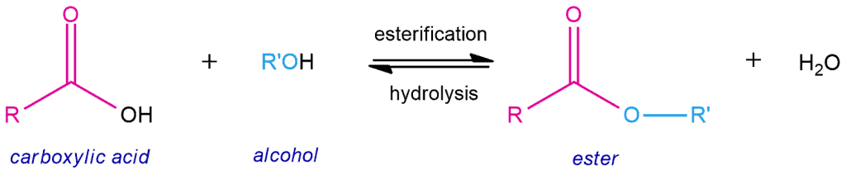

1. The question to be answered is in H2O formation whether -OH from the acid and -H from the alcohol or whether -OH from alcohol and -H from the acid are used.
2. Oxygen from alcohol is labeled using 18O. No 18O was detected in water, indicating that -OH from the acid and -H from the alcohol must have been utilized in water formation.

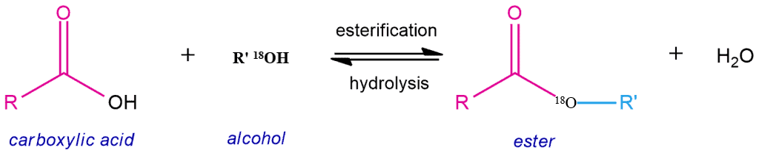

1. ***Friedel Craft reaction:***
2. Anhydrous AlCl3 is used as a catalyst in the reaction. To decide the role of catalyst, one of the chlorines is substituted by radioactive chlorine, i.e., Al*Cl3or AlCl2*Cl.

Consider the reaction between aromatic hydrocarbon and acyl-chloride

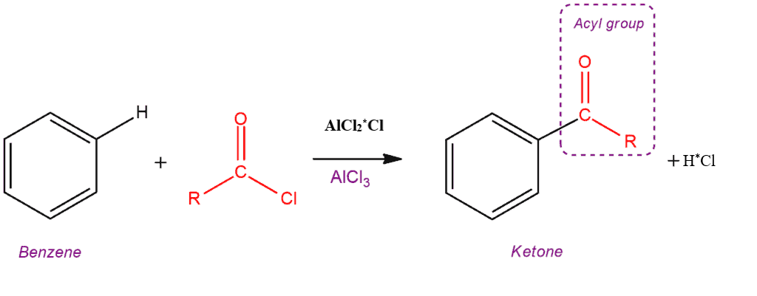

1. The radioactive chlorine in the hydrochloric acid suggested that this chlorine comes from the catalyst rather than acyl chloride.
2. To account for this, it is suggested that chlorine is first removed from CH3COCl, and then it gets attached to AlCl3, forming (CH3CO) (Al*Cl4)

**3.10.2 Use of tracers in the structure determination:**

***Phosphorous pentachloride (PCl5):***

1. PCl5 is synthesized using PCl3 and *Cl2***(labeled radioactive chlorine)***

PCl3 + *Cl2  ----------------🡪 P*Cl5

P*Cl5 + H2O ---------------🡪 POCl3 + 2H*Cl ----- ***(Hydrolysis of P*Cl5)***

After analyzing the product, it was found that all chlorine activity (*Cl) in the hydrochloric acid (H*Cl) is not in the POCl3, which indicates that two Cl are different from another three Cl atoms the PCl5 molecule.

1. All the five chlorines in the PCl5 are **not structurally equivalent**; this observation support the PCl5 shows trigonalbipyramidal geometry (fig.)

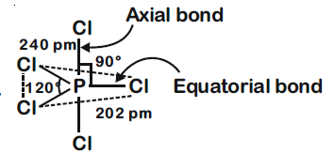

* + 1. **Age determination – Use of tritium and C-14 dating**

1. **Use of tritium (3H):**
2. Tritium *(3H, half-life of 12.43 years* ***(Unterweger and others, 1980)****)* has provided an excellent tracer of young waters, the mole ratio of $\frac{{}_{1}^{3}H}{{}_{1}^{1}H}$ A water sample can be used to measure its age, up to 40 yrs.
3. Tritiated water (HTO) is generated in the atmosphere and mixed with many water sources such as rivers, seas, and lakes.
4. The mole ratio of $\frac{{}_{1}^{3}H}{{}_{1}^{1}H}$ It is steady at equilibrium and is around 10-18. When any water is stored, the mixing of tritiated and regular water ceases, and the tritium in the stored water begins to disintegrate, ----------------🡪 +
5. As the concentration ratio decreases, the ratio gives the period (age) of the stored water, which is expressed by the following equation,

**= log [**

N0 = A0 (Activity of tritium in the fresh sample of water)

N = A (Activity of tritium in given samples of water)

$t$**= $\frac{2.303}{λ }$ log [$\frac{Ao}{A}]$**

(λ = Disintegration constant), the liquid scintillation counter is used to detect the

the intensity of beta particles.

1. **Carbon (14C) dating:**
2. The method was developed in the late 1940s at the University of Chicago by **Willard Libby**; he was awarded the **Noble prize in 1960**.
3. Radioactive carbon dating can be used to **determine the age of an old piece of organic material** like wood and fossils up to the age of 20,000 yrs.
4. 14C is formed due to the following nuclear transformation, and it converts into 14CO2

+ ----------------🡪 +

1. The ratio of radioactive carbon dioxide to regular carbon dioxide in the atmosphere is constant.
2. While living, a plant absorbs both forms of carbon dioxide and uses photosynthesis to convert them to carbon-14 and carbon-12. As a result, a live plant has a fixed radioactive carbon-14 to stable carbon-12 (fig. 3.20).

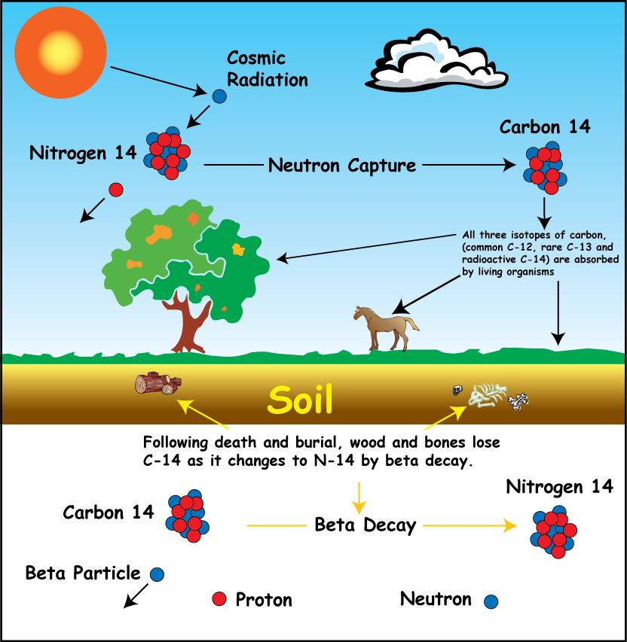

**Fig. 3.20 :14C dating**

1. When a plant dies, it stops absorbing carbon from the atmosphere. Carbon-12 remains unaltered from now on, whereas carbon-14 decays via beta-emission.

----------------🡪 + (Half-life = 5730 yrs.)

Radioactive

----------------🡪 No change

$\frac{{}_{6}^{14}C}{{}_{6}^{12}C}$**= decreases**

1. Therefore, the concentration of carbon-14 declines with time. The concentration of carbon-14 can be measured by counting radioactivity, and it knows the concentration of carbon-14 in a given sample of old wood and that in a living plant, the sample's age can be calculated.