**K. T. S. P. MANDALS**

**HUTATMA RAJGURU MAHAVIDYALAYA,**

**RAJGURUNAGAR, TA. KHED, DIST. PUNE 410505**

**T.Y. B.SC. CHEMISTRY - SEM II**

**CBCS PATTERN AS PER NEW SYLLABUS**

**SUBJECT - PHYSICAL CHEMISTRY CH-601 CHAPTER NO. 3** **Nuclear Chemistry**

**PART - IV**

**BY**

**DR. SUNITA JADHAV**

**The Group Displacement Law (Soddy-Fajan's):**

1. *When the parent nuclide emits an α-particle, the position of the daughter nuclide is shifted to the left, in which two groups from the position of parent nuclide. i.e., Z is decreased by two units.*
2. *When a β- particle is emitted, the position of the nuclide is shifted to the right side by one group. i.e., Z is increased by 1 unit.*

|  |  |  |
| --- | --- | --- |
| *daughter* | *-α -β*  *<--------------- X-----------------🡪* | *daughter* |

1. *Note: However, this rule fails for emissions by f-block nuclides in which the parent nuclide & daughter nuclides come to the same group (IIIB) in the periodic table. The daughter nuclide formed by β decay is the isobar to the parent nuclide.*

**Rate of radioactive decay:**

**Rate of Radioactive Decay and Decay Constant:**

The number of radioactive atoms disintegrating per unit time is called the ***rate of radioactive decay or the rate of radioactive disintegration***. The rate of a decay process is proportional to the number of radioactive atoms present at the given instant.

**Rate Expression (Expression for the decay constant):**

The rate of radioactive disintegration varies with the concentration of the radioactive element. Consider a general radioactive decay equation,

A ---------🡪 P

t = 0 N0  0

t = t Nt x

Where N0 = total number of atoms in the atomic nucleus A, (t = 0)

N = total number of atoms in the atomic nucleus A, (t = t)

If dNt number of atoms disintegrates in a given time of interval dt, then the rate of disintegration as,

**r = - $\frac{dN}{dt}$ = $\frac{dx}{dt}$**

(-ve sign indicates; decreases the number of atoms with time).

The rate law as,

r = - $\frac{dN}{dt}$ = $\frac{dx}{dt}$ α N

- α N

- = λ N

λ is proportionality constant or disintegration or decay constant.

***The decay constant (λ) is defined as the fraction of the total number of atoms of radioactive nuclide or element disintegrating per unit time.***

**- $\frac{dN}{N}$ = λ dt**

Integrating the above equation with proper limits,

- = {}

- =

- {ln N – ln N0} = [t - o]

= ln [

= log [$\frac{No}{N}]$

Exponential equation of Decay constant:

= ln [

[ =

N = N0 {A α N}

A = Activity of radioactive nuclide,

**A = A0**

**Graphical method:**

1. ***Activity (A) Vs. t***

A = A0

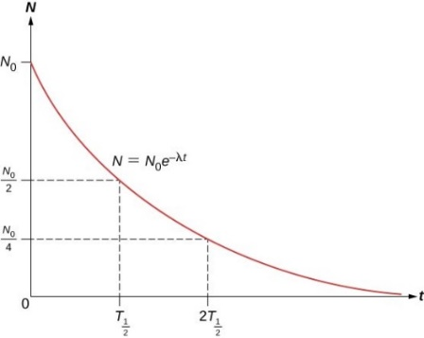

**Fig. 3.16 :A Vs. t**

1. ***ln N Vs. t***

= ln [, t = ln N0- ln N

ln N = - t + ln N0

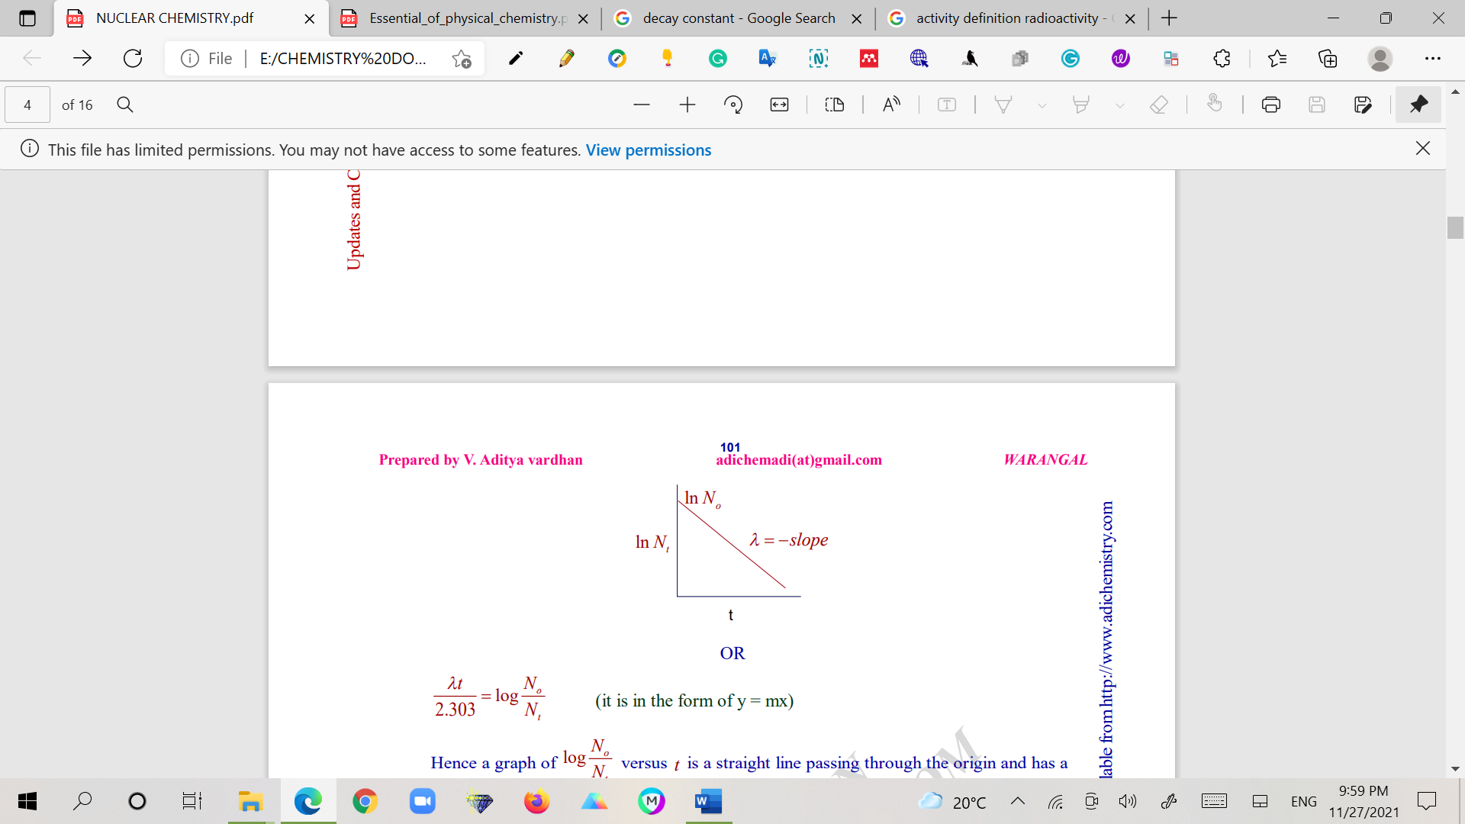

**Fig. 3.17 :ln N Vs. t**

**Half-life (t1/2) period:**

The time taken for an initial number of radioactive atoms to become half is called the half-life period.

Substitute, t = t1/2 and N = $\frac{N0}{2}$  in the decay constant (first-order) equation,

$λ$ = $\frac{2.303}{t}$ log [$\frac{No}{N}]$

t1/2 = log [$\frac{No}{N0/2}]$

t1/2 = log [$2]$

t1/2 = x 0.3010*[log 2 = 0.3010]*

**t1/2 =**

t1/2 is independent of the initial total number of atoms on the parent nuclide.

**Average life (τ):**

1. *The* ***average life or the mean life*** *of a radioactive element can be given by the ratio of the total lifetime of all the individual parent nuclide atoms to the total number of such atoms present in the sample.*
2. It is denoted by τ and is reciprocal of the decay constant, λ

**τ = $\frac{1}{λ}$**

1. The average life of a radioactive element is related to its half-life by the expression;

**Average life = 1.44 × Half-life**

**τ = 1.44 × t1/2**

1. The average life is used to express the rate of disintegration of a radioactive nuclide.

**Becquerel (Bq):***One nuclear disintegration per second. (SI unit; 1 Bq = 1 dps)*

**Curie (Ci):***3.7 × 1010 disintegrations per second is called curie.*

**1 Ci = 3.7 x 1010Bq**

**Problem 1:**

A sample of radioactive 133I gave with a Geiger counter of 3150 counts per minute at a certain time and 3055 counts per unit exactly after one hour later. Calculate the half-life period of 133I.

**Solution:**

Given: N0 = 3150 counts, N = 3055 counts, t = 1 hr. t1/2= ?,  **= ?**

= log [$\frac{No}{N}]$

$λ$**= $\frac{2.303}{1 hr}$** log [$\frac{3150}{3055}]$

$λ$**= 0.03062 hr-1**

Half -life period, **t1/2 = = ,**

**t1/2 = 22.63 hrs**

**Problem 2:**

How much time would it take for a sample of 60Co to disintegrate to the extent that only 2.0 % remains? The disintegration constant λ is 0.13 yr-1.

**Solution:**

Given: N0 = 100, N = 2,  **=** 0.13 yr-1, t = ?

= log [

**=** log [

**t = 30.09 years**

**Problem 3:**

**60**Co disintegrates to give 60Ni. Calculate the fraction and the percentage of the sample that remains after 10 years. The disintegration constant of 60Co is 0.13 yr– 1.

**Solution:**

Given:  **------------🡪 +**

= ?,  **=** 0.13 yr-1, t = 10 yrs

$λ$ = $\frac{2.303}{t}$ log [$\frac{No}{N}]$

$∴$ log [ $\frac{No}{N}]$ = $\frac{λ x t}{2.303}$

log [ $\frac{No}{N}]$ = $\frac{0.13 x 10}{2.303}$

$∴$ log [$\frac{No}{N}]$ = 0.5644

$\frac{No}{N}$ = $e^{0.5644}$ = 1.7583

The fraction remaining is the amount at time t divided by the initial amount.

$\frac{N}{N0}$ = $\frac{1}{1.7583}$ = 0.5687

Hence the fraction remaining after 10 years is 0.5687 or 56.87 percent of that present initially.

**Problem 4:**

Calculate the disintegration constant of 60Co if its half-life to produce 60Ni is 5.2 yrs.

**Solution:**

**t1/2**= 5.2 years, $λ$ = ?

t1/2 =

= =

**= 0.1332 yrs-1**