**K. T. S. P. MANDALS**

**HUTATMA RAJGURU MAHAVIDYALAYA,**

**RAJGURUNAGAR, TA. KHED, DIST. PUNE 410505**

**T.Y. B.SC. CHEMISTRY - SEM II**

**CBCS PATTERN AS PER NEW SYLLABUS**

**SUBJECT - PHYSICAL CHEMISTRY CH-601 CHAPTER NO. 3** **Nuclear Chemistry**

**PART - III**

**BY**

**DR. SUNITA JADHAV**

**Film Badges:**

1. A photographic film is encapsulated in a plastic container to make a film badge (fig. 3.11).
2. They discolor the silver grains of the photographic film when exposed to radiation. The film is processed and examined with a magnifying lens.
3. As α or β particles pass through the film, a trail of black particles is left behind. It is possible to count these particles. γ radiation, on the other hand, darkens the photographic film uniformly. The type of radiation and its strength can be determined in this manner.

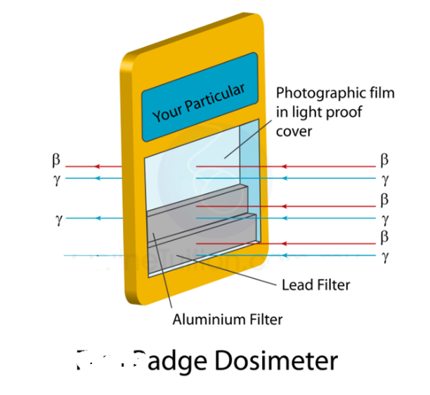

**Fig. 3.11 :Film Badges**

1. The level of darkening indicates how much radiation is there. A film badge is an essential tool for monitoring radiation exposure status. The badge film is processed regularly to see if the wearer has absorbed any substantial doses of radiation.

**Nuclear structure:**

The basic idea of the nuclear structure was introduced in the chapter on atoms, molecules, and ions, which stated that an atom's nucleus is made up of protons and, except for H, neutrons. Remember that the **atomic number (Z)** of an element is the number of protons in the nucleus, and the **mass number (A)** is the sum of the number of protons and neutrons (A = Z + N). The proton carries a positive charge of the same magnitude as an electron. The charge on the nucleus is (+Ze) while on the outer sphere is (-Ze), -e charge is on an electron.

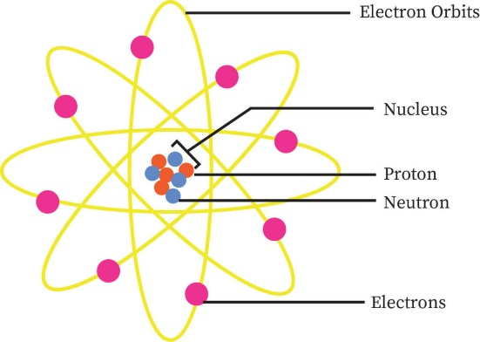

**Fig. 3.12 :Atomic structure**

Protons and neutrons, generally known as nucleons, are densely packed together in a nucleus (fig. 3.12). A nucleus has a radius of around 10-15 meters, which is relatively modest compared to the complete atom's 10-10 meters radius. Nuclei are extraordinarily dense compared to bulk matter, averaging 1.8 x 1014gm per cubic centimetre.

* 1. **Classification of nuclides:**

1. **Based on their atomic number (Z), proton number (P) & neutron number (N):**
2. **Isotopes:** *The nuclides with the same atomic number but the different mass numbers are called isotopes.*

***e.g****. ${}_{1}^{1}H, {}_{1}^{2}H, {}_{1}^{3}H$ (Isotopes of hydrogen)*

${}_{6}^{12}C, {}_{6}^{13}C, {}_{6}^{14}C$*(Isotopes of carbon)*

*They belong to the same element*

*It shows similar chemical properties but different physical & nuclear properties.*

*It has the same number of protons but the different number of neutrons.*

1. **Isobars:**

*The nuclides with different atomic number but the same mass number is called isobars.*

***e.g****. ${}_{20}^{40}{Ca}\&{}_{19}^{40}K$*

${}_{6}^{14}C\&{}_{7}^{14}N$

1. **Isotones:**

*Those nuclides which contain the same number of neutrons are called isotones.*

*e.g. ${}_{20}^{40}{Ca}\&{}_{19}^{39}K$*

${}_{16}^{32}S\&{}_{15}^{31}P$

1. **Isomers:**

*Two nuclides with the same atomic number (Z) and neutron number (N) values but differing energy states are called isomers.*

***e.g****. ${}_{27}^{60m}{Co}\&{}_{27}^{60}{Co}$*

1. **Based on nuclear stability:**
2. **Stable nuclides:**

The nuclides are permanent; their proton and neutron content remain unchanged; they can be changed only under serving conditions of bombardment by external radiation or particles of very high energy.

Two hundred seventy-four (274) naturally occurring nuclides are stable.

For examples: ${}_{1}^{1}H, {}_{1}^{2}H$, ${}_{8}^{16}O, {}_{8}^{17}O$, ${}_{9}^{19}F, {}_{11}^{23}{Na}$, etc.

1. **Radioactive or unstable nuclides:**

The nuclides are unstable; their proton and neutron content remain changed spontaneously, forming new nuclides.

**Above 2000 nuclides, including a vast number of artificial ones**

For examples: ${}_{1}^{1}H, {}_{1}^{2}H$, ${}_{8}^{16}O, {}_{8}^{17}O$, ${}_{9}^{19}F, {}_{11}^{23}{Na}$, etc.

1. **Magic numbers:**

The nuclides with 2, 8, 20, 28, 50, and 82 protons or 2, 8, 20, 28, 50, 82, and 126 neutrons are exceptionally stable.

For example: ${}_{2}^{4}He$, ${}_{8}^{16}O, {}_{20}^{40}{Ca}$, etc.

**Types of Radioactive Decay:**

*Rutherford and Soddy (1903) proposed that radioactivity is a nuclear property. A radioactive atom's nucleus is unstable, and it disintegrates or decays due to the spontaneous emission of a - or β -particle. This causes the nucleus' proton-neutron composition to shift, resulting in a more stable nucleus. The parent nucleus is the initial nucleus, while the product is the daughter nucleus.*

**1) Alpha (α) decay (${}_{2}^{4}α$ or ${}_{2}^{4}{He}$):**

***Alpha decay****or****α****-****decay****is a type of radioactive decay in which an atomic nucleus emits an****alpha****particle* ***(helium nucleus)****and thereby transforms or '****decays****' into a different atomic nucleus, with a reduced mass number by four and an atomic number that is reduced by two (Fig. 3.13)*

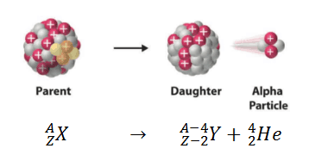

**Fig. 3.13 :Alpha decay**

***For examples:***

**i) ------------🡪 + or ${}_{2}^{4}{He}$**

**(**Parent) (Daughter) (Alpha particle)

**ii) --------🡪 + or ${}_{2}^{4}{He}$**

**(**Parent) (Daughter) (Alpha particle)

**2) Beta (β) decay (${}_{-1}^{0}β$ or ${}_{-1}^{0}e$):**

***Beta-decay****or****β****-****decay****is a radioactive decay in which an atomic nucleus emits a* ***beta****particle* ***(electrons)****and thereby transforms or '****decays****' into a different atomic nucleus, with no change in atomic mass number, but the atomic number is increased by one (Fig.3.14)*

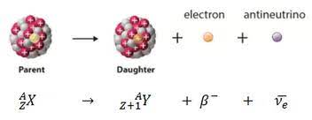

**Fig. 3.14 :Beta-decay**

***For examples:***

**i) ------------🡪 +  *or ${}_{-1}^{0}e$***

**(**Parent) (Daughter) (beta particle)

**ii) -----------🡪 +  *or ${}_{-1}^{0}e$ + ${}_{0}^{0}ϑ$***

**(**Parent) (Daughter) (beta) (antineutrino)

**3) Gamma (γ) decay (${}_{0}^{0}γ$):**

*In this radioactive decay process,* ***unstable atomic nuclei can dissipate excess energy by a spontaneous electromagnetic process****. It is known as gamma emission, in which gamma rays (photons, packets of electromagnetic energy, of extremely short wavelength) are radiated (fig. 3.15).*

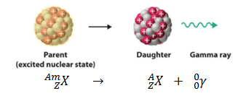

**Fig. 3.15 :Gamma decay**

***For examples:***

1. **------------**🡪 **+**

**ii) --------🡪 +**