**K. T. S. P. MANDALS**

**HUTATMA RAJGURU MAHAVIDYALAYA,**

**RAJGURUNAGAR, TA. KHED, DIST. PUNE 410505**

**T.Y. B.SC. CHEMISTRY - SEM II**

**CBCS PATTERN AS PER NEW SYLLABUS**

**SUBJECT - PHYSICAL CHEMISTRY CH-601 CHAPTER NO. 3** **Nuclear Chemistry**

**PART - II**

**BY**

**DR. SUNITA JADHAV**

**Ionization Chamber:**

1. **Introduction:**

The ionization chamber is a **gas-filled radiation detector that detects and measures nuclear particles** and specific forms of ionizing radiation such as X-rays, γ rays, and β particles.

1. **Principle:**

*The term "ionization chamber" refers to detectors that work on the concept of excitation or ionization of atoms in the medium that the incident charged particles travel through. While passing through matter, charged particles leave a path of ionized or excited atoms, which may be detected and measured.*

1. **Construction:**

The ionization chamber comprises a metallic cylinder, two opposing electrodes are placed in a container with filled gas, and high voltage is applied (fig. 3.7).

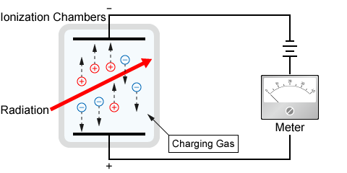

**Fig. 3.7 :Ionization Chamber**

1. **Working:**

Two metal plates are separated by air in an ionization chamber. When radiation travels through this chamber, it knocks electrons out of gas molecules, resulting in positive ions. Positive ions travel to the cathode while electrons flow to the anode. A slight current flow between the plates as a result. The radiation intensity passed through the ionization chamber is determined by measuring this current using an ammeter. A Dosimeter ionization chamber measures the total electric charge traveling between the plates in a particular period. The amount of radiation intensity that has passed through the chamber is proportional to the total amount of radiation that has passed through it.

1. **Advantages:**

***Current mode***; no "dead time" in the ionization chamber is employed for high radiation dosage rates.

***Simplicity;*** The power supply that is less costly and more portable can be utilized in an ionization chamber.

***Detection of neutrons;*** Ionization chambers in current mode are often used in nuclear reactors to detect neutrons and are part of the Neutron Instrumentation System (NIS).

1. **Disadvantages:**

No charge amplification and low density.

**Geiger Muller Counter:**

1. **Principle:**
2. Radiation ionizes the gas when it passes through it & produces fewer ions. These ions have a secondary avalanche if the voltage is applied strong enough. A small voltage drop is recorded across the load, and this voltage is amplified so that the counter can record it.
3. **Construction:**
4. It consists of a hollow metal enclosed in a thin glass tube and acts cathode (fig. 3.8).
5. A fine tungsten (W) wire is stretched along the axis of the tube & is insulated by ebonite plugs. This fine tungsten wire acts as an anode.
6. The tube is evacuated & then partially filled with a mixture of 90% Ar at 10 cm pressure and 10% ethyl alcohol vapors at 1cm pressure.
7. The fine tungsten wire is connected to the +ve terminal of a high-tension battery through a resistance (R), & the -ve terminal is connected to the metal tube.
8. A thin mica window is used at the tube end to allow radiation entry into the tube.

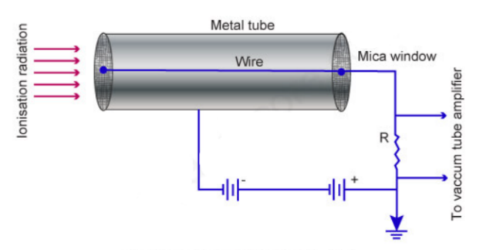

**Fig. 3.8 :Geiger Muller Counter**

1. **Working:**
2. The tube is filled with Ar gas, & around +400 Volts is applied to the thin wire in the middle.
3. When a particle arrives in the tube, it takes an electron from the Ar atom.
4. The electron is attracted to the middle wire, and as it rushes on the wire, the electron knocks other electrons from Ar atoms, causing an "avalanche." Thus, one incoming particle causes many electrons to arrive at the wire, creating a pulse that can be amplified and counted. This gives us a very sensitive detector.
5. **Characteristics of G. M. counter:**
6. For voltage less than 1000 V, there is no discharge & hence no counts (fig. 3.9).
7. Between 1000 -1200 V, the number of counts increases linearly with the applied voltage; the region is proportional.
8. Above 1200 V up to 1500 V, the count rate shows the slightest variation, almost constant the region is known as the plateau region.

If the voltage is applied above 1500 V, a continuous discharge occurs; the count rate increases rapidly due to discharge at Ar gas which is undesirable.

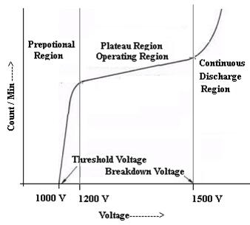

**Fig. 3.9 :Counts Vs. Voltage**

1. **Disadvantages:**
2. Energies cannot be measured by it as it lacks differentiating abilities.
3. It cannot detect uncharged particles like Neutrons.
4. Due to the significant paralysis time limits and significant dead time.
5. The quenching agent used in this counter often decomposes, leading to less lifetime of the GM Counter.

**Scintillation Counter:**

1. **Introduction:**

Scintillation Counter is an instrument used to measure ionizing radiation similar to the Geiger Muller counter and ionization chamber. It comprises the scintillator that generates photons in response to incident radiation. A photomultiplier tube converts an electronics and electric signal to process the signal.

1. **Principle:**

*When high-energy atomic radiations are incident on the surface coated with some fluorescent material, flashes of light (called scintillators) are produced. The scintillators are detectors with the help of a photomultiplier tube that gives an equivalent electric pulse.*

1. **Construction:**
2. The scintillation counter consists of two parts; Scintillator and a photomultiplier tube (fig. 3.9).
3. The scintillator contains a scintillation crystal, which produces a brief flash of light each time struck by alpha, beta, or gamma radiation.

***For example;*Sodium iodide, anthracene, zinc sulfide, and naphthalene.**

1. The flash of light is produced by striking the scintillation crystal with alpha or beta, or gamma particles are called ***scintillation.***
2. The construction of the photomultiplier tube is given in fig. 3.10.

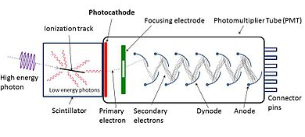

**Fig. 3.10 :Scintillation Counter**

1. **Working:**
2. The radiation strikes the scintillation crystals present in the scintillator; a tiny flash of light is produced.
3. The flash of light, i.e., scintillations, is amplified with the help of a photomultiplier tube.
4. Each radiation particle produces a pulse of anode current at the output of the photomultiplier.
5. The photomultiplier output is connected to an electronic counter with counts for each flashlight generated by the scintillation crystals (phosphors).
6. The intensity of radiation can be detected by counting the number of pulses.
7. **Advantages:**
8. Its counting rate is high-speed.
9. It is also used to detect X-rays.
10. It is more sensitive than the Geiger Muller counter.
11. It can also detect a lower level of radiation.