**K. T. S. P. MANDALS**

**HUTATMA RAJGURU MAHAVIDYALAYA,**

**RAJGURUNAGAR, TA. KHED, DIST. PUNE 410505**

**T.Y. B.SC. CHEMISTRY - SEM II**

**CBCS PATTERN AS PER NEW SYLLABUS**

**SUBJECT - PHYSICAL CHEMISTRY CH-601 CHAPTER NO. 3** **Nuclear Chemistry**

**PART - I**

**BY**

**DR. SUNITA JADHAV**

**INTRODUCTION:**

A nuclear reaction differs from a chemical reaction in several ways. In a chemical reaction, extranuclear or valence electrons rearrange to combine the atoms of the reactants, but the nuclei of the atoms are unaffected. The nucleus of the atom, on the other hand, is participating in a nuclear reaction. The number of protons or neutrons in the nucleus changes to generate a new element. ***Nuclear chemistry is the study of nuclear changes in atoms.***

**Difference between Chemical Reactions and Nuclear Reactions :**

|  |  |
| --- | --- |
| **Chemical Reactions** | **Nuclear Reactions** |
| It occurs when bonds are broken. | It occurs when nuclei emit particles & or rays. |
| Atoms remain unchanged, although they may be rearranged. | Atoms can be converted into atoms of another element. |
| Involve only valence electrons | It may involve protons, neutrons, and electrons. |
| It is associated with small energy changes (KJ/mole). | It is related to significant energy changes (MeV). |
| The reaction rate is influenced by temperature, pressure, concentration, and surface area. | The reaction rate is not influenced by temperature, pressure, concentration, and surface area. |

**Radioactivity:**

1. Several elements, including uranium (U) and radium (Ra), are unstable. Their atomic nucleus spontaneously breaks, forming a smaller atomic nucleus of a different element. The unstable nucleus' protons and neutrons recombine to form a new nucleus. Radiation results from the emission of excess particles and energy from the originating nucleus. Radioactive elements are those whose atomic nucleus emits radiation, and radioactive disintegration or radioactive decay is the spontaneous breakdown of unstable atoms.
2. ***The disintegration or decay of unstable atoms or nuclides accompanied by the emission of radiation is called radioactivity.***

**Types of Radiations:**

There are three types of radioactive radiation. Rutherford (1902) sorted them out by passing them between two plates with opposing charges (Fig. 3.1). The ones that bent towards the negative plate were known as ***α (alpha) rays*** because they carried a positive charge. ***Β (Beta) rays*** turned towards the positive plate and carried a negative charge. The third form of radiation, known as *γ* ***(gamma) rays*,** was uncharged and flowed right through the electric field. As they create luminescence on the zinc sulfide screen put in their path, rays such as, and may are easily recognized.

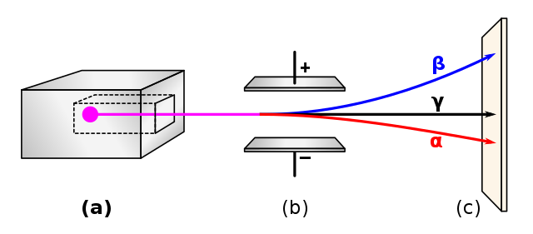

**Fig. 3.1 :Detection of α, β, and γ rays (a. Lead box with a radioactive substance, b. Electrically charged plates, and c. Photographic plate**

**Properties of Radiations:**

The following are the alpha, beta, and gamma rays, and their properties are discussed here;

**A) Alpha rays (α):**

1. ***Nature:***
2. *It comprises two protons and two neutrons; it has a positive charge (due to the presence of two protons) (fig. 3.2). They are helium nuclei (He) and may be represented as ${}_{2}^{4}α$*  ***or ${}_{2}^{4}{He}$***
3. ***Velocity:***

*α or helium nuclei at* ***high velocity****, around a tenth of the speed of light (3 x 108 m/s)*

1. ***Ionizing power:***

*Alpha particles are* ***highly***[***ionizing***](https://www.arpansa.gov.au/understanding-radiation/what-is-radiation/radiation/glossary)*because of their double positive charge, large mass (compared to a beta particle), and relatively slow.*

1. ***Penetrating power:***

*It has extremely* ***low penetrating power****through matter due to its charge and comparatively large size. They are stopped by a thick sheet of paper or even a layer of clothes.*

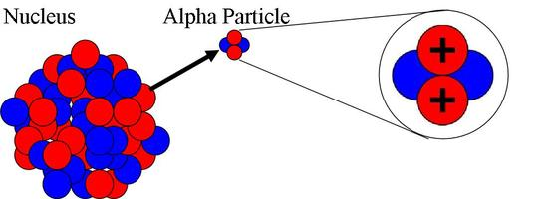

**Fig. 3.2 :Alpha rays**

**B) Beta rays (β):**

1. **Nature:**

*It is β particles; Becquerel demonstrated that they are similar to electrons (fig. 3.3). It has extremely low mass and has –1 charge and may be represented as ${}_{-1}^{0}β$*  ***or ${}_{-1}^{0}e$***

1. **Velocity:**

*They have a greater velocity than that of α-rays, very close to that of light.*

1. **Ionizing power:**

*They have less ionizing power than alpha particles. Though the velocity of β-particles is higher, the mass being smaller, their kinetic energy is much less than α-particles. Hence, they are poor ionizers.*

1. **Penetrating power:**

*Compared to α particles, β particles are more penetrating. Because they have a faster velocity and a lower mass, these particles can be passed through paper but are stopped by aluminium foil.*

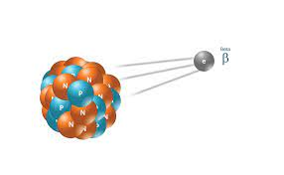

**Fig. 3.3 :Beta rays**

**C) Gamma rays (γ):**

1. **Nature:**

*They are nonmaterial and chargeless, hence remain undeflected due to electric or magnetic fields. It is electromagnetic radiation of shorter wavelength than X-rays and may be represented as ${}_{0}^{0}γ$*

1. **Velocity:**

*γ-rays travel with the velocity of light (its speed same as the speed of light) (fig. 3.4).*

1. **Ionizing power:**

*Gamma rays are* ***very low***[***ionizing***](https://www.arpansa.gov.au/understanding-radiation/what-is-radiation/radiation/glossary) *because of chargeless, negligible mass, and relatively faster.*

1. **Penetrating power:**

*It has extremely* ***high penetrating power*** *through matter due to its chargeless and comparatively small size. These rays are the most difficult to stop & require concrete, lead, or another heavy shielding to block them.*

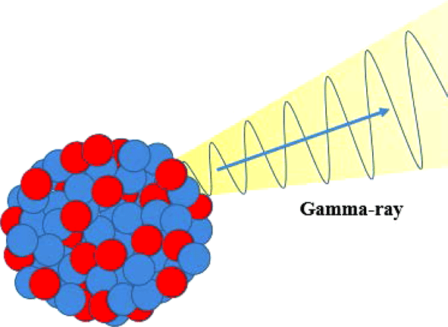

**Fig. 3.4 :λ rays**

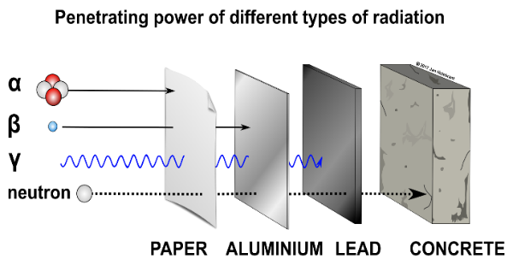

**Fig. 3.5 :Penetrating power: γ> β > α. (Ionizing power: α > β >γ)**

|  |  |  |  |
| --- | --- | --- | --- |
| Properties | Alpha | Beta | Gamma |
| **Nature** | $${}_{2}^{4}{He}$$ | ${}_{-1}^{0}β$***or ${}_{-1}^{0}e$*** | $${}_{0}^{0}γ$$ |
| **Velocity** | *1/10th velocity of light* | *Close to the velocity of light* | *Velocity of light* |
| **Penetrating power** | Low | Intermediate | High |
| **Ionizing power** | High | Intermediate | Low |

**Table 1.**Comparison between the alpha, beta, and gamma rays

**Detection and Measurement of Radioactivity:**

Several methods can be used to detect and measure radioactive radiation. Below is given the list of most common ones utilized in current practice.

**Cloud chamber:**

1. **Introduction:**

It is also known as the *Wilson cloud chamber*; It is an instrument used to *detect and identify the path of subatomic particles*. The tracks of subatomic particles or ionized particles can be photographed.

1. **Principle:**

*When a particle is allowed to pass through the supersaturated vapors, droplets may be formed onto the line because of ionization along the track, and the particle is detected.*

1. **Construction:**

It consists of a closed cylindrical chamber with a transparent glass top and a movable piston placed at the bottom. On the topsides, the cylinder is provided with a glass window inside the cylinder (fig. 3.6).A liquid of a low boiling point (methanol and ethanol) is placed, and the piston can be moved up or down. The whole system is air-tight. A strong light source is used to illuminate the chamber while the camera takes a photograph.

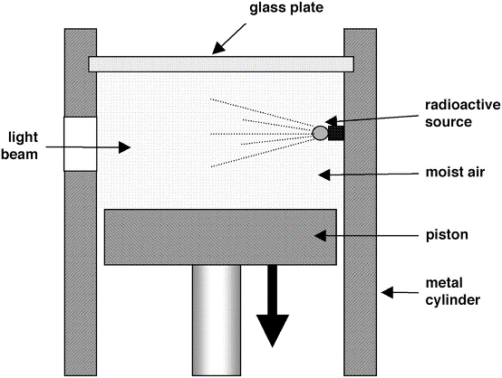

**Fig. 3.6 :Cloud Chamber**

1. **Working:**

The air in the chamber is saturated with water vapor. The gas expands and is super cool when the piston is rapidly dropped. Ions are formed along the path of α or β particle as it travels through the gas. These ions serve as nuclei for the condensation of water droplets. The particle's track is marked by the trail or cloud that results. The track can be seen via the window above and photographed instantly.

1. **Disadvantage:**

One disadvantage of the cloud chamber is the **relatively low density of the gas**, which limits the number of interactions between ionizing radiation and molecules of the gas.