**K. T. S. P. MANDALS**

**HUTATMA RAJGURU MAHAVIDYALAYA,**

**RAJGURUNAGAR, TA. KHED, DIST. PUNE 410505**

**T.Y. B.SC. CHEMISTRY - SEM II**

**CBCS PATTERN AS PER NEW SYLLABUS**

**SUBJECT - PHYSICAL CHEMISTRY CH-602**

**CHAPTER NO. 2**

**KINETICS OF REACTIONS IN THE SOLID STATE**

**PART - III**

**BY**

**DR. SUNITA JADHAV**

* 1. **The Prout–Tompkins Equation**

Plotting the graph of concentration *vs* time curve will show sigmoidal nature. *Those reactions in which the products catalyze the reaction itself or the product itself acts as a catalyst and accelerate the rate of reactions are called* ***autocatalysis or autocatalytic reactions****.*

If No is the number of nuclei present at the beginning of the reaction, the change in the number of nuclei with time, $\frac{dN}{dt}$, it can be expressed as,

$\frac{dN}{dt}= k_{o}N_{o}+k_{1}N_{1}-k_{2}N_{2}$---------------(2.51)

The first two terms in the above equation on the right-hand side give the number of nuclei initially present and the number of nuclei produced by branching. The last term expresses the loss of nuclei that results when nuclei are terminated. Termination occurs when a spreading nucleus encounters a product and thus cannot continue to spread as a reaction site. After the original nucleation sites are spent, the modified equation as,

$\frac{dN}{dt}= \left(k_{1}-k_{2}\right)N$------------------ (2.52)

For reactive sites that are linear nuclei, the fraction of the sample reacted (α) will vary with the number of nuclei as;

$\frac{dα}{dt}=kN$-------------- (2.53)

At thefinal equation that expresses α as a function of time, itis necessary to obtain a relationship between the constants (k). Forthe symmetrical sigmoidal Curve, there will be an inflection point, *α*, at 0.5. Atthe infection point, *dα/dt* has its maximum value because, at that point, the second derivative is equal to zero;therefore, at that point, k1=k2. At the inflection point,

$$k_{2}= \frac{k_{1}∝}{∝_{i}}$$

Substituting the equation of k2 in the equation (2.52), we get;

$$\frac{dN}{dt}= \left(k_{1}N-\frac{∝}{∝_{i}}k_{1}N\right)$$

$\frac{dN}{dt}= \left(1-\frac{∝}{∝_{i}}\right)k_{1}N$---------------- (2.54)

From equation 2.53, we get;

$$N= \frac{1}{k}.\frac{d∝}{dt}$$

Substituting the N in equation (2.54), we can write;

$$\frac{dN}{dt}= \frac{k_{1}}{k}.\frac{dα}{dt}\left(1-\frac{∝}{∝_{i}}\right)$$

$$\frac{dN}{dα}= \frac{k_{1}}{k}. \left(1-\frac{∝}{∝_{i}}\right)$$

$$dN= \frac{k_{1}}{k}. \left(1-\frac{∝}{∝_{i}}\right)dα$$

$$dN=\left(\frac{k_{1 }dα}{k}-\frac{k_{1}}{k}\frac{∝}{∝_{i}}dα \right)$$

Integrating the above equationcan get the relationship between α and the number of nuclei (N),

$$\int{dN}=\left(\int{K_{1}}\frac{dα}{k}-\int{\frac{k_{1}}{k}}\frac{∝}{∝_{i}} dα\right)$$

$$N=\frac{k_{1 }α}{k}\left(1-\frac{∝}{{2∝}_{i}}\right)$$

When the fraction reacted at the inflection point is 0.5*, αi= 0.5*

$$N=\frac{k_{1 }α}{k}\left(1-α \right)$$

From equation (2.53),

$$\frac{dα}{dt}=kN$$

Substitute N in the above equation we get;

$$\frac{dα}{dt}=k\frac{k_{1 }α}{k}\left(1-α \right) \\ \frac{dα}{dt}=k_{1 }α \left(1-α \right)$$

$$dα=k_{1 }α \left(1-α \right) dt$$

$$\frac{dα}{α \left(1-α \right)}=k_{1 }dt$$

Integration of this equation involves evaluating an integral of the form

[$\int{\frac{dx}{x(ax+b)}}=\frac{1}{b} ln\frac{x}{ax+b}$]

$$\int{\frac{1}{α \left(1-α \right)}}dα=k_{1 }\int{dt}$$

$$ln\frac{α}{\left(1-α \right)}= k_{1 }t+C$$

**Graph: $ln\frac{α}{\left(1-α \right)} Vs t$**

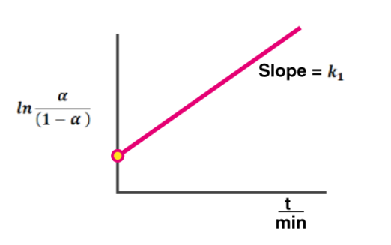

The above equation is called theProut–Tompkins rate law; it describes a process that involves linear branching chain nuclei that can be terminated when they reach the product phase.This equation was used to study the decomposition of potassium permanganate, and it has also been applied to the decomposition of silver oxide.

* 1. **Rate law based on Nucleation:**

1. The solid-state reaction follows the rate law based on the nucleation process. *Nucleation is the initial process of forming a new discrete particle of product from the solid reactant; this new small particle acts as an active site on which a small number of product particles arranges and grows crystal.* **For example**,the Condensation of droplets is also a process that involves nucleation.
2. The general form of the rate law that is used to describe nucleation processes is known as the ***Avrami (or Avrami–Erofeev) rate law,***and given as;

$$α=1-e^{-{kt}^{n}}$$

Taking log along both sides;

ln ( $α)$ = ln(1) – ktn ln (e)

ln(1) - ln ( $α)$ = ktn  [ln(e) = 1]

$${\left[-ln⁡(1-α)\right]}^{1/n}=kt$$

N (index of reaction, 1.5, 2, 3, or 4).Rate law abbreviated as A1.5, A2, A3, etc. In particular, the A1.5 rate law (when n=1.5, 1/n is 2/3, so this rate law is sometimes identified in that way has been used to describe crystallization processes in some solids. The rate laws with n = 2 and n = 3 are associated with nuclei' 2D and 3D growth.

1. Several solid-state reactions generally obeyAvrami–Erofeev rate law. For example, the **dehydration of CuSO4. 5H2O** as represented below;

**CuSO4.5H2O(s) -------------🡪 CuSO4.3H2O(s) + 2H2O(g) -------- (47 to 63 oC)**

**CuSO4.3H2O(s) -------------🡪 CuSO4.H2O(s) + 2H2O(g) ---------- (70.5 to 86 oC)**

Both steps appear to follow an Avrami–Erofeev rate law with an index of 2 over a range of α from 0.1 to 0.9.

1. To provide a practical example of the type of behaviour exhibited by a reaction that follows an Avrami–Erofeev rate law, the data presented in Table 2.1 were derived.

**Table2.6:** Values of $α$ as a function of time for a reaction followingan Avrami–Erofeevrate law with n=2 and k = 0:025 min-1

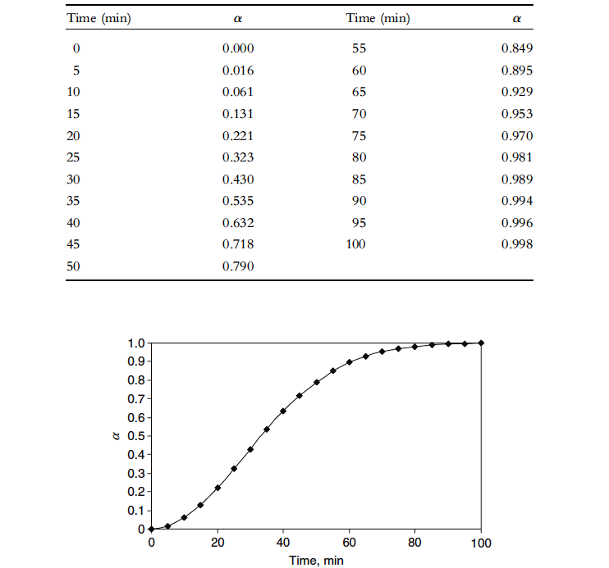

Graph of $α vs. ti$ me (t) was plotted to explain the nature of the Curve, and it is observed that the Curve has a sigmoidal shape, as represented as



**Figure 2.6:***Plot of α versus time for the data shown in Table 2.6.*

**2.7. Applying rate laws for solid reactions**

The rate laws discussed up to this point contains a large number of mathematical forms that involve functions of $\left(1-α \right)$. Those shown earlier and a few others are summarized in Table 2.7.

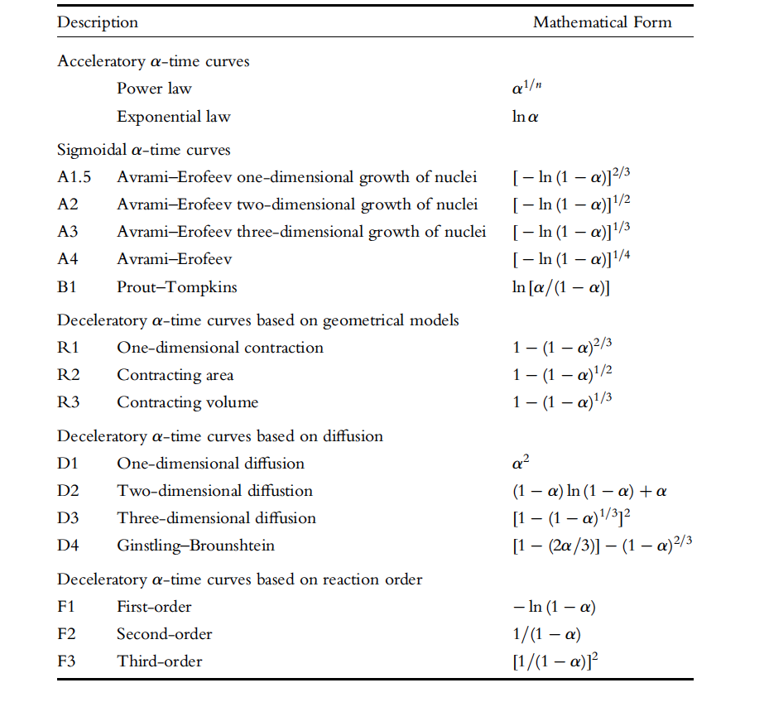**Table 2.7:***Rate laws for reactions in solids.*

**2.8. Kinetic study for solid Deaquation–Anation reaction of [Co(NH3)5H2O]Cl3**

1. When [Co(NH3)5H2O]Cl3 and other similar compounds are heated, the water is driven off, and an anion replaces it in the coordination sphere of the metal. Because an anion replaces a volatile ligand, this type is known as an ***anation reaction*.** *As the water is driven off hence called* ***deaquation,****the anion is replacing a volatile ligand hence also called* ***anation.***
2. The overall reaction can be represented as;

[Co(NH3)5H2O]Cl3(s) ---------------🡪 [Co(NH3)5Cl]Cl2(s) + H2O(g)

***Mechanism:***

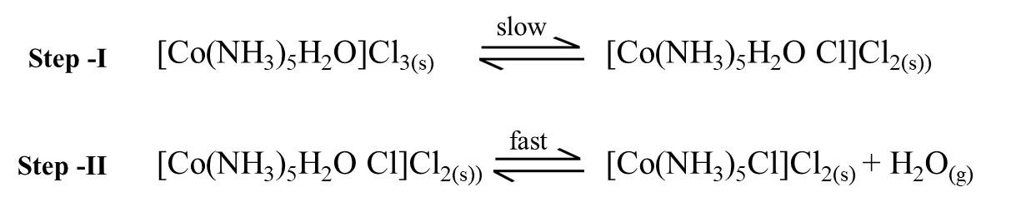

1. The ***1st step is slow***in which an anion (Cl**-**) must leave from lattice site, here form Schottky defect (an ion missing from a lattice site), is introduced in the coordination sphere. This includesa seven-membered transition state (Coordination number = 7) becausethe [Co(NH3)5H2O]3+ cation and the Cl**-** anion is involved in creating the transition state; the process has been referred to as **SN2**. The ***2ndstep is a fast*** process in which water molecule is driven off from the coordination sphere of molecule [Co(NH3)5Cl]Cl2(s).
2. The diffusion of water strongly depends on the size of the cation & anion. Diffusion of H2O through the lattice is favoured by the cation and anion having wildly differing sizes because the fraction of free space increases as the difference in the size of the cation and anion increases.Therefore, since the cation is large, water should escape soon from the chloride compound. Thus, the activation energy should vary with the size of the anion Cl-< Br-< I-, and reported activation energies are 110.5, 124.3, and 136.8 kJ mol-1, respectively, for these anions.
3. Deaquation–Anation reaction of [Co(NH3)5H2O]Cl3  fallows **Avrami–Erofeev rate law** gives sigmoidal nature of the plot as shown in figure 2.3.

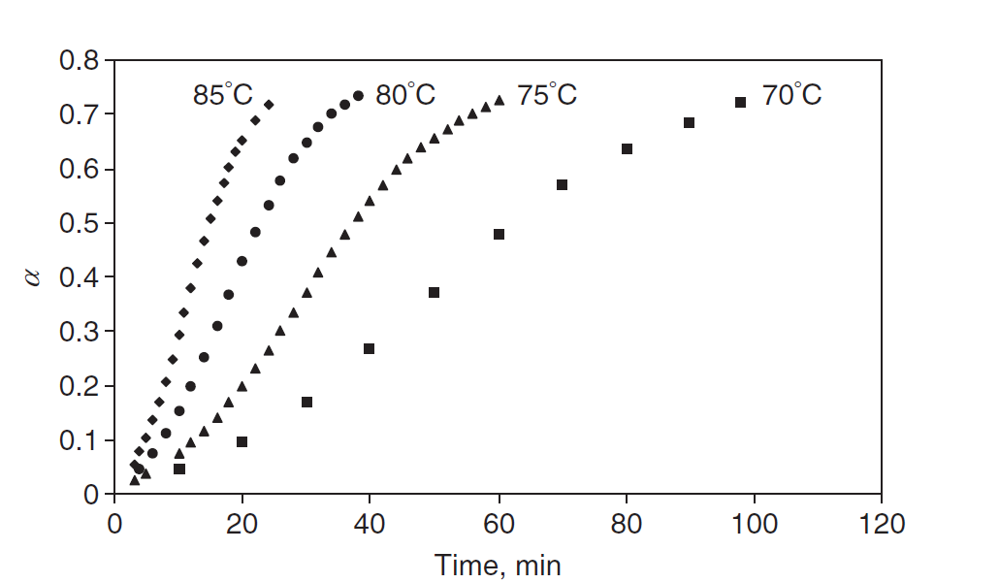

**Figure 2.3:** Rate plots for the dehydration-anation reaction of [Co(NH3)5H2O]Cl3.

An A1.5 nucleation rate law has also been shown to represent a diffusion process. The rate constants were obtained using the A1.5 rate law to represent the (α,t) by using the Arrhenius plot data shown in Figure 2.4.

**ln (K) = - $\frac{E_{a}}{RT}$ + ln (A)**

The plot slope will give the activation energy, whereas the intercept will provide the Arrhenius witha factor.

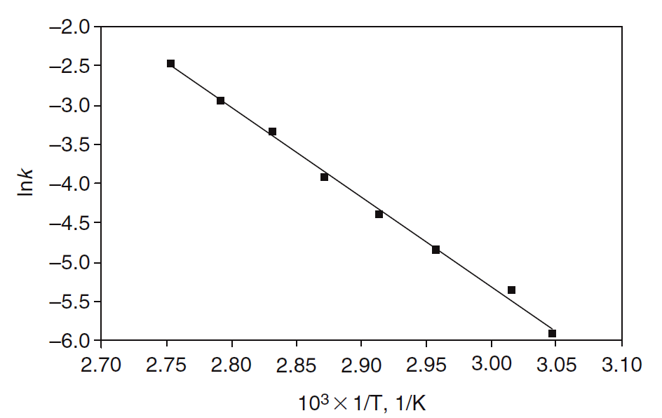

**Figure 2.4:** Arrhenius plot for the dehydration-anation reaction of [Co(NH3)5H2O]Cl3(Avrami–Erofeev rate law, n=1.5)

**2.9: Two reacting solids**

1. Under certain conditions, particles of two different solid materials may react. According to the hard-soft interaction principle, this can result from a more favourablecharacter match. Some energy sources are generally applied to make the structural units (usually ions) mobile. The most common way to react between two solids is by *heating them in close contact, using pressure and ultrasonic conditions.*
2. The rate law of reaction between two different types of reacting solid is given by the ***Jander equation*** as provided below;

$${\left[1-{\left(\frac{100-γ}{100}\right)}^{1/3}\right]}^{2}= kt$$

Where $γ$ =per cent react or fraction of solid reacted.

$${\left[1-{\left(1-\frac{γ}{100}\right)}^{1/3}\right]}^{2}= kt$$

If y is the percent reacted, γ/100 is the fraction reacted, α, so this equation is analogous to

the three-dimensional diffusion rate law,

$${\left[1-{\left(1-α\right)}^{1/3}\right]}^{2}= k$$

1. ***For example:***



In thisexperiment, a 1:1 ratio of CdI2 and Na2S was sonicated at a lower power input for a more extended period. The results as shown in Table 2.9.

***Table2.9: Extent of Reaction Between CdI2 and Na2S When Sonicated at Low Power***

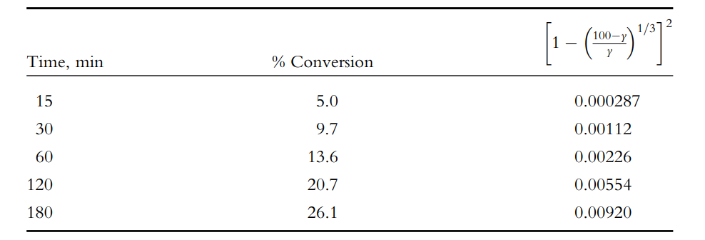

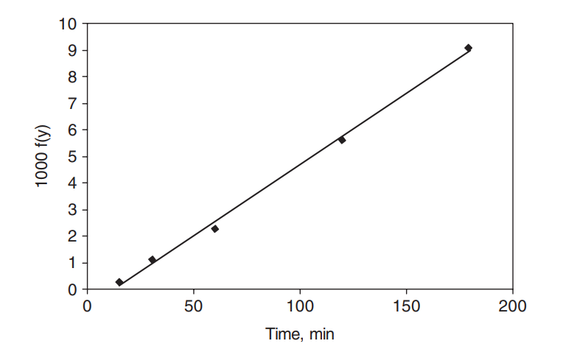

**Fig. 2.9:** The results of Wtting the Jander equation to data obtained from sonicating a 1:1 mixture of CdI2 and Na2S at low power.