**K. T. S. P. MANDALS**

**HUTATMA RAJGURU MAHAVIDYALAYA,**

**RAJGURUNAGAR, TA. KHED, DIST. PUNE 410505**

**T.Y. B.SC. CHEMISTRY - SEM II**

**CBCS PATTERN AS PER NEW SYLLABUS**

**SUBJECT - PHYSICAL CHEMISTRY CH-602**

**CHAPTER NO. 2**

**KINETICS OF REACTIONS IN THE SOLID STATE**

**PART - II**

**BY**

**DR. SUNITA JADHAV**

**2. 4. Rate laws for reactions in solid**

Approximately ***twenty rate laws*** are found to provide the kinetics of reactions in the solid-state. The rate law is derived starting with specific models and has diverging mathematical forms. Some essential rate laws will now be described, and derivations will illustrate how the principles are applied. After doing this, here below are some of the rate laws.

1. **The Parabolic Rate Law**

Considering the reaction of oxygen (O2(g)) with a solid (metal surface), the oxide layer on the surface thickens as the reaction proceeds.

2M(s) + O2(g) --------------🡪 2MO(s)

***t = 0 0***

***t = t x***

For example, oxidation of iron in the presence of oxygen,

**4Fe(s) + 3O2(g) -------------🡪 2Fe2O3(s)**

The rate of the reaction can be described with the help ofthe *thickness of the layer (x);* we get

$$Rate= \frac{dx}{dt}$$

Therefore, x increases, the reaction rate decreases because the oxygen must diffuse through the metal oxide layer, the rate is proportional to $\frac{1}{x}$, then the rate law as,

$$\frac{dx}{dt} α \frac{1}{x}$$

$$\frac{dx}{dt}=k \frac{1}{x}$$

Where *k = rate constant or velocity constant or proportionality constant*

Rearrangement of the above equation as;

$$x dx=k dt$$

Integrating the above equation with the proper limits,

$$\int_{0}^{x}{x dx=k\int_{0}^{t}{dt}}$$

*(K is the constant, it is independent of change in the time; therefore, it should be outside the sign of the integration)*

($\int{x^{n}} dx= \frac{x^{n+1}}{n+1}+C$)

[$\frac{x^{2}}{2}]_{0}^{x}=k[t]_{o}^{t}$

[$\frac{x^{2}}{2}-\frac{0^{2}}{2}]=k[t-0]$

$$x^{2}=2kt$$

$$k=\frac{x^{2}}{2t}$$

$$x={(2kt)}^{1/2}$$

The above equation is in a parabola; hence this rate law is known as ***parabolic rate law*.**

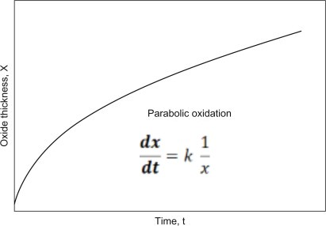

**Fig. 2.4:** *Oxide thickness vs time (t)*

***Unit of k;***

|  |  |  |
| --- | --- | --- |
| Sr. No. | Description | Units of k |
| 1 | If the thickness of the product layer is measured in *cm* and time in a *sec* | **cm2 sec-1** |
| 2 | If we consider the weight of the product layer in *g cm-'* and time in *sec* | ***g2 cm-4 sec-****1* |
| 3 | If the amount of layer is expressed in *mol cm-2* and time in '*sec* | ***mol2 cm-4 sec-****1* |

1. **The First-Order Rate law**

Let's consider general solid-state reaction;Reactant R is converting into product P as below;

R(s) -------------🡪 P(s) + G(g)

(Reactant) (Product) (Gas)

t = 0 W0 0 0

t = t W x x

Where Wo= initial weight of reactant at t = 0

W = amount of reactant at t = t

X = amount of the product at t = t

If the reaction follows a first-order, the *rate equation* is, (the weight of the reactant decreases with change in time)

Rate = $-\frac{dW}{dt}$

The *rate law* for this reaction as,

$$-\frac{dW}{dt} α W$$

$$-\frac{dW}{dt}=k W$$

$$-\frac{dW}{W}=k dt$$

Integrating the aboveequationwith the proper limits,

$$\int_{W_{0}}^{W}{-\frac{1}{W}} dW=k\int_{0}^{t}{dt}$$

[ $\int{\frac{1}{x} dx=lnx+C}$]

-[ ln(W) $]_{w0}^{w}$ = k [t

- [ln W – ln W0] = k [ t – 0 ]

The exponential form of the equation, **W = W0**

**K = log --------- (2.1) [ln x = 2.303 log x]**

However, the fraction reacted, $α$, is given by the amount reacted (Wo - W) divided by the amount of reactant initially present, Wo

$$∝ = \frac{W_{o}-W}{W_{o}}=1-\frac{w}{W_{o}}$$

$$-\frac{W}{W_{o}}=(∝-1)$$

$$\frac{W}{W_{o}}=(1-∝)$$

Substituting $\frac{W}{W_{o}}$ into 2.1 equation, we can get,

$k t$ = $-2.303 log(1-∝)$

The plot of the $-log\left(1-∝\right) vs. t$ givesa straight line with zero intercept and positive slope. **The slope of the plot directly gives the value of k.**

$log(1-∝)$ = - $\frac{kt}{2.303}$

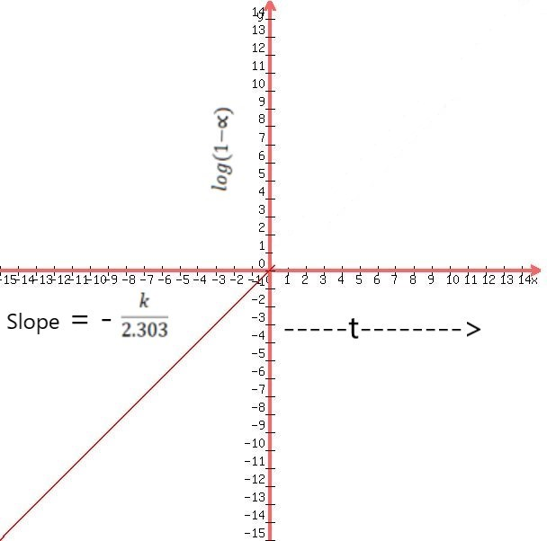

The unit of k =***min-1 or sec-1****.*

The rate law equation and unit of k are similar to first-order reactions.

**3. The Contracting Sphere Rate Law**

To describe the contracting sphere rate law,If the reaction occurs on the Sphere's surface of the solid particles, the rate will be proportional to the surface area, S, then rate law for this reaction can be written as,

$$-\frac{dV}{dt} α S$$

$-\frac{dV}{dt}=k_{o} S$------------ (3.1)

The surface area of the spherical solid particles as,

$$S=4πr^{2}$$

Where V is the volume of spherical solid at time t

K0 = Rate constant

r = radius of spherical solid particles

Substituting the equation of S in equation (3.1), we get

$-\frac{dV}{dt}=k_{o} 4πr^{2}$-------------- (3.2)

The volume of the spherical solid particles as,

$V= \frac{4}{3} πr^{3}$ or $r={\left(\frac{3V}{4π}\right)}^{1/3}$

Substituting the equationof*r*in equation (3.2), we can write;

$$-\frac{dV}{dt}=k_{o}4π {\left(\frac{3V}{4π}\right)}^{2/3}$$

$-\frac{dV}{dt}=k V^{2/3}$--------------- (3.3)

Where, $k= k_{o}4π {\left(\frac{3}{4π}\right)}^{2/3}$ and called as rate constant or velocity constant.

By integrating equation (3.3) with the proper limits,

$$-\int_{V_{0}}^{V}{\frac{dV}{V^{2/3}}}=\int_{0}^{t}{k dt}$$

$$-\int_{V_{0}}^{V}{\frac{dV}{V^{2/3}}}=K\int_{0}^{t}{dt}$$

After solving the above integration and adding limits, we get,

$K=\frac{3\left(V_{O}^{1/3}-V^{1/3}\right)}{t}$---------------- (3.4)

Where k = rate constant,

Vo= initial volume of the spherical solid particles (t = 0)

V =volume of the spherical particles(t = t) of the reactant.

Since the general kinetic treatment of solid-state reactions cannot be made in terms of concentrations, we need to put the integrated rate law for the contracting Sphere in a form containing $α$. In this case, the amount reacted is Vo– V

$α= \frac{V_{0}-V}{V_{0}}$ = 1- $\frac{V_{0}}{V}$

$\frac{V_{0}}{V}$ = 1- $α$

Taking the cube root of each side of this equation gives,

()1/3 = )1/3

V1/3 = V01/3)1/3

Substituting the V equation in the (3.4) equation, we get,

$$\frac{kt}{3}=V_{O}^{1/3}-V^{1/3}$$

$$\frac{kt}{3}={{Vo}^{\frac{1}{3}}-Vo}^{1/3}(1-α)^{1/3}$$

Since the initial volume of the particle, Vo, is a constant, this equation can be written as

$$\frac{kt}{3{Vo}^{1/3}}=1-(1-α)^{1/3}$$

$$k^{'}t=1-(1-α)^{1/3}$$

(K' = $\frac{k}{3{Vo}^{1/3}}$)

An equation involving the function written as $1-(1-α)^{1/3}$ It also results in other cases where a volume of the reacting material contracts in all three dimensions.The unit of rate constant of the contracting sphere model is **k = cm3 min-1 or m3 min-1*.***

*This equation describes the reaction rate and indicates that the amount of material reacting is proportional to the solid volume.* Equation 3.4 represents the rate law for contacting sphere model. This equation also involves the "concentration" (actual volume) to the 2/3 power. Therefore, it is also called $\frac{2}{3}$***Order rate law equation.***

***Determine how the radius of the contracting Sphere will change with time:***

The change in volume of the **contracting Sphere** can be expressed in terms of the radius as;

$-\frac{dV}{dt}=-\left(\frac{dV}{dt}\right)\left(\frac{dr}{dt}\right)=k_{o}(4πr^{2} )$--------------- (3.5)

Taking the derivative ofthis equation ($V=\frac{4}{3} πr^{3}$)with the radius;

$$\frac{dV}{dr}=4πr^{2}$$

Substituting $\frac{dV}{dr} the$ equation in the equation (3.5), we can write;

$$- 4πr^{2}\left(\frac{dr}{dt}\right)=k_{o}(4πr^{2} )$$

This equation can be written as;

$$-\frac{dr}{dt}=k_{o}$$

*This equation indicates that the radius of the spherical particle decreases at a constant rate.*

**4. The Contracting Area Rate Law**

Consider a particle of the solid-state reactant with cylindrical rod shape having radius '*r'* and height '*h'*as follows,

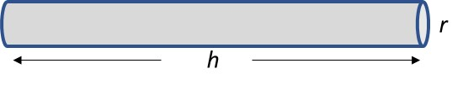

**Fig. 4.1:** Cylindrical rod shape

Suppose that the cylinder is very long compared tothe radius**(h >> r)**. Therefore, *the area of the ends will be considered insignificant compared to the curved surface area*,and assume that there is no significant reaction on the ends.Consequently, we are assuming that the length remains constant duringthe reaction.

Since the amount of material in the cylinder is represented bythe volume and the reaction occurs on the surface, we can write the rate law,

$$-\frac{dV}{dt} α S$$

$-\frac{dV}{dt}=k_{o} S$------------ (4.1)

The surface area of the cylindrical rod-shaped solid particles as,

$$S=2πr^{2}+2πrh$$

Where V is the volume of cylindrical rod shape solid at time t

K0 = Rate constant

r = radius of the solid particles

Assuming that there are no significant reactions takes place at the end, so $2πr^{2}$ term from above equations can be neglected, and the surface area equation as;

$S=2πrh$--------------- (4.2)

The volume of the cylinder is given by;

$$V= πr^{2}h$$

Thus, the radius is,

$$r={\left(\frac{V}{πh}\right)}^{1/2}$$

Substituting the S equation(4.2) into the equation of(4.1), we get;

$$-\frac{dV}{dt}=k_{o}(2πrh)$$

"r" is the radius that can be substituted into the above equation, we get;

$$-\frac{dV}{dt}=2πhk_{o}{\left(\frac{V}{πh}\right)}^{1/2}$$

$$-\frac{dV}{dt}=2k_{o}{(πh)}^{1/2}V^{1/2}$$

$$-\frac{dV}{dt}=k V^{1/2}$$

(k = constant and written as $k=2k_{o}{(πh)}^{1/2}$)

$$-\frac{dV}{{ V}^{1/2}}=k dt$$

Integrating the above equation with proper limits, we get;

$$-\int_{V_{o}}^{V}{\frac{1}{{ V}^{1/2}}}=k \int_{t_{o}}^{t}{dt}$$

($\int{V^{-1/2}dv=\frac{V^{-\frac{1}{2}+1}}{-\frac{1}{2}+1}+C}$)

After solving the integration and adding upper and lower limits, we get;

$$-2 \left(V^{1/2}-V_{o}^{1/2}\right)=kt$$

$$2 \left(V_{o}^{1/2}-V^{1/2}\right)=kt$$

$k= \frac{2 \left(V_{o}^{1/2}-V^{1/2}\right)}{t}$---------------- (4.3)

Where k = rate constant or velocity constant for this solid-state reaction

Vo = initial volume of the cylindrical shape rod solid particles (t = 0)

V = volume of the cylindrical shape rod solid particles (t = t) of the reactant.

Equation (4.3) mentioned the rate law (rate constant) equation for the contracting area model in which the cylindrical rod shape solid reactant particles. Since this equation also involves the "concentration" (actually volume) term to the 1/2 power. Therefore, it is also calledthe "**1/2-order" rate law equation.**

Since the general kinetic treatment of solid-state reactions cannot be made in terms of concentrations, we need to put the integrated rate law for the contracting area in a form containing $α$. In this case, the amount reacted is Vo– V

$α= \frac{V_{0}-V}{V_{0}}$ = 1- $\frac{V_{0}}{V}$

$\frac{V_{0}}{V}$ = 1- $α$

Taking the square root of each side of this equation gives,

()1/2 = )1/2

V1/2 = V01/2)1/2

Substituting Vo1/2 equation in the (4.2) equation, we get,

$$\frac{kt}{2}=V_{O}^{1/2}-V^{1/2}$$

$$\frac{kt}{2}={{Vo}^{\frac{1}{2}}-Vo}^{1/2}(1-α)^{1/2}$$

Since the initial volume of the particle, Vo, is a constant, this equation can be written as

$$\frac{kt}{2{Vo}^{1/2}}=1-(1-α)^{1/2}$$

$$k^{'}t=1-(1-α)^{1/2}$$

(K' = $\frac{k}{2{Vo}^{1/2}}$)

The unit of rate constant of the contracting area model is ***k = cm3 min-1 or m3 min-1***

***Determine how the radius of the cylinder will change with time:***

The change in volume of the cylinder can be expressed in terms of the radius as;

$-\frac{dV}{dt}=-\left(\frac{dV}{dt}\right)\left(\frac{dr}{dt}\right)=k_{o}(2πrh)$--------------- (4.4)

Taking the derivative ofthis equation ($V=πr^{2}h$)with the radius;

$$\frac{dV}{dr}=2πrh$$

Substituting $\frac{dV}{dr} the$ equation in the equation (4.4), we can write;

$$-2πrh\left(\frac{dr}{dt}\right)=2πrk_{o}h$$

This equation can be written as;

$$-\frac{dr}{dt}=k_{o}$$

*This equation indicates that the radius of the cylindrical particle decreases at a constant rate;the same was observed in the contracting sphere model considered earlier.*