**K. T. S. P. MANDALS**

**HUTATMA RAJGURU MAHAVIDYALAYA,**

**RAJGURUNAGAR, TA. KHED, DIST. PUNE 410505**

**T.Y. B.SC. CHEMISTRY - SEM II**

**CBCS PATTERN AS PER NEW SYLLABUS**

**SUBJECT - PHYSICAL CHEMISTRY CH-602**

**CHAPTER NO. 2**

**KINETICS OF REACTIONS IN THE SOLID STATE**

**PART - I**

**BY**

**DR. SUNITA JADHAV**

**Kinetics of Reactions in the Solid State**

**2.1. Introduction**

Chemical kinetics deals with the ***rates of chemical reactions***, factors that influence the rates, and the explanation of the reaction mechanisms of chemical processes. In chemical equilibria, thermodynamics governs the energy relations between the reactants and the products without considering intermediate states or time. In chemical kinetics, the time variable is introduced, and *the reaction rate is the change of concentration of reactants or products concerning time*. The chemical kinetics is thus, concerned with the quantitative determination of the rate of chemical reactions and the factors upon which the rates depend. It's no different for solid-state reactions, and many important industrial processes involve solid-state transformations. ***For example***, when a solid product is dried (a standard procedure in industrial chemistry), water vapour is lost from the substance. In some situations, the water may be created by the decompositionof a solid hydrate. Other processes involve the conversion of one solid phase of a chemical into another without changing its composition.Due tosome of the difficulties involved in studying reactions in solids, kinetic studies on solid-state reactions have been a neglected area of chemical kinetics. However, some unusual aspects of solid-state reactions deserve special attention, and many of these factors will be discussed. This chapter will present an overview of this growing and economically important field.

**2.2. Some General Consideration**

*The reaction rate in the solutionsor gas phase is given to****change in reactant concentration or product with respective time*.**

Consider a general reaction; We can write;

A ---------🡪 B

t = 0 [A]0 0

t = t [A] x

Where [A]0 = initial concentration of the reactant A at t = 0

[A] = concentration of the reactant A at t = t

X = concentration of the product B at t = t

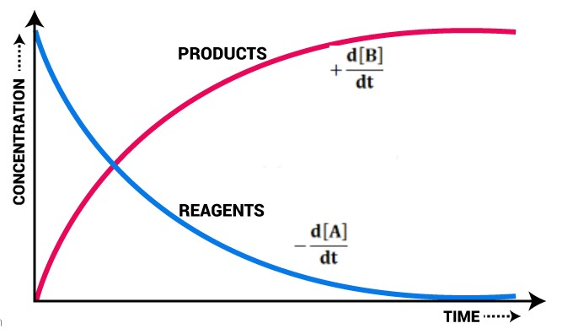

**Fig. 2.1:** Concentration Vs time

The rate of a reaction as,

$$Rate of reaction=-\frac{d\left[A\right]}{dt}=+\frac{d\left[B\right]}{dt}$$

(-ve sign indicates a decrease in the concentration and +ve sign indicates an increase in the concentration)

If the above reaction is first-order, the rate law is given as

$$Rate of reaction=-\frac{dA}{dt}=k\left[A\right]$$

K is the rate constant or velocity constant, which is dependent on the temperature; it can be expressed by using the***Arrhenius equation***, then we can write;

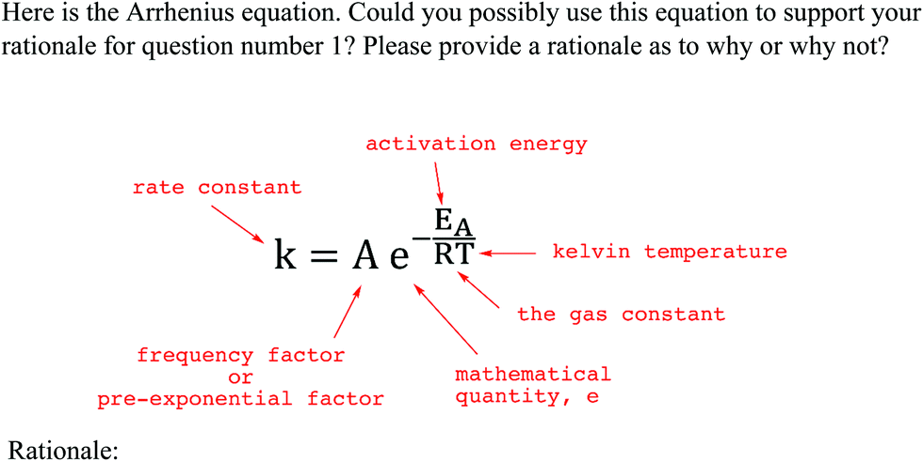

***Graphical method:***

A plot of **'*ln k vs 1/T'*** gives a straight line with a negative slope (fig. 2.2). Taking the ln of an Arrhenius equation

**ln (K) = ln (A) - $\frac{E_{a}}{RT}$**

**ln (K) = - $\frac{E_{a}}{RT}$ + ln (A)**

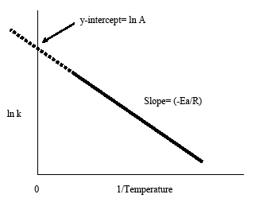

**Fig. 2.2.*ln k vs 1/T***

*Slope ($-Ea/RT)$ of the graph gives activation energy,and intercept $(lnA)$ gives Arrhenius factor.*

In general, we can write the rate law;

**R ----------------🡪 P**

**(Reactant) (Product)**

The rate law as,

$$-\frac{d[R]}{dt}=kf[R]$$

Where [R] is the concentration of a reactant,

$f$ [R] is some function of the concentration of this species.

However,the above rate law is only for solutions or gaseous phase reactions because in ***solid-state reactions concentration of reactant remains almost constant***. One factor that becomes apparent immediately when dealing with solid-state reactions is that the rate can generally not be expressed in concentrations. The reactivity of solid-state reactions strongly depends on the configuration of the solid particles.

Generally, the solid-state reaction in which the fraction of solid reacted (α) with time (t)dependson some reaction variables, includingthe *thickness of the product layer (x),the weight of the product (W),the volume of product/reactant (V)* can also be considered.

If *α* is the fraction of the reactant reacted with time (*t*), then (1- α) the fraction of solid reactant remains unreacted afterthe time (t). Then general expression can be written as;

**Reactant(s) ----------🡪 Product(s) + Gas(g)**

t = 0 1 0

t = t (1- α)α

$$Rate of reaction=\frac{dα}{dt}=k\left(1-α\right)$$

Suppose α =1, and then the reaction is found to be completed. If we plot the graph of the fraction of solid reacted (α) *vs* time (t), it shows sigmoidal Curve is obtained as shown in **figure 2.3.**

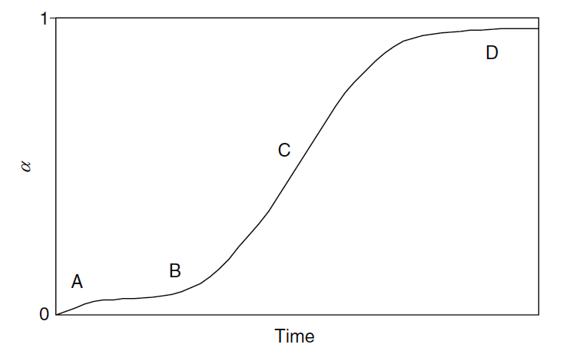

**Figure 2.3:** A plot of α vs time for solid-state reactions

**TheCurve shows four different regions labelled as A, B, C, and D.**

1. ***Region A:***

The Curve region labelled as A represents the rapid evolution of adsorbed gases from the sample, which results in a slight mass loss.

1. ***Region B:***

This region is also known asthe ***induction period of a reaction*;** this reaction rate accelerates. The induction period of the reaction is defined as *the initial slow stage of the reaction and is the minimum time needed for the transformation of the reactant*.

1. ***Region C:***

In this region, the reaction where is progressing at the ***maximum rate*.**For most reactions in the gas phase or solution, the initial rate is the maximum rate because that is the time when the concentration of the reactant is highest. Thus, in a solid reaction initial rate of reaction is minimum, and then it increases.

1. ***Region D:***

This region is also known as the***decay region*,** where the reaction ratedecreases significantly as the reaction approaches completion. If α = 1 reaction is observed to be completed practically, the reaction rate will become constant. However, reactions in solid-phase never reach α = 1 for several reasons.

The sigmodal Curve (Fig. 2.3)represents different regions such as A, B, C and D for the solid-state reaction, but some of the reactions may not show all the areas. Therefore ***solid-state reaction shows an induction period (region B).***

**2.3. Factors affecting the Reactions in solid**

Several factorsaffect the reactionsinsolid-state;the following are the factors discussed below

1. ***The particle size of a solid (Surface area):***

if the reaction takes place on the solid surface, the particle size may be necessary because *the smaller the particles, the larger the surface area for a given volume of materia*l. The physical characteristics of the surface itself are important because imperfections may determine reactivity. In a solid reaction, there is an interface between the reactant and product referred to as the topochemistry of the reaction.

1. ***The geometry of the Nuclei:***

Reactions of solids frequently depend on *the formation and growth of active sites* called **nuclei.** For some of the kinetic models, ***the geometric nature of the development of these nuclei determines the form of the rate law for the reaction***. For example, a nucleus that grows in two dimensions gives rise to a different rate law than one extending in one or three dimensions.

1. ***Phase transition (transition point):***

It is observed that the reactivity of some solids increases drastically in the temperature range where a phase transition takes place.*The increased reactivity of a solid during and as a consequence of a crystalline transformation is commonly known as the* ***Hedvall effect***. This effect may include increased reactivity near a transition point in the broader sense. This is because, at that temperature, the solid undergoes some crystal rearrangement due to the mobility of lattice members increases resulting increase in the reactivity of the solid.

1. ***History of the sample:***

The sample's history up to the moment the reaction is carried out may influence the solid's reactivity. The treatment of the solid, such as heating or annealing, can result in ***surface damage, cracks, pores, and other defects, all of which can affect the rate of reaction of the solid***. It is also possible to heat a sample to a temperature below it reacts but high enough to cause some annealing. This procedure can eliminate defects while lowering the solid's eventual reactivity. The slow cooling of a solid formed at a high temperature causes lattice members to migrate to positions that result in a nearly defect-free and highly regular structure.However, if the sample is prepared at a high temperature and quickly quenched, there will be defects that are "quenched in" because the crystal will not have the opportunity to reorient as it might have during slow cooling.

1. ***Crystal Defects:***

In the solid reaction, the reactivity of a solid depends on the defects in the crystal lattice. The defect may be stoichiometric and nonstoichiometric defects; both defects are helpful for the diffusion of materials,affectingtheir reactivity. ***The reactivity of solid is proportional to the number of imperfections present in the crystal lattice***.