**K. T. S. P. MANDALS**

**HUTATMA RAJGURU MAHAVIDYALAYA,**

**RAJGURUNAGAR, TA. KHED, DIST. PUNE 410505**

**T.Y. B.SC. CHEMISTRY - SEM II**

**CBCS PATTERN AS PER NEW SYLLABUS**

**SUBJECT - PHYSICAL CHEMISTRY CH-602**

**CHAPTER NO. 3**

**ELECTRONIC STRUCTURE AND MACROSCOPIC PROPERTIES**

**PART - II**

**BY**

**DR. SUNITA JADHAV**

**3.4 Conductors and insulators**

1. ***Conductor and insulator:***
2. *A crystal with partially filled energy bands is called a****conductor****and a crystal with filled energy bands is called an* ***insulator****.*

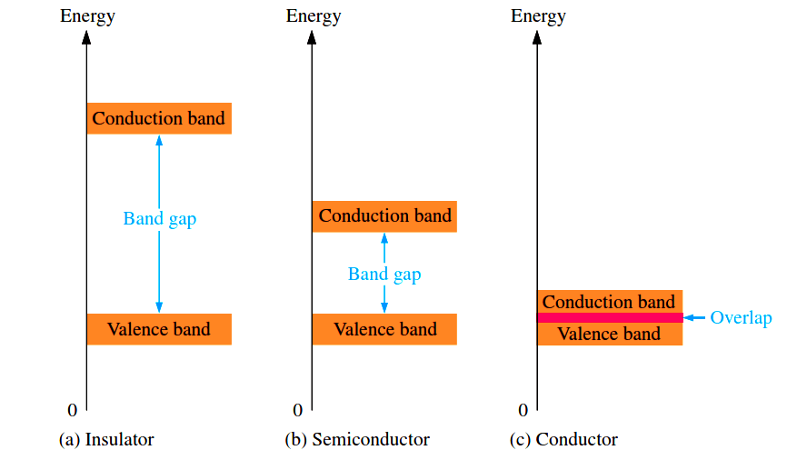

**Fig. 3.4** Bandgap (Insulator, Semiconductor and Conductor)

1. The band is a real crystal that contains as many levels as atoms in the crystal. Suppose that the band has only eight levels.

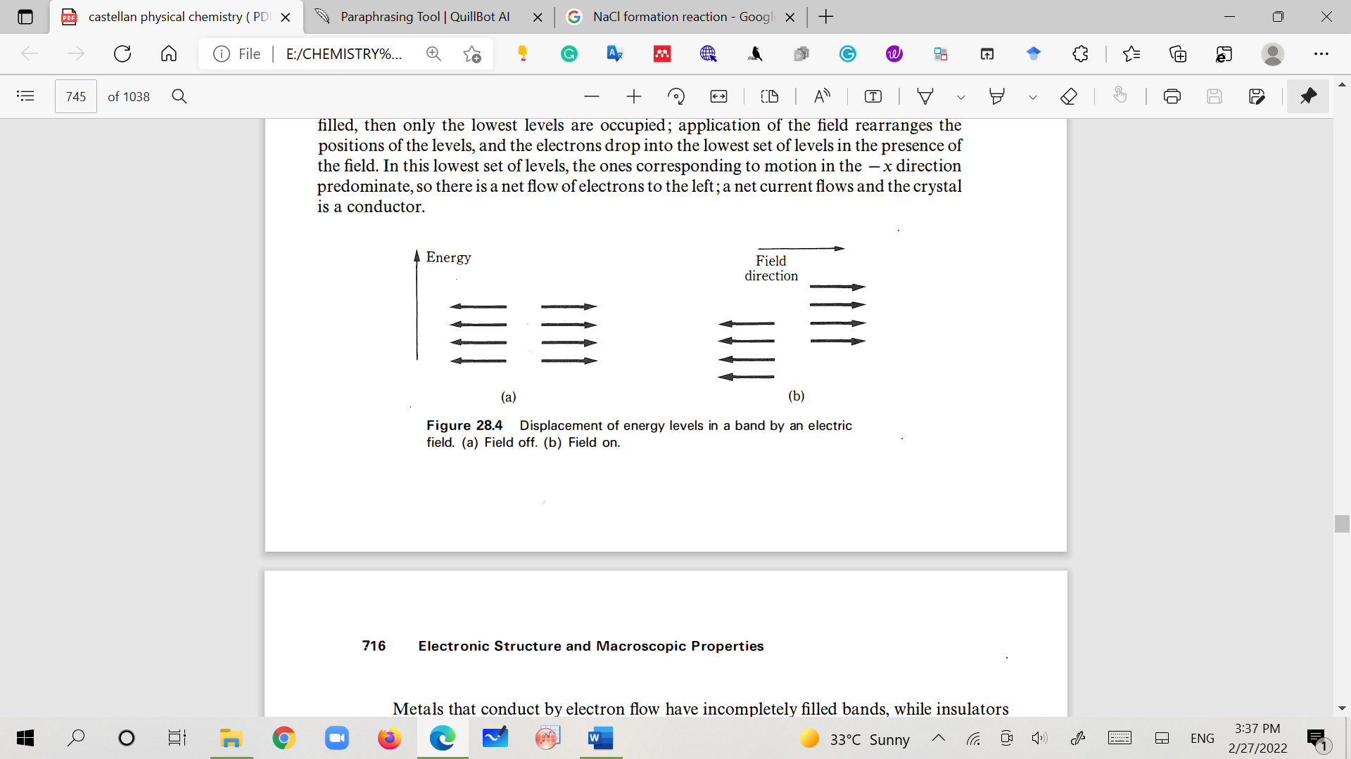

**Fig. 3.5**Displacement of energy levels in a band in the presence of an electric field.

(a) Field off (b) Field on

1. considers half of the energy levels with the motion of the electrons in the +x-direction (arrowheads) and half with motion in the -x-direction (arrowheads) (no net motion in one direction and no current flow) (fig. 3.5).
2. Ifwe apply an electric field in the + x-direction, the energy of one set oflevels is lowered and the energy ofthe other set is raised. ***If the band is full, then all levels are occupied before and after the application of the field, and there is still no net electronic motion in either direction; the crystal is an insulator.***
3. However, if the band is only partly filled, then only the lowest levels are occupied; application of the field rearranges the positions of the levels, and the electrons drop into the lowest set of levels in the presence of the field. In this lowest set of levels, the ones corresponding to motion in the - x-direction predominate, ***so there is a net flow of electrons to the left; a net current flows and the crystal is a conductor.***

**3.5 Ionic crystals**

The band system of a crystal containing two different kinds of atoms can be thought of as a superposition of the band systems of the two individual particles in the first approximation.

1. The sodium chloride (NaCl) band system is shown in fig. The eight electrons fill the chloride ion's 3s and 3p bands, whereas the sodium ion's 3s band, which has greater energy, is vacant (fig. 3.6).
2. The crystal is made up of sodium ions and chloride ions rather than sodium and chlorine atoms.

**Na+ + Cl- --------------🡪 NaCl(s)**

1. Because an energy gap separates the full and from the empty bands, sodium chloride acts as an insulator.

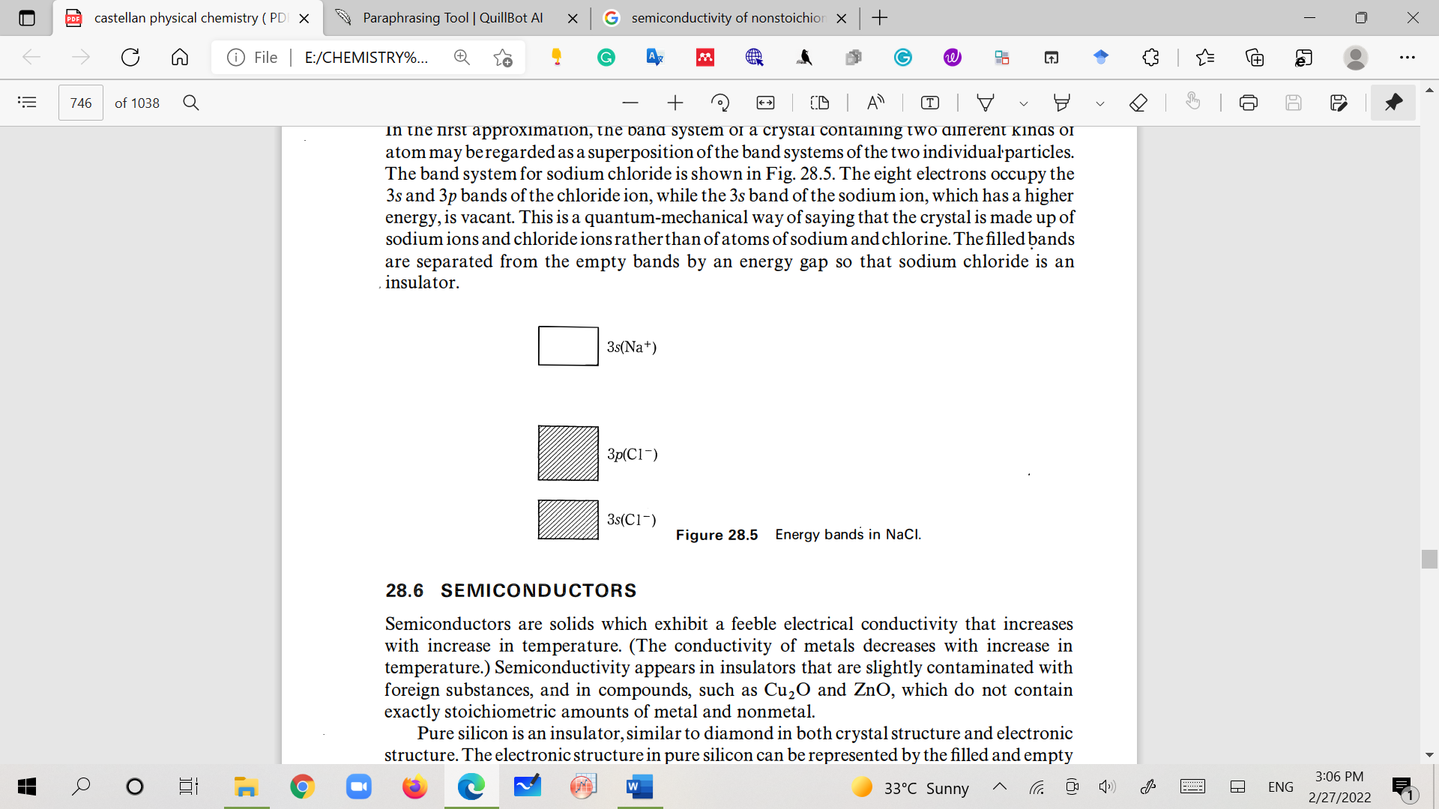

**Fig. 3.6 Energy bands in NaCl**

**3.6 Semiconductors**

Semiconductors are solids that exhibit a feeble electrical conductivity that increases with an increase in temperature. (The conductivity of metals decreases with an increase in temperature.) Semiconductivity appears in insulators that are slightly contaminated with foreign substances, and in compounds, such as Cu20 and ZnO, which do not contain exactly stoichiometric amounts of metal and nonmetal.

1. ***N-type semiconductor***: (excess of electrons)
2. Pure silicon is an insulator, the electronic structure can be represented by the filled and empty bands shown in Fig 3.7 and 3.8.

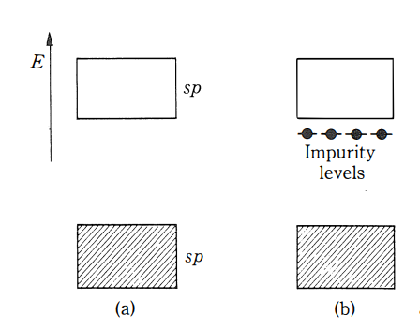

**Fig. 3.7 (a) Pure silicon. (b) Impurity levels in silicon, an n-type semiconductor**

1. In pure silicon, some silicon atoms replace with phosphorus atoms, each of which has one more electron than the silicon atom. The energy levels of the phosphorus atoms, impurity levels, are superposed on the band system of the silicon; these levels do not match those in silicon exactly.

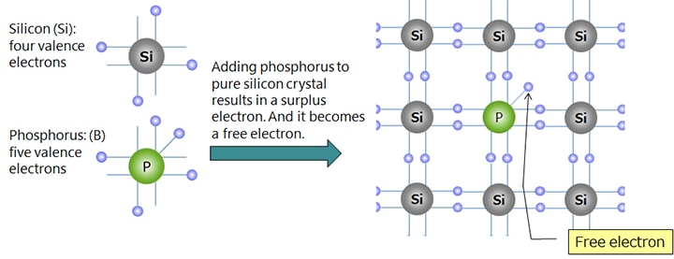

**Fig. 3.8n-type semiconductor**

1. It is found that the extra electrons introduced by the phosphorus atoms occupy the impurity levels, which are located slightly below the empty band of the silicon lattice. In these levels the electrons are bound to the phosphorus atoms and cannot conduct a current; since the energy gap between these levels and the empty band of silicon (conduction band) is comparable to **kT (thermal energy),** a certain fraction of these electrons are thermally excited to the conduction band in which they can move under the influence of an applied field. ***At higher temperatures, more electrons are excited to the conduction band and the conductivity is larger***. If several phosphorus atoms are introduced in the lattice, the impurity level itself widens into a band that overlaps the conduction band of the silicon; the conductivity then becomes metallic.
2. ***P-type semiconductor:*(Excess of holes)**
3. If atoms of aluminium or boron are introduced in the silicon lattice, they also introduce their system of levels. Since the aluminium atom has one less electron than silicon, *the impurity levels are vacant.*

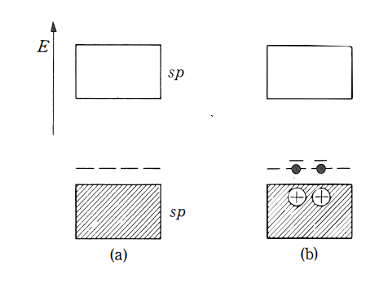

**Fig. 3.9 Impurity levels in a p-type semiconductor**

1. Figure 3.9 shows the position of the impurity levels, which in this case are only slightly above the filled band of the silicon lattice. Electrons from the filled band can be excited thermally to the impurity levels, where they are bound to the aluminium atoms to produce the species AI- or B-in the lattice (fig. 3.10).
2. ***The holes left in the band effectively carry a positive charge that can move under the influence of an applied field, and thus carry a current.***

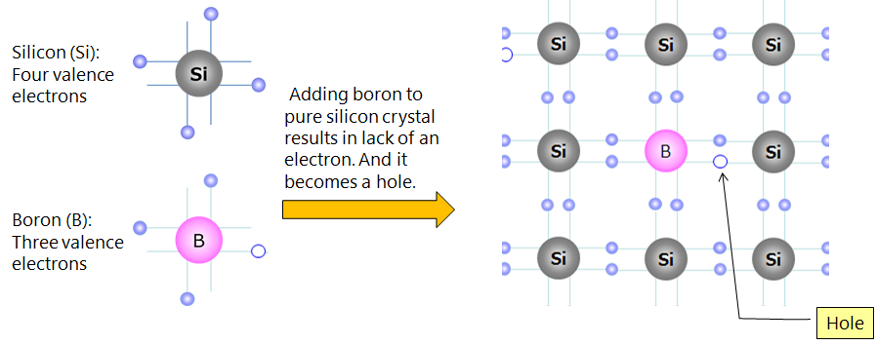

**Fig. 3.10p-type semiconductor**

1. The semiconductivity of nonstoichiometric compounds (ZnO and Cu20) can be explained similarly.
2. If ZnO loses a little oxygen, it can be considered as ***ZnO with a few zinc atoms as impurities***. The zinc atoms have two more electrons than the zinc ions; therefore the semiconductivity is ***n-type***.
3. The crystal Cu20 may contain extra oxygen, it may be considered as ***Cu20 with some Cu2+ ions as impurities***. The Cu2+ ion has one less electron than the Cu+ ion, so the conductivity is ***p-type.***
4. NaCl exposed at high temperatures to sodium vapour incorporates ***sodium atoms as impurities***; the impure crystal has ***n-type semiconductivity***. *Excess halogen can be introduced into sodium chloride to yield a p-type semiconductor.*

**3.7 Cohesive energy in metals**

Any detailed mathematical calculation of metal cohesive energy is extremely difficult, but a qualitative evaluation of the band systems can provide some insight into the problem.

1. Consider the transition metals (Ni, Cu and Zn) that as isolated atoms have partially filled d shells (s2d8, s1d10and s2d10) as solids have partially filled d bands. The d band can hold 10 electrons/atom. Since the d shell in the atoms is shielded somewhat by the outer electrons, the d band is very narrow compared with the sp band.

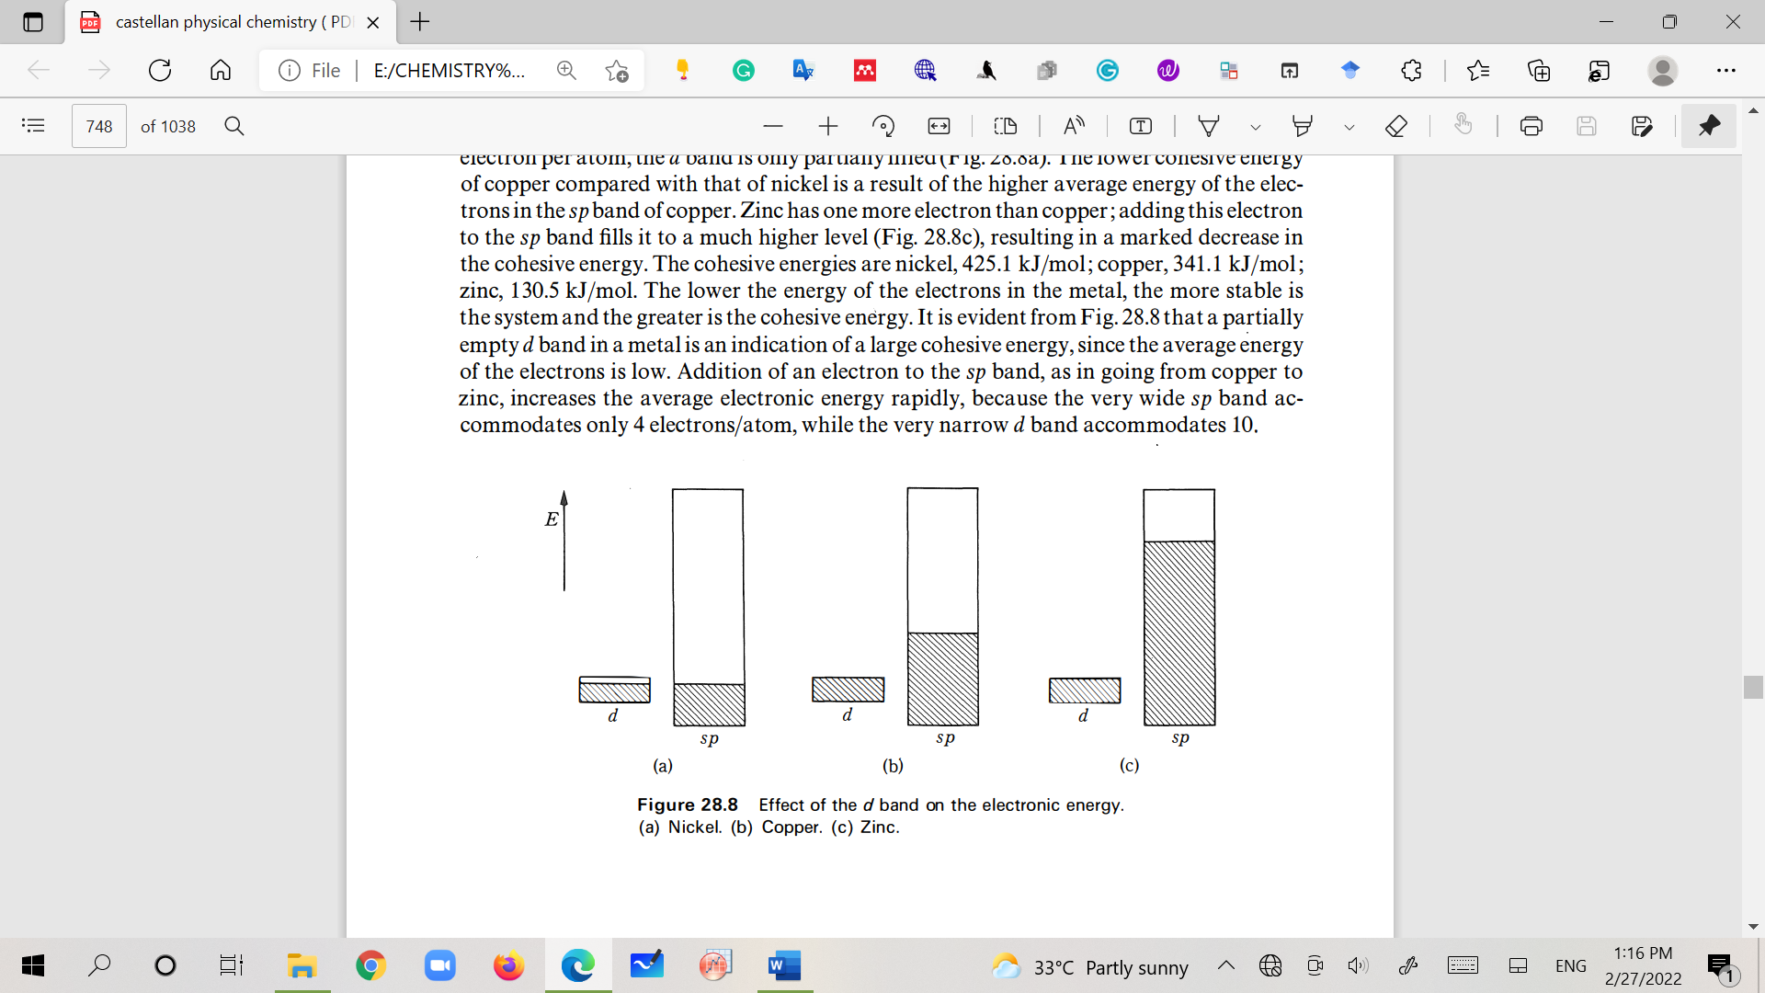

**Fig. 3.11 Effect of the d band on the electronic energy. (a) Nickel. (b) Copper. (c) Zinc**

1. Figure 3.11 shows the relative widths and *the filling of the d and sp bands in copper*. The d band is filled. In nickel, which has one less electron per atom, the *d band is only partially filled.*
2. The lower cohesive energy of copper compared with that of nickel is a result of the higher average energy of the electrons in the sp band of copper.
3. Zinc has one more electron than copper; adding this electron to the sp band fills it to a much higher level, resulting in a marked decrease in the cohesive energy.

|  |  |
| --- | --- |
| Metal | Cohesive energy (KJmole-1) |
| Nickel (Ni) | 425.1 |
| Copper (Cu) | 341.1 |
| Zinc (Zn) | 130.5 |

1. ***The lower the energy of the electrons in the metal, the more stable is the system and the greater is the cohesive energy***.
2. It is evident from Fig. that a partially empty d band in metal is an indication of large cohesive energy since the average energy of the electrons is low. The addition of an electron to the sp band, as in going from copper to zinc, increases the average electronic energy rapidly, because the very wide sp band accommodates only 4 electrons/atom, while the very narrow d band accommodates 10.