**K. T. S. P. MANDALS**

**HUTATMA RAJGURU MAHAVIDYALAYA,**

**RAJGURUNAGAR, TA. KHED, DIST. PUNE 410505**

**T.Y. B.SC. CHEMISTRY - SEM II**

**CBCS PATTERN AS PER NEW SYLLABUS**

**SUBJECT - PHYSICAL CHEMISTRY CH-601**

**CHAPTER NO. 1 ELECTROCHEMICAL CELL**

**PART - II**

**BY**

**DR. SUNITA JADHAV**

**Salt bridge and its function:**

Salt bridge is usually an inverted U-tube filled with concentrated solution of inert electrolytes. An inert electrolyte is one whose ions neither involved in any electrochemical change nor do they react chemically with the electrolytes in two half-cells. Generally salts like KCl, KNO3, and K2SO4 etc. are used. For the preparation of salt bridge, gelatin or agar-agar is dissolved in a hot concentrated aqueous solution of an inert electrolyte and solution thus formed is filled in the U-tube. On cooling the solution set in the form of a gel in the U-tube. The ends of the U-tube are plugged with cotton wool as to minimize diffusion effects.

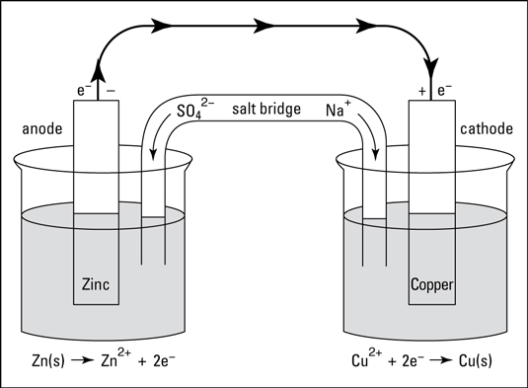

**Function of salt bridge:**

(a) It connects the solutions of two half cells and complete the cell circuit.

(b) It prevents transference or diffusion of the solutions from one half cells to the other.

(c) It keeps the solutions in the two half-cells, electrically neutral. In anodic half-cell, positive ions pass into solution and there shall be accumulation of extra positive charge in the solution around the anode, which will prevent flow of electrons from anode. Similarly in the cathodic half cell accumulate around cathode due to deposition of positive ions by reduction. To neutralize these ions, sufficient numbers of positive and negative ions are provided by salt bridge. Thus salt bridge maintains electrical neutrality of the solution.

(d) It prevents liquid-liquid junction potential i.e. the potential difference

which arises between two solutions when contact with each other.

**1.4 Types of electrodes:**

**1.** Metal-metal ion electrode: A metal rod dipped in a solution of its own ion. Example Zn rod dipped in ZnSO4 solution, Zn2+/Zn. Copper rod dipped in CuSO4, Cu2+/Cu. The electrode potential depends on logarithm of concentration of Mn+ ions.

2. Metal-metal insoluble salt electrode: A metal in contact with its own sparingly soluble salt dipped in a solution containing a common anion. Example calomel electrode Cl- /Hg2Cl2(aq)/Hg(aq) Silver-silver chloride electrode Cl- /AgCl(s)/Ag(s) The electrode potential depends on logarithms of concentration of common anion.

3. Gas electrode: Gases continuously bubbled through the solution of their ions. The gases are non conductors of electricity; therefore an inert metal like Pt, Au etc is employed for establishing electrical contact. Example Oxygen electrode OH- (aq)/O2(g)/Pt Hydrogen electrode H+ (aq)/H2(g)/Pt Chlorine electrode Cl- (aq)/Cl2(g)/Pt Electrode potential depends on the logarithm of concentration of ions and the pressure at which gas is bubbled.

4. Redox electrodes: A metal in contact with a redox system. Example Pt/Fe3+/Fe2+ Pt/Ce4+/Ce3+ Here the electrode potential depends on the logarithm of concentration of ionic species involved in redox system.

5. Ion selective electrode: Sensing part is an ion specific membrane. The membrane can be a glass membrane or ion exchange resin. These are sensitive to specific ions like H+ , Na+ , Ag+ etc. Example H+ ion selective glass electrode.

**1.5 Single electrode potential:**

Origin of Single electrode potential - Helmholtz double layer A metal can be imagined as - metal ions embedded in a pool of valence electrons. When a metal rod is dipped in its own salt solution, two possibilities, Oxidation: M ◊M n+ + ne. The positive ions in the metal go into the solution leaving behind the electrons on the metal. Hence metal acquires a negative charge. As oxidation continues more and more negative charge accumulate on the metal surface. Reduction: Mn+ + ne ◊ M. The positive Mn+ from the solution enters to the metal. Hence metal acquires a positive charge. As reduction continues more and more positive charge accumulates on the metal surface. Due to oxidation or reduction a charge density is created at the electrode surface, which attracts ions of opposite charge from the electrolyte. The charge held on the electrode surface is balanced by the redistribution of ions close to the electrode surface. A simplified model to imagine this situation is Helmholtz electrical double layer. A layer of positive and negative charge remains close to each other, one on the electrode surface and other on the electrode-electrolyte inter phase.



A difference in potential is consequently developed between the metal and solution. This potential difference is called single electrode potential. The electrode potential of a metal is the measure of tendency of metallic electrode to loose or gain electrons, when it is in contact with its own salt.

Its magnitude depends on

1. Nature of the metal.

2. Concentration of ions.

3. Temperature.

If the concentration is 1M and temperature is 298K (25 ⁰C)then it is called standard electrode potential.

Tendency of electrode for oxidation (loose electrons) is oxidation potential Eoxd and tendency for reduction (gain electrons) is reduction potential Ered.Ered=-Eoxd

Generallythestandardelectrodepotentialreferstoreductionpotential.It is impossible to measure the absolute value of electrode potential, because neither oxidation nor reduction takes place independently (both occurs conjointly. Therefore one can only measure the cell potential. That is, relative value of emf with respect to a reference electrode can only be obtained.

1.6 Reference electrode and its applications

It should have a stable and well defined electrode potential at a particular temperature. One application of reference electrode is to evaluate the potential of other electrodes.UseofreferenceelectrodesElectrodepotentialofotherelectrodescanbeevaluated.PHofasolutioncanbedetermined.

Examples of reference electrodes

a. Standard Hydrogen electrode (H+(1M)/H2(1atm)/Pt). It is a primary reference electrode. Its electrode potential value is arbitrarily assigned as zero.

b. CalomelElectrode(Cl-(xM)/Hg2Cl2/Hg).Itisasecondaryreferenceelectrodes

c. Glass electrodes (Pt/H+(0.1M)/glass). It is internal reference electrode used for Ph measurements.

1.6.1 Standard Hydrogen Electrode:

Construction and its working

Standard Hydrogen Electrode (SHE) or Normal Hydrogen Electrode (NHE) is the primary reference electrode. Its electrode potential is arbitrarily fixed as zero.

SHE is an example of gas electrode.

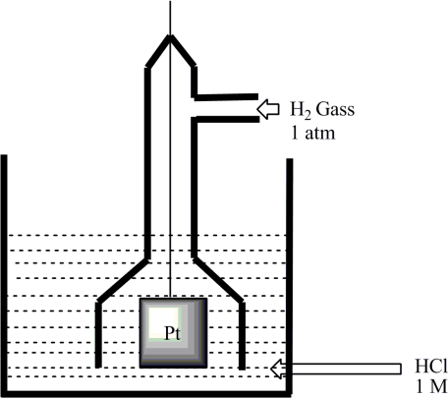It consists of an inert platinum rod dipped in 1M HCl solution. H2 gas is bubbled at 1 atm pressure at 298 K temperature. Pt/ H2(g)(1 atm)/H+(aq)(1M).

It can act as anode or cathode depending on the potential of the electrode to which it connected. Thus SHE is a reversible electrode. If the potential of the coupled electrode is less than zero, then SHE acts as cathode. Reduction takes place at SHE. H++e½H2.

If the potential of the coupled electrode is greater than zero, then SHE acts as anode. Oxidation takes place at SHE.

½H2H++e

Limitations of SHE

1. SHE is difficult to construct. Bubbling H2 gas at1atm around Pt through the solution is difficult. Maintaining activity of H+ at unity is difficult.

2. Pt metal has high adsorption and catalytical activity. Hydrogen on Pt surface is reduction catalyst. A number of organic substances are reduced. Inorganic ions like Fe3+, MnO4-etc reduce to their lower valence state. Cations of Ag, Cu, Cd, Pb will get reduce and deposit on Pt metal. Substance like arsenic and sulphides also interfere.

1.6.2 Measurement of single/Std. electrode potential of Zinc electrode Using SHE as reference electrode

It is impossible to know the absolute value of electrode potential because neither oxidation nor reduction takes place independently. It is measured relative to a reference electrode.

The reference electrode taken is standard hydrogen electrode SHE (also called normal hydrogen electrode NHE).The electrode potential of SHE is arbitrarily assigned a value of zero. All other electrode potential values are expressed relative to this value.

In order to measure standard electrode potential of Zn (Zn metal dipped in 1M ZnSO4 at 25 ⁰C) Zn/Zn2+metal-metalionelectrodeiscoupledwithSHE through a salt bridge. The direction of flow of current further indicates on which electrode oxidation or reduction takes place with respect to SHE (one can use analogue voltmeter to find out the direction of current flow).Here Zn is oxidised, therefore Zn is anode. Zn|Zn2+||H+(aq)(1M)|H2(g)(1atm)|Pt.

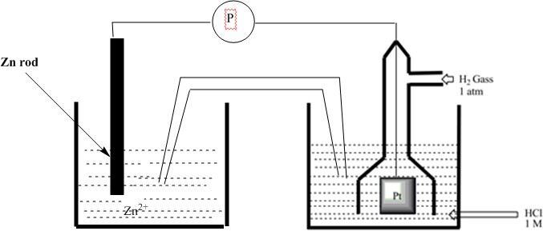

The emf of the cell must be measured without drawing current from the cell. Analogue voltmeter cannot be used but digital voltmeter can be used. In digital voltmeter the measurement of potential is based on using field effect transistor, which draws no current from the cell during emf measurement.

The digital volt meter reading directly gives the cell emf.

E⁰cell=E⁰cathode-E⁰anode

SHE is cathode therefore, E⁰cell=E⁰SHE-E⁰Zn2+/ZnieE⁰cell=0-E⁰Zn2+/Zn

E⁰Zn2+/Zn=-E⁰cell

The emf of cell is found to be 0.76V (ieoxidationpotentialis0.76V). Therefore reduction potentialis-0.76V.

1.6.3 Measurement of single electrode potential of Copper electrode Using SHE as reference electrode:

It is impossible to know the absolute value of electrode potential because neither oxidation nor reduction takes place independently. One can only measure the cell emf. Ie, It is measured relative to a reference electrode. Construct a cell. One half cell is Cu/Cu2+ Other half cell is SHE Pt/H2 (1atm)/H+(1M) Direction of Flow of Current can be obtained by connecting an analogue voltmeter. (Cu to SHE). Therefore SHE is a node and Cu is cathode Cell Rep:Pt/H2 (1atm)/H+(1 M)||Cu2+/Cu

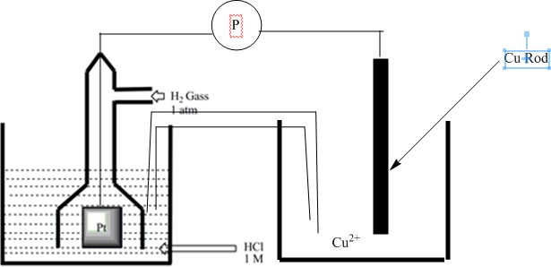

The digital voltmeter reading directly gives the cell emf.

E⁰cell= E⁰cathode -E⁰anode

=E⁰Cu(2+)/Cu-E⁰SHE=E⁰Cu(2+)/Cu–0=E⁰Cu(2+)/Cu

E⁰Cu(2+)/Cu=E⁰cell

**1.6.4 Calomel electrode:**

Its Construction and its working Due to limitations of SHE, secondary reference electrodes are needed. The potential of secondary reference electrodes are calibrated using SHE. Calomel Electrode is an example of metal-metal insoluble salt electrode.

Composition: Mercury is the metal. Mercurous chloride (Hg2Cl2, calomel) is the insoluble salt. Soluble salt with common anion is KCl. Electrical contact is made using Pt wire.

Electrode representation: Cl- (aq) / Hg2Cl2 /Hg

Construction: It is made up of glass tube. Mercury is kept at the bottom. Over which a paste of Hg + Hg2Cl2 kept. A solution of KCl is placed over calomel. A platinum wire is used to make electrical contact. The side tube is used to make contact with other electrodes through a salt bridge

1.7 Nernst Equation Derivations:

Nernst equation allows one to predict cell voltages (emf) when the conditions are not standard. Nernst showed that for the electrode reaction:

Mn+(aq) + ne–→ M(s)

the electrode potential at any concentration measured with respect to standard hydrogen electrode can be represented by:

E (Mn+ /M)= E-(Mn+ /M)+ = – RT/nF ln [M]/ [Mn+]

but concentration of solid M is taken as unity and we have

E (Mn+ /M)= E-(Mn+ /M) + = – RT/nF ln 1/[M ]…………………(1.6)

E-(Mn+ /M)has already been defined, R is gas constant (8.314 JK–1 mol–1), F is Faraday constant (96487 C mol–1), T is temperature in kelvin and [Mn+] is the concentration of the species, Mn+.

Ecell = E0cell - ln $\frac{activity of product}{activity of reactant}$………………..(1.7)

R is universal gas constant (8.314 J K-1 mol-1 ) F is Faraday (96500 C) = Charge Carried by 1 mole of electrons T is temperature in Kelvin scale. n is number of electrons involved in electrode process. Activity is effective concentrations (in dilute solutions activity is molar concentration).

The voltage difference between electrodes of an electrochemical cell is called cell voltage (or emf) – E cell or E at standard conditions we call it standard emf –E0cell or E0 The emf associated with any redox reaction can be calculated,

E0 = E0Cathode - E0Anode

E = E cathode - Eanode

For a spontaneous reaction both E and E0 should be positive.

Electrical energy produced per mole = quantity of charge in one mole multiplied with EMF For the general reaction Mn+ + ne $→$ M

1.7.1 Electrical energy produced per mole = n F E

F is faraday, which is charge carried by one mole of electrons = 6.023 x 10 23 x 1.6 x 10-19 C = 96500 C. In a reversible electrochemical cell electrical energy is produced at the expense of decrease in free energy. Then,

$∆G$ = -nF E………….(1.8)

Under standard conditions,

$∆G°$ = -nF E………….(1.9)

The decrease in free energy ΔG associated with an equilibrium reaction is given by,

$∆G$ = $∆G°$ + RT ln Q………………………….(2.0)

R is universal gas constant (8.314 J K-1 mol-1 )

T is temperature in Kelvin scale

Q is the reaction quotient = $\frac{activity of product}{activity of reactant}$

Activity is effective concentrations (in dilute solutions activity is molar concentration) Substituting equation 1.8 and 1.9 in 2.0, we get

-nF E = -nF E0 + RT ln Q

Rearranging it,

E = E0 - lnQ

In dilute solutions activities can be replaced by molar concentrations In general for single electrode reduction reaction, Mn+ + ne M

E = E0 - ln

[e] and [M] ie concentration of pure solid both are taken as unity. Then,

E = E0 - ln

At 25 ⁰C the equation becomes

E = E0 - ln This is the Nernst Equation for single electrode at 25 ⁰C.

In general for the reaction aA + bB $→$ cC + dD

E = E0 - ln ()

At 25 ⁰C the equation becomes,

Ecell = E0cell - ln($\frac{\left[C\right]c[D]d}{\left[A]a[B\right]b}$)

This is the Nernst Equation for the cell reaction.

1.7.2 Nernst Equation Applications:

1. It allows one to predict the cell voltage when the conditions are not standard. 2. To find the concentration of one of the ionic species in the cell if the concentrations of other ionic species are known.

3. It can be used to find the number of electrons involved in the redox process.

4. PH of a solution can be obtained, PH = -log [H+]. Make this solution a hydrogen electrode, couple this half cell with any reference electrode and apply Nernst equation.

5. To find the equilibrium constant of a reaction. At equilibrium ΔG = 0 and Q = Kc (equilibrium constant) (a cell at which overall reaction at equilibrium can do no work and the cell potential is zero) Then Ecell = 0. Nernst Eqn becomes,

0 = E0 -

6. To study the effect of electrolyte concentration of single electrode potential.