**K. T. S. P. MANDALS HUTATMA RAJGURU MAHAVIDYALAYA,**

**RAJGURUNAGAR, TA. KHED, DIST. PUNE 410505**

**T.Y. B.SC. CHEMISTRY - SEM II CBCS PATTERN AS PER NEW SYLLABUS**

**SUBJECT - PHYSICAL CHEMISTRY CH-601 CHAPTER NO. 1 ELECTROCHEMICAL CELL PART - I**

**BY**

**DR. SUNITA JADHAV**

# CHAPTER NO. 1 ELECTROCHEMICAL CELL

* 1. **Introduction:**

Electrochemistry is the study of production of electricity from the energy released during a spontaneous chemical reaction and the use of electrical energy to bring about non-spontaneous chemical transformations.

# Electrochemical cell:

A spontaneous chemical process is the one which can take place on its own and in such a process the Gibb’s energy of the system decreases. It is this energy that gets converted to electrical energy. The reverse process is also possible in which we can make non-spontaneous processes occur by supplying external energy in the form of electrical energy. These inter conversions are carried out in equipment’s called Electrochemical Cells.

# Types:

Electrochemical Cells are of two types:

1. Electrolytic Cell:-Converts electrical energy into chemical energy.
2. Galvanic Cell or Voltaic Cell:-Converts chemical energy into electrical energy **1] Electrolytic Cell:** It is a device in which electrolysis (chemical reaction involving oxidation and reduction) is carried out by using electricity or in which conversion of electrical energy into chemical energy is done.
3. **Galvanic Cell:** The device used to convert the chemical energy produced on a red-ox reaction into electrical energy is called an electrochemical cell or simply a chemical cell. These are also called galvanic cells or voltaic cell after the names of Luigi Galvanic and Alessandro Volta who were first to perform experiments on the conversion of chemical energy into electrical energy.

In electrochemical cell, a spontaneous red-ox reaction is carried out in an indirect manner and the decrease in free energy during chemical reaction appears as electrical energy. An indirect red-ox reaction is such that reduction and oxidation processes are carried out in two separate vessels called half-cells.

**Example - Daniel Cell:** It consists of two half-cells. The left hand half-cell contains a zinc metal electrode dipped in ZnSo4 solution. The half-cell on the right hand side consists of Cu metal electrode in a solution of CuSo4. A salt bridge that prevents the mechanical mixing of the solution joins the half-cells.

When the zinc and copper electrodes are joined by a wire the following observation are made.

* 1. There is flow of electric current through the external circuit.
  2. The Zn rod loses its mass while copper rod gains in the mass.
  3. The concentration of ZnSo4solution increases while the concentration of CuSo4 solution decreases.
  4. The solutions in both the compartments remain electrically neutral.

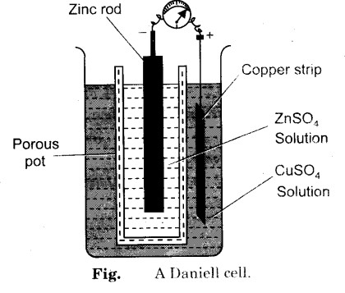

During the passages of electric current through external circuit, electrons flow from zinc electrode to the copper electrode. At the zinc electrode, zinc metal is oxidized to zinc ions, which go into the solution. The electrons released at the electrode travel through the external circuit to the copper electrode where they are used in the reduction of Cu2+ ions to metallic copper which is deposited on the electrode.

# Cell Reaction

*Zn* →*Zn*2+ +2*e-*(Oxidation So anode)

*Cu*2++ 2*e-*→*Cu* (Reduction So cathode)

Net reaction *Zn* +*Cu*2+→*Zn*2+ +*Cu* (1.1)

At the zinc rod, oxidation occurs. So it is the anode of the cell and negatively charged.

**Electrode Sign:** The sign of the anode and cathode in the voltaic or galvanic cells are opposite to those in the electrolytic cells.

# Table 1. 1 Difference between Galvanic cell and Electrolytic cell

**Galvanic Cell / Voltaic Cell Electrolytic Cell**

Chemical energy is transformed into electrical energy in these electrochemical cells.

Electrical energy is transformed into chemical energy in these cells.

The redox reactions that take place in these cells are spontaneous in nature.

An input of energy is required for the redox reactions to proceed in these cells, i.e. the reactions are non-spontaneous.

In these electrochemical cells, the anode is negatively charged and the cathode is positively charged.

These cells feature a positively charged anode and a negatively charged cathode.

|  |  |
| --- | --- |
| The electrons originate from the species that undergoes oxidation. | Electrons originate from an external source (such as a battery). |

# Reversible and Irreversible cells:

In order that the electrical energy produced by a galvanic cell may be related thermodynamically to the process occurring in the cell, it is essential that the latter should behave reversibly in the thermodynamic sense. According to thermodynamics, it may be recalled that a thermodynamically reversible process is one which satisfies the following conditions:

1. It should be spontaneous.
2. The driving and opposing forces must differ by only an infinitesimally small amount.
3. It should be possible to reverse the change taking place by applying a force slightly higher than the acting force.

Thus, any cell which satisfies the above conditions is said to be reversible and its potential difference measured can be substituted in relevant thermodynamic relations. Whereas, when the above conditions are not satisfied then the cell is said

to be irreversible and thermodynamic equation cannot be applied to the process occurring in it.

Consider for example the above mentioned Daniell cell in which one gram equivalent of zinc dissolves and one gram equivalent of copper is deposited to produce one Faraday of electricity, the difference of potential is 1.09 volts and the cell reaction is

Zn + Cu2+→ Zn2+ + Cu (1.2)

This process continues as long as the external opposing potential is infinitesimally smaller than that of the cell However, if now an external emf exactly equal to 109 voit is applied then the cell reaction stops. But if the external emf is increased by an infinitesimally higher than the cell e.m.f 1.09 volts then we observe that the cell reaction is reversed and zinc ions form zinc metal of one electrode and copper starts dissolving as copper ions Thus, we have

Cu(s) + Zn2+→ Zn(s) + Cu2+ (1.3)

As this cell satisfies all the conditions of reversibility, it is reversible and it may therefore be treated with thermodynamic methods without any ambiguity Many reversible electrochemical cells are in use, such as,

Zn| Zn2+ ||Hg+ Hg The cell reaction is,

(aq) (aq)|

Zn + 2Hg+ →Zn2++ Hg

On the other hand, consider a cell of zinc and copper electrodes dipped in a solution of H₂SO₂ When the two electrodes are connected through a metallic wire, zinc dissolves in a solution forming ZnSO4, and hydrogen gas is liberated at the copper electrode according to the reaction

Zn(s) + H2SO4→ZnSO4 + H2(g) 𝗍 (1.4)

If this cell is connected with an external source of potential slightly greater than its own copper dissolves at one electrode and hydrogen gas is evolved at the zinc electrode and the cell reaction becomes

Cu(s) + H2SO4→CuSO4 + H2(g) (1.5)

The above reaction is not reversible The original state is not produced and the reaction is not reversed It is evident from equations (1.4) and (1.5) that this cell even though satisfies the first and second conditions of reversibility, the third condition does not hold good and hence the above cell is an irreversible cell. Thus, the potential difference of such a cell does not have any thermodynamic significance.

# Electrode Potential

When a metal is placed in a solution of its ions the metal acquires either a

positive or negative change with respect to the solution due to this. A definite potential difference is developed between the metal and the solution. This potential difference is called electrode potential.

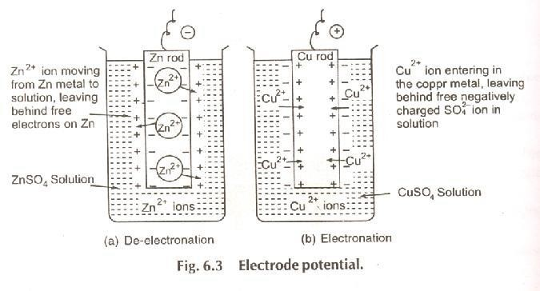

For example when a plate of zinc placed in a solution having Zn2+ ions, it becomes negatively charged with respect to the solution and thus a potential difference is set up between zinc plate and solution. This potential difference is termed electrode potential of zinc. Similarly when copper is placed in a solution having Cu2+ ions it becomes positively charged with respect to the solution. A potential is setup between the copper plate and the solution. The potential

difference is established due to the formation of electrical double layer at the interface of metal and the solution. The development of negative charge (as on Zn plate) or positive charge (as on Cu plate) can be explained as follows.

When a metal rod is dipped in its salt solution, two charges occur.

1. Metal ions pass from the electrode into solution leaving an excess of electrons and thus a negative charge on the electrode.
2. Metal ions in solution gain electrons from the electrode leaving a positive charge on the electrode.

**Definition: “**The electrical potential difference setup between the metal and its ions in the solution is called electrode potential or the electrode potential maybe simply defined as the tendency of an electrode to lose or gain electrons when it is in contact with solution of its own ions”. The electrode potential is further termed as oxidation potential if oxidation takes place at the electrode with respect to standard hydrogen electrode and is called reduction potential. If in the half-cell, the metal rod is suspended in a solution of one molar concentration and the temperature is kept at 298K, the electrode potential is called standard electrode potential, represented usually by E0.

# Measurement of Electrode Potential:

The absolute value of the electrode potential of a single electrode (called single electrode potential) cannot be determined because oxidation half reaction or

reduction half reaction cannot takes place. It can only be measured by using some electrode as the reference electrode. The reference electrode used is the standard or normal hydrogen electrode (SHE or NHE). So the electrode potential of a given electrode is measured by connecting a standard hydrogen electrode through a salt bridge. The e.m.f of the cell is measured either by a calibrated potentiometer or by a high resistance voltmeter. In the standard hydrogen gas electrode, hydrogen gas at atmospheric pressure is passed into 1M HCl at 298K in which a foil of platinum coated with platinum black (finely divided platinum) remains immersed.