**K. T. S. P. MANDALS**

**HUTATMA RAJGURU MAHAVIDYALAYA,**

**RAJGURUNAGAR, TA. KHED, DIST. PUNE 410505**

**T.Y. B.SC. CHEMISTRY - SEM II**

**CBCS PATTERN AS PER NEW SYLLABUS**

**SUBJECT - PHYSICAL CHEMISTRY CH-602**

**CHAPTER NO. 1**

**COLLIGATIVE PROPERTIES OF DILUTE SOLUTIONS**

**PART - III**

**BY**

**DR. SUNITA JADHAV**

**1.9 Osmosis and Osmotic pressure:**

Let us consider a pure solvent and solution separated by a membrane which permits the passage tosolvent molecules but not to solute molecules. Only the solvent will diffuse through the membraneinto solution. A membrane which is permeable to solvent and not to solute, is called a semipermeablemembrane.

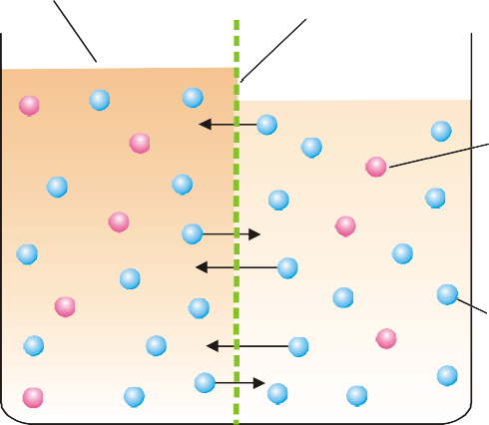

Semipermeable membrane

Concentrated solution Dilute solution

Solute molecule

Solvent molecule

Level rise

Fig.1.9.1 Illustration of the process of osmosis.

**“The flow of the solvent through a semipermeable membrane from pure solvent to solution,or from a dilute solution to concentrated solution, is termed Osmosis” (Greek *Osmos*= to push).**

It must be clearly understood that the diffusion of solvent molecules through a semipermeablemembrane is taking place in both directions. That is, solvent molecules are passing from solvent tosolution, and also from solution to solvent. But since the diffusion from solvent to solution or fromdilute to concentrated solution, is more rapid, **the net flow of the solvent is from low to highconcentration.**

**The hydrostatic pressure built up on the solution which just stops the osmosis of pure solvent**

**into the solution through a semipermeable membrane, is called Osmotic Pressure.**

Osmosis can be counteracted not only by hydrostatic pressure but also by application of externalpressure on the solution. The external pressure may be adjusted so as to prevent the osmosis of purewater into solution. This provides another definition of osmotic pressure.Osmotic pressure may be defined as the external pressure applied to the solution in order to stop the osmosis of solvent into solution separated by a semipermeable membrane.

**1.9.1 Determination of Osmotic Pressure:**

**1. BerkeleyandHartley’sMethod:**

BerkeleyandHartley(1904-1909)employedthetechniqueofapplyingexternalpressureonthesolution just enough to prevent osmosis. The osmometer used by them is illustrated in Fig. 1.9.2.Aporcelaintubewithcopperferrocyanidemembranedepositedinitswallsisenclosedinametallicjacket.Thetubeisfittedwithareservoirofpuresolvent(water)atoneendandacapillarytubeattheother. Mechanical pressure can be applied on the solution with a piston connected to a pressuregauge.

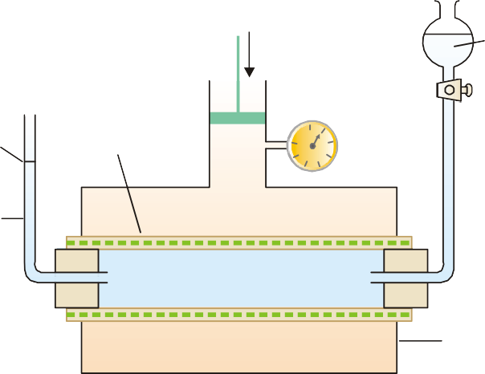

Solventreservoir

Metallic jacket

Solution

Solution

Solvent

Pressure

Guage

Pressure

Capillary

tube

Meniscus

Porcelain tubewith

Cu2Fe(CN)6

membrane

Fig. 1.9.2 Berkeley and Hartley's osmometer.

This method is superior to the older methods because:

(*a*) It is quick and accurate.

(*b*) It can be used for determining high osmotic pressures. The osmotic pressure being balancedby the external pressure, there is no strain left on the membrane and the danger of itsbursting is eliminated.

**Procedure.**Theinnerporcelaintubeisfilledwithpuresolventandthejacketwiththesolutionwhose osmotic pressure is to be determined. The level of the solvent meniscus in the capillary tubewill tend to move down as solvent flows into the solution across the membrane. Pressure is thenapplied through the piston so that the meniscus becomes stationary. It indicates that osmosis hasbeen stopped and now the pressure recorded by the pressure gauge gives the osmotic pressure ofthesolution.

**1.10 Van’t Hoff Theory of Dilute Solutions:**

Van’t Hoff noted the striking resemblance between the behaviour of dilute solutions and gases.Dilute solutions obeyed laws analogous to the gas laws. To explain it van’t Hoff visualised those gases consist of molecules moving in vacant space (or vacuum), while in solutions the soluteparticles are moving in the solvent. The exact parallelism between solutions and gases is illustratedby experimental demonstration shown in Fig. 1.10.1 As shown in Fig. 1.10.1 (*a*), the pure solvent flows into the solution by osmosis across thesemipermeable membrane. The solute molecules striking the membrane cause osmotic pressure andthe sliding membrane is moved towards the solvent chamber. In case of a gas (Fig. 1.10.1 *b*), the gasmolecules strike the piston and produce pressure that pushes it towards the empty chamber. Here itis the vacuum which moves into the gas. This demonstrates clearly that there is close similaritybetween a gas and a dilute solution.Thinking on these lines, van’t Hoff propounded his theory of dilute solution. The van’t Hofftheory of dilute solutions states that :**a substance in solution behaves exactly like a gas and theosmotic pressure of a dilute solution is equal to the pressure which the solute would exert if it werea gas at the same temperature occupying the same volume as the solution.**



Motion ofmembrane

Flowofsolvent

Solution

Solvent

(a)

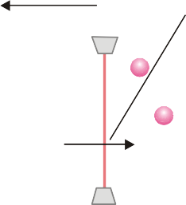

Motion ofpiston

Effective flowofvacuum

)

Gas molecule moving

in vacuum

Pure Solvent

(b)

Fig. 1.10.1 (a and b) The analogy between osmotic pressure and gas pressure.

Suppose a dilute sugar solution to be contained in an exactly full, covered beaker. Then supposethe water to vanish, leaving the sugar molecules suspended in otherwise empty space. The sugarwould then function as a gas, exerting pressure equal to its former osmotic pressure.According to the van’t Hoff theory of dilute solutions, all laws or relationship obeyed by gaseswould be applicable to dilute solutions.

**1.11 Laws of Osmotic Pressure:**

From the above findings, van’t Hoff (1877) established the laws of osmotic pressure and pointedout that these were closely related to the gas laws.

**(1) Boyle-van’t Hoff Law for Solutions:**

If π is the osmotic pressure and *C* its concentration, from (*a*) we can write π ∝*C*, if temperature isconstant.If the concentration of the solute is expressed in moles per litre and *V* is the volume of the solutionthat contains 1 mol of solute,

C = $\frac{1}{V}$ Thus $π$ ∝ $\frac{1}{V}$ at constant temperature

This relationship is similar to the Boyle’s law for gases and is known as the Boyle-van’ t Hoff lawfor solutions.

**(2)Charles-van’t Hoff Law for Solutions:**

If T is the absolute temperature, from the statement (b), we can write

π ∝ T, if temperature is constant This relationship is similar to the Charles’ Law for gases and is known as Charles-van’t Hoff law for solutions.

**(3)Van’t Hoff Equation for Solutions:**

As shown above the osmotic pressure (π) of a dilute solution is inversely proportional to thevolume (*V*) containing 1 mole of the solute and is directly proportional to the absolute temperature (*T*).This is,

$π$ ∝ $\frac{1}{V}$……………(1)

$π$ ∝ T …………..(2)

Combining (1) and (2) van’t Hoff gave the general relationship

π *V* = *R' T* ………....(3)

where *R'* is a constant. He showed that this equation was parallel to the general *Gas Equation*(*PV* = *RT*), as the value of *R'* calculated from the experimental values of π, *V*, and *T* came out to bealmost the same as of the *Gas constant, R*.

It is noteworthy that the *van’t Hoff Equation* (3) was derived for 1 mole of solute dissolved in *V*litres. If *n* moles of solute are dissolved in *V* litres of solution, this equation assumes the form

π *V* = *n R T*

**Problem 1.**Calculate the osmotic pressure of a 5% solution of glucose (mol wt = 180)at 18°C.

Solution: π*V* = *nRT*………..van’t Hoff Equation

where π = osmotic pressure in atmospheres; *V* = volume in litres; *n* = number of moles of solute(*w*/*M*), *w* being the weight in grams and *M* its molecular weight; *R* = gas constant.

In this case :π = ?

V = 100ml = $\frac{1}{10}lit$

n = $\frac{5}{M}$ = $\frac{5}{180}$

*R* = 0.0821 litre-atmosphere deg–1 mole–1

*T* = 273 + 18 = 291 K

Substituting the values in van’t Hoff Equation

Πx $\frac{1}{10}$ = $\frac{5}{180} x 0.0821 x 291$

π = **6.64 atm**

**Problem 2.**Find the osmotic pressure in millimetres of mercury at 15°C of a solution of naphthalene (C10H8) in benzene containing 14g of naphthalene per litre of solution.

Solution:π*V* = *nRT*...vant Hoff equation

Here, π = ? atmosphere

*V* = 1 litre

n = $\frac{14}{128}$ (mol mass of naphthalene = 128)

*R* = 0.0821 litre-atmosphere *K*–1 mol–1

*T* = 15 + 273 = 288 K

Substituting values in van’t Hoff equation,

πx = $\frac{14}{128}$ x 0.0821 x 288

π = 2.586 atm

= 2.586 × 760 = **1965 mm**