**K. T. S. P. MANDALS**

**HUTATMA RAJGURU MAHAVIDYALAYA,**

**RAJGURUNAGAR, TA. KHED, DIST. PUNE 410505**

**T.Y. B.SC. CHEMISTRY - SEM II**

**CBCS PATTERN AS PER NEW SYLLABUS**

**SUBJECT - PHYSICAL CHEMISTRY CH-602**

**CHAPTER NO. 1**

**COLLIGATIVE PROPERTIES OF DILUTE SOLUTIONS**

**PART - II**

**BY**

**DR. SUNITA JADHAV**

**1.4.2 Measurement of Boiling–Point Elevation:**

There are several methods available for the measurement of the elevation of boiling point. Someof these are outlined below :

**1]Landsberger-Walker Method:**

This method was introduced by Landsberger and modified by Walker.

**Apparatus.** The apparatus used in this method is shown in Fig. 1.4.2 and consists of : (*i*) An *innertube* with a hole in its side and graduated in ml; (*ii*) A *boiling flask* which sends solvent vapour in tothe graduated tube through a ‘rosehead’ (a bulb with several holes)’ (*iii*) An *outer tube* whichreceives hot solvent vapour issuing from the side-hole of the inner tube; (*iv*) A *thermometer* readingto 0.01 K, dipping in solvent or solution in the inner tube.



Hole

Graduatedtube

Hot Vapour Jacket

Solvent or Solution

To Condenser

Boiling solvent vapour

Rose Head

**Fig.1.4.2.Landsberger-Walker apparatus.**

**Procedure.** Pure solvent is placed in the graduated tube and vapour of the same solvent boilingin a separate flask is passed into it. The vapour causes the solvent in the tube to boil by its latent heatof condensation. When the solvent starts boiling and temperature becomes constant, its boilingpoint is recorded.

Now the supply of vapour is temporarily cut off and a weighed pellet of the solute is droppedinto the solvent in the inner tube. The solvent vapour is again passed through until the boiling pointof the solution is reached and this is recorded. The solvent vapour is then cut off, thermometer androsehead raised out of the solution, and the volume of the solution read.From a difference in the boiling points of solvent and solution, we can find the molecular weightof the solute by using the expression,

m = $\frac{1000 x Kb x w}{∆T x W}$

where *w* = weight of solute taken, *W* = weight of solvent which is given by the volume of solvent (orsolution) measured in ml multiplied by the density of the solvent at its boiling point.

**2] Cottrell’s Method:**

A method better than Landsberger-Walker method was devised by Cottrell (1910).

**Apparatus.** It consists of : (i) a graduated boiling tube containing solvent or solution; (ii) areflux condenser which returns the vapourised solvent to the boiling tube; (iii) a thermometerreading to 0.01 K, enclosed in a glass hood; (iv) A small inverted funnel with a narrow stem which branches into three jets projecting at the thermometer bulb.

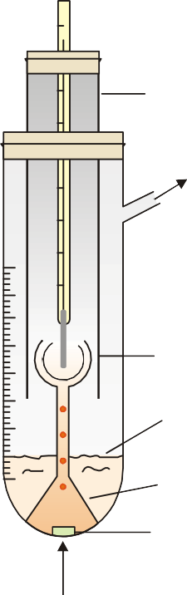

Hoodtube

To Condenser

Pump tube

Boiling Solvent

Inverted Funnel

Porcelain piece

Heat

**Fig.1.4.3.Cottrell’s Method apparatus.**

**3] Beckmann Thermometer:** It is *differential thermometer*. It is designed to measuresmall changes in temperature and not the temperature itself. It has a large bulb at the bottom of a finecapillary tube. The scale is calibrated from 0 to 6 K and subdivided into 0.01 K. The unique feature ofthis thermometer, however, is the small reservoir of mercury at the top. The amount of mercury in thisreservoir can be decreased or increased by tapping the thermometer gently. In this way the thermometeris adjusted so that the level of mercury thread will rest at any desired point on the scale when theinstrument is placed in the boiling (or freezing) solvent.

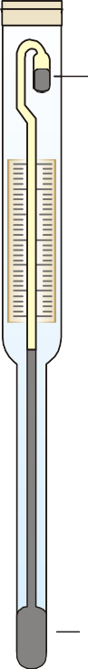

Scalereads6Kby0.01K

Bulb

Reservoir

**Fig.1.4.4.Beckmann Thermometer.**

**Procedure.** The apparatus is fitted up as shown in Fig. 1.4.4 Solvent is placed in the boilingtube with a porcelain piece lying in it. It is heated on a small flame (micro burner). As the solutionstarts boiling, solvent vapour arising from the porcelain piece pump the boiling liquid into the narrowstem. Thus a mixture of solvent vapour and boiling liquid is continuously sprayed around thethermometer bulb. The temperature soon becomes constant and the boiling point of the pure solventis recorded.Now a weighed pellet of the solute is added to the solvent and the boiling point of the solutionnoted as the temperature becomes steady. Also, the volume of the solution in the boiling tube isnoted. The difference of the boiling temperatures of the solvent and solute gives the elevation ofboiling point. While calculating the molecular weight of solute the volume of solution is convertedinto mass by multiplying with density of solvent at its boiling point.

**1.5 Freezing–Point Depression:**

**1.5.1 Relation between Depression of Freezing-point and Lowering of Vapour-pressure:**

The vapour pressure of a pure liquid changes with temperature as shown by the curve *ABC*, inFig. 15.8. There is a sharp break at B where, in fact, the freezing-point curve commences. Thus thepoint *B* corresponds to the freezing point of pure solvent, *Tf*. The vapour pressure curve of a solution(*solution* 1) of a nonvolatile solute in the same solvent is also shown in Fig. 15.8. It is similar to thevapour pressure curve of the pure solvent and meets the freezing point curve at *F*, indicating that *T*1is the freezing point of the solution. The difference of the freezing point of the pure solvent and thesolution is referred to as the **Depression of freezing point.**

It is represented by the symbol Δ*T* or Δ*Tf*.

*Tf*– *T*1 = Δ *T*

A

F

B

D

E

C

*T2 T1 Tf*

Temperature

Vapour Pressur

P

P1

P2

Solvent

Solution 1

Solution 2

**Fig.1.5.1.Relation between lowering of vapour-pressure anddepression of freezing point.**

When more of the solute is added to the solution 1, we get a more concentrated solution(*solution* 2.) The vapour pressure of *solution* 2 meets the freezing-point at *C*, indicating a furtherlowering of freezing point to *T*2.

For dilute solutions *FD* and *CE* are approximately parallel straight lines and *BC* is also a straightline. Since the triangles *BDF* and *BEC* are similar,

$$\frac{DF}{EC}= \frac{BD}{BE}$$

Or $\frac{Tf-T1}{Tf -T2}= \frac{P-P1}{P-P2}$

where *p*1 and *p*2 are vapour pressure of *solution* 1 and *solution* 2 respectively. **Hence depression offreezing point is directly proportional to the lowering of vapour pressure.**

or Δ*T* ∝*p* – *ps…………….(1.17)*

**1.5.2 Determination of Molecular Weight from Depression of Freezing point:**

Since *p* is constant for the same solvent at a fixed temperature, from (1.17) we can write,ΔT $∝\frac{P-Ps}{P}$………………………(1)

But from Raoult’s Law for dilute solutions,

$\frac{P-Ps}{P} ∝\frac{wM}{Wm}$……………………………….(2)

Since *M* (mol wt) of solvent is constant,

$\frac{P-Ps}{P} ∝\frac{w}{Wm}$……………………………….(3)

From equation (1) and (3),

Δ*T* ∝Kf x $\frac{w}{m}$ x $\frac{1}{W}$

Or Δ*T =* Kf x $\frac{w}{m}$ x $\frac{1}{W}$………………………………(4)

where *Kf*is a constant called **Freezing-point constant or Cryoscopic constant or Molal depressionconstant.** If *w*/*m* = 1 and *W* = 1, *Kf*= Δ*T*. Thus,

**Molal depression constant may be defined as the freezing-point depression produced when1 mole of solute is dissolved in one kg (1000 g) of the solvent.**

If the mass of solvent (*W*) is given in grams, it has to be converted into kilograms. Thus theexpression (4) assumes the form

ΔT = Kf x $\frac{w}{m} x\frac{1}{w/1000}$ or

ΔT = Kf x $\frac{w}{m} x\frac{1000}{w}$

Hence m = $\frac{1000 x Kf x w}{ΔT x w}$………………(5)

where m = molecular mass of solute ;*Kf*= molal depression constant ; *w* = mass of solute ;Δ*T* = depression of freezing point ; *W* = mass of solvent.

Given the value of *Kf*, the molecular mass of solute can be calculated.

Sometimes the value of *Kf*is given in K per 0.1 kg. (100 g.) In that case, the expression (5)becomes,

m = $\frac{100 x Kf x w}{ΔT x w}$

**Problem 1.**0.440 g of a substance dissolved in 22.2 g of benzene lowered the freezingpoint of benzene by 0.567°C. Calculate the molecular mass of the substance. (*Kf*= 5.12°C mol–1)

Solution: We can find the molecular mass by applying the expression,

m = $\frac{1000 x Kf x w}{ΔT x w}$

In this case :

*w* = 0.440 g

Δ*T* = 0.567°C

*W* = 22.2 g

*Kf*= 5.12°*C* mol–1

Substituting the values, m = $\frac{1000 x 5.12 x 0.440}{0.567 x 22.2}$ = 178.9

∴ Molecular mass of substance = **178.9**

**1.6 Freezing–PointDepression:**

The depression of freezing point can bemeasured more correctly and with less

difficulty. Two simple methods commonly usedare outlined below.

(1) **Beckmann’s Method (1903):**

**Apparatus.** It consists of (*i*) A *freezingtube* with a side-arm to contain the solvent orsolution, while the solute can be introducedthrough the side-arm; (*ii*) An outer larger tubeinto which is fixed the freezing tube, the spacein between providing an air jacket whichensures a slower and more uniform rate ofcooling; (*iii*) A *large jar* containing a freezingmixture *e.g.*, ice and salt, and having a stirrer.

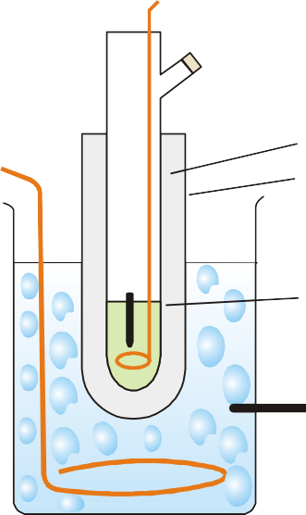

Beckmannthermometer

Air jacketOutertube

Freezingtube

Freezingmixture

Fig. 1.6.1Relation between lowering of vapour-pressure and depression of freezing point.

**Procedure.** 15 to 20 g of the solvent istaken in the freezing point of the solvent bydirectly coding the freezing point tube andthe apparatus set up as shown in Fig. 1.6.1 so that the bulb of the thermometer is completely immersed in the solvent. First determine the approximate freezing point of the solvent by directly cooling the freezing point tube in the cooling bath. When this has been done, melt the solvent and place the freezing-point tube again in the freezing bath and allow the temperature to fall.When it has come down to within about a degree of the approximate freezing point determined above, dry the tube and place it cautiously in the air jacket. Let the temperature fall slowly and when it has come down again to about 0.5° below the freezing point, stir vigorously. This will cause the solid to separate and the temperature will rise owing to the latent heat set free. Note the highest temperature reached and repeat the process to get concordant value of freezing point.The freezing point of the solvent having been accurately determined, the solvent is remelted by removing the tube from the bath, and a weighed amount (0.1–0.2 g) of the solute is introduced through the side tube. Now the freezing point of the solution is determined in the same way as that of the solvent. A further quantity of solute may then be added and another reading taken. Knowing the depression of the freezing point, the molecular weight of the solute can be determined by using the expression

m = $\frac{1000 x Kf x w}{ΔT x w}$

This method gives accurate results, if the following precautions are observed:

i) The supercooling should not exceed 0.5°C.

ii) The stirring should be uniform at the rate of about one movement per second.

iii) The temperature of the cooling bath should not be 4° to 5° below the freezing point of the liquid.

**1.7 Colligative Properties of Electrolytes:**

The colligative properties of solutions *viz*, vapour-pressure lowering, boiling-point elevation, freezing-point depression and osmotic pressure, all depend solely on the total number of solute particles present in solution. The various electrolytes ionize and yield more than one particle per formula unit in solution. Therefore, **the colligative effect of an electrolyte solution is always greater than that of a nonelectrolyte of the same molal concentration.**

To represent the colligative properties of electrolytes by means of the same relations as for nonelectrolytes, van’t Hoff (1880) suggested the use of a factor *i*. This is now known as **van’t Hoff factor** and is defined as: **the ratio of the colligative effect produced by an electrolyte solution to the corresponding effect for the same concentration of a nonelectrolyte solution.**

Applying this definition of *i*to the freezing-point depression, we have

i = $\frac{∆Tf }{\left[∆Tf \right]0}$……………………..[1]

where Δ*Tf*is the freezing-point depression for the electrolyte measured experimentally and [Δ*Tf*]0 isthe corresponding value calculated for a nonelectrolyte of the equal concentration. In other words,[Δ*Tf*]0 is the value of depression of freezing-point of the electrolyte solution assuming no ionization.

From (1)Δ*Tf*= *i*[Δ*Tf*]0

We know that ,

[Δ*Tf*]0= ……………..(2)

Δ*Tf*= *I x $\frac{1000Kf W}{mW}$…………………(3)*

A similar relation will hold for the observed elevation of boiling point of an electrolyte solution*i.e.*,

Δ*Tb = i x $\frac{1000Kb W}{mW}$…………………..(4)*

The value of *i*can, therefore, be calculated from the experimental data as mentioned in (4).It has been found that once *i*is known for a particular concentration of an electrolyte for one colligative property, the same value of *i*is essentially valid for other properties at the same concentration. That is,

i = $\frac{ΔTf}{[ΔTf]0}$ = $\frac{ΔTb}{[ΔTb]0}$ = $\frac{ΔP}{[ΔP]0}$ = $\frac{π}{[π0]}$

Where the subscript zero refers in each case to the effect produced by a solute that is a nonelectrolyte.

**1.7.1 Abnormal molecular masses of electrolytes:**

Dividing (2) by (3), it is evident that

$$\frac{ΔTf}{\left[ΔTf\right]0}= \frac{m0}{m}=i or m=i x m0$$

where *m*0 = molecular mass calculated from formula

*m* = molecular mass from observed data

Since the value of *i*is always greater than 1 **the experimental molecular weight will always beless than the theoretical value calculated from the formula.**

**1.7.2 Relation Between van’t Hoff Factor and Degree of Dissociation:**

Since colligative properties depend on the number of particles in solution, the van’t Hoff factormay be interpreted as the ratio of the **number of particles present in solution to the number obtainedassuming no ionization.** That is,

i = $\frac{Actual Number ofParticles}{Number of particles for ni Ionization}$

The **degree of dissociation** is the fraction of an electrolyte which is dissociated into ions inaqueous solution. If an electrolyte is 50 per cent dissociated, its degree of dissociation is 0.5. Thedegree of dissociations is usually represented by α.

Suppose 1 mole of an electrolyte is capable of forming *v* (‘nu’) ions on complete dissociation. Ifthe degree of dissociation be α, the total number of particles in solution are :

Number of undissociated molecules = 1 – α

Number of ions produced = α*v*

∴ Total number of particles = $1 – α + αv$

Hence i = $\frac{1-α+ αv}{1}$ or i – 1 = $α\left(v-1\right)$

$α$ = i-1/v-1

This expression states the relationship between van’t Hoff factor and the degree of dissociation.Knowing the value of *i*from colligative property measurements, α can be calculated.

**Problem 1.**A solution containing 1.5g of barium nitrate in 0.1 kg of water freezes at272.720 K. Calculate the apparent degree of dissociation of the salt.

*Kb*= 1.86, Molecular mass of Ba(NO3)2 = 261

Solution: Calculation of Depression of Freezing point [Δ *T*]0 for no ionization

Δ*T*= $\frac{1000Kf W}{mW}$ = $\frac{1000 x 1.5 x 1.86}{261 x 0.1 x 1000}$ = = 0.1068°C

**Calculation of van’t Hoff Factor**

i = $\frac{ΔT}{[ΔT]0}$ = $\frac{1 – 0.720}{0.1068}$ = $\frac{0.280}{0.1068}$

**Calculation of Degree of dissociation:**

$α$ = $\frac{i-1}{v-1}$

Here

Ba(NO3 )2⎯⎯→ Ba2+ + 2NO–3

and 1 formula unit yields 3 particles on dissociation.

∴*v* = 3

And $α$ = $\frac{0.280}{0.1068}-1$/3-1 = 0.81 = 81%

**1.8 Concept of Activity and Activity Coefficient:**

From the studies of solutions, G.N. Lewis discovered that **the experimentally determined valueof concentration whether of molecules or ions in solution is less than the actual concentration.**The apparent value of concentration is termed ‘activity’. It may be defined as: **the effectiveconcentration of a molecule or ion in a solution.**

The **activity coefficient ‘**γ**’**is defined as: **the ratio between the activity, denoted by *a*, or effectiveconcentration and actual concentration of the molecule or ion in solution.** That is,

$γ= \frac{effective concentration}{actual concentration}$ = $\frac{a}{c}$ or a = $γc$

γ can be determined experimentally and is given in Tables. Thus, the value of activity can be calculatedby applying the above relation.

**Explanation**

The effective number of cations and anions in solution becomes less as these tend to form ionpairs(Fig. 1.8.1) because of strong electrostatic attractions. Thus, the effective concentration of theions becomes less than the actual concentration.

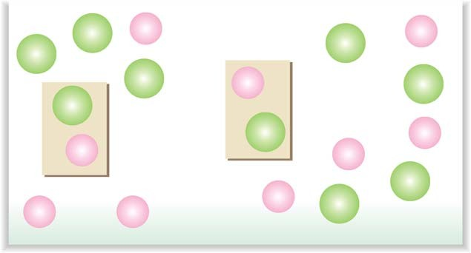

2

2+

2

2+

2

2

2+

2

2

2

2+

2+

2+

2

2+

2+

2+

2

Ion-pairformation

Fig. 1.8.1 Ion-pair formation of a 2+ cation and a 2– anion in a solution reduces the effective concentration of ions compared to actual concentration.

**Problem 1**. Calculate the effective concentration of a 0.0992 M solution of NaCl at 25°Cfor which activity coefficient is 0.782.

**Solution:**

We know that :*a* = γ *c*

Substituting the values, we have

*a* = (0.782) x (0.0992 M)

= 0.0776 M