**K.T.S.P.MANDAL’S**

**HUTATMA RAJGURU MAHAVIDYALAYA**

RAJGURUNAGAR, TAL-KHED, DIST-PUNE 410501

**BBA DEPARTMENT (2024-25)**

A log sheet with the following details of program

|  |  |  |
| --- | --- | --- |
| Sr. No | Item | Particulars |
| 1 | Date | 20th July- 25th July |
| 2 | Name of Event | **PUBLIC SPEAKING ACTIVITY** |
| 3 | Venue | CLASSROOM |
| 4 | Time | Class timings |
| 5 | Duration of the program | 4 Day |
| 6 | Expense | - |
| 7 | Source of Financial Assistance | - |
| 8 | Names of resource persons | - |
| 9 | Name of coordinator | DR. P.P.OSWAL |
| 10 | Number of participants | All Students |
| 11 | Copy of the program | - |
| 12 | Curricular/Co-Curricular/Extra-Curricular | Extra-Curricular |
| 13 | Activity belongs to Which Criteria of NAAC | - |

Date:- 20th – 25th July , 2024

**Report**

Public speaking activity was conducted for SYBBA students to improve communication skills and body language. The activity took place in the Classroom. Public speaking and good communication skills are a part of Personality Development. Recognizing this need for students, the activity Pick and Speak was organized as a part of extra curriculum. The topics were related to AI, DIGITAL MARKETING and SHARE MARKET, so that students enjoy the discussion and can ask the queries. It was indeed a great joy to see students speak on these topics. Each one wanted to exhibit their best eloquence. The competition brought out skills including quick thinking and oratory. Over all it was an enjoyable and a learning experience for the students as they could keep abreast with the happenings in the wider world around them.

The event was concluded with a formal vote of thanks.

Dr.P.P.Oswal

HOD-BBA

**Photos:-**

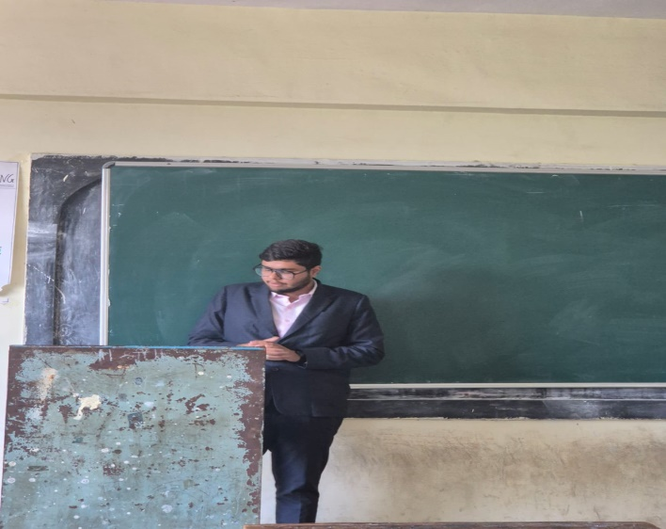

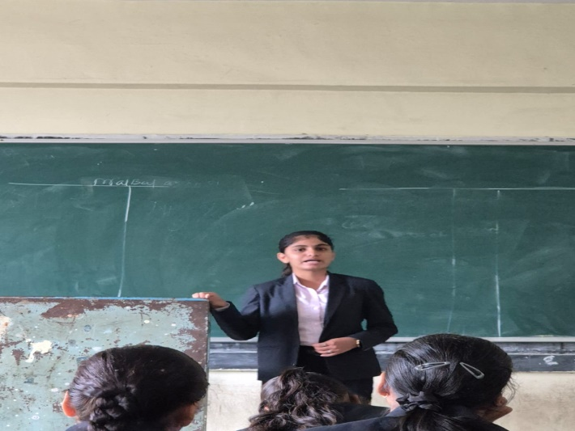

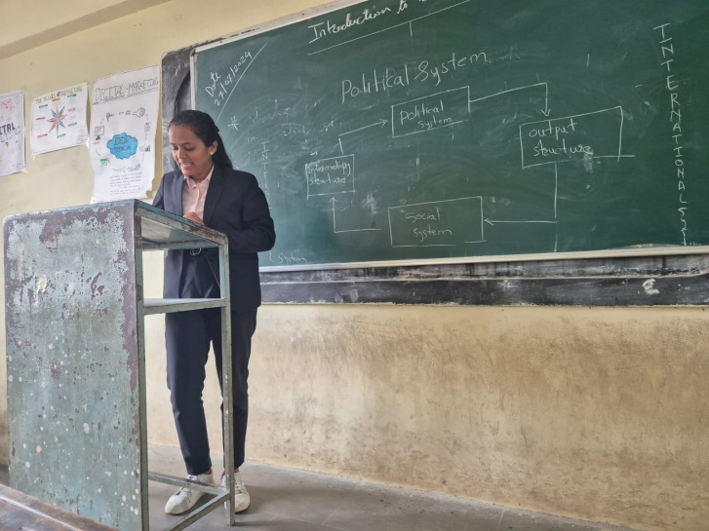

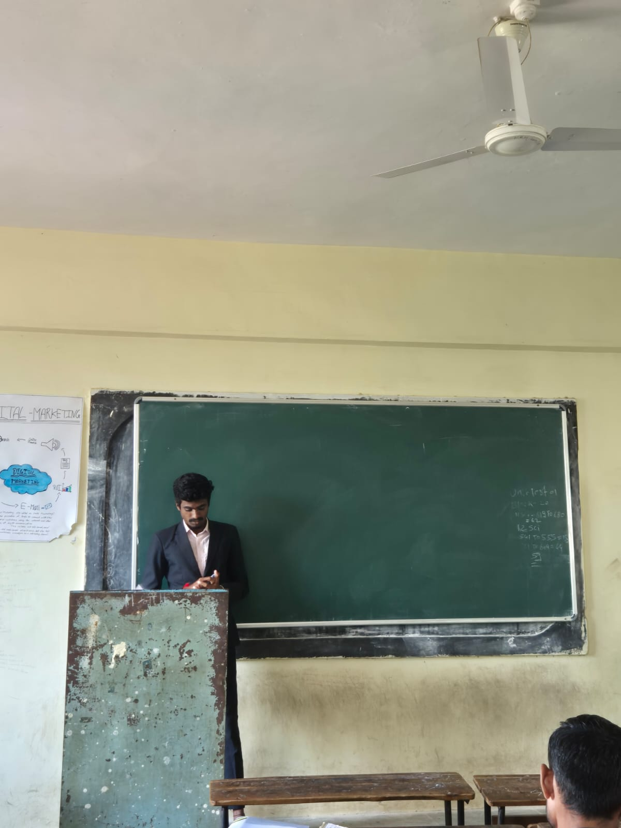

**Attendance of student:-**

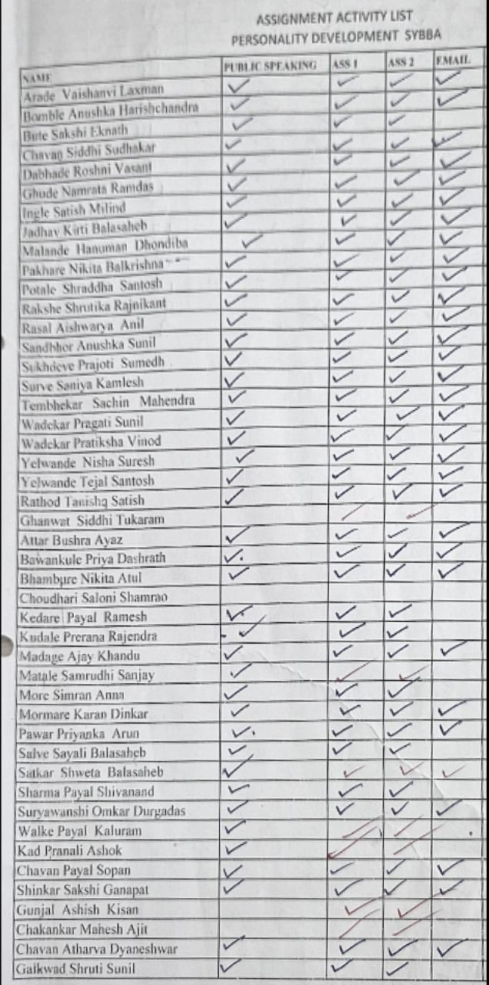

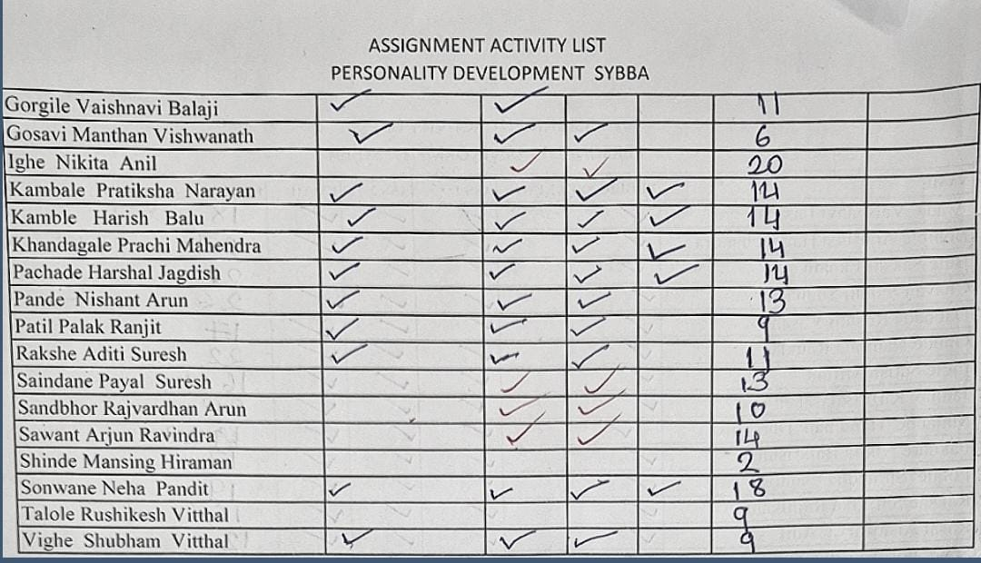

Dr. P.P.OSWAL

HOD-BBA