**K.T.S.P.MANDAL’S**

**HUTATMA RAJGURU MAHAVIDYALAYA**

RAJGURUNAGAR, TAL-KHED, DIST-PUNE 410501

**BBA DEPARTMENT (2024-25)**

A log sheet with the following details of program

|  |  |  |
| --- | --- | --- |
| Sr. No | Item | Particulars |
| 1 | Date | 28th September |
| 2 | Name of Event | **Email – curriculum vitae & self-recommendation letter** |
| 3 | Venue | CLASSROOM |
| 4 | Time | Class timings |
| 5 | Duration of the program | WORKING HOURS OF COMPANY |
| 6 | Expense | - |
| 7 | Source of Financial Assistance | - |
| 8 | Names of resource persons | - |
| 9 | Name of coordinator | PROF. Y.R.SEMLANI |
| 10 | Number of participants | All Students |
| 11 | Copy of the program | - |
| 12 | Curricular/Co-Curricular/Extra-Curricular | Extra-Curricular |
| 13 | Activity belongs to Which Criteria of NAAC | - |

Date:- 28th September , 2024

**Report**

SYBBA Students were informed to write formal email based on topic of Curriculum Vitae & Self-recommendation letter. Taking into consideration of email etiquettes and detail studies about social and international cultural & etiquettes.

Email, also known as electronic mail, is a medium of written communication used to send and receive information over the Internet. It has been in use since the beginning of the Internet era. Initially, people used it for informal communication before social media apps were introduced into our lives. Later, social media took the spotlight, and now emails are used mostly for professional communication in schools, colleges, offices, banks, etc. Poorly written, unclear, misleading or ineffective emails not only cause a loss of time and productivity, but can also harm one’s reputation by leaving a poor impression on the reader. It, therefore, becomes imperative that we make the best possible use of emails to communicate effectively at the workplace. To do so, you must keep in mind some basic email etiquette to draft the perfect official email.

Learning outcomes-

1. demonstrate an understanding of different report types, and in particular analytical reports that require research
2. know how to interpret and respond to briefs/terms of reference
3. be aware of the different phases in the report-writing process, and be able to apply Them recursively
4. know which main elements are regularly included in reports, and how they are Typically ordered
5. know which style, tense and level of formality to use, and how these are Influenced by the (various) audience(s) that might read the report, and

DR. P.P.OSWAL

HOD of BBA

**Photos:-**

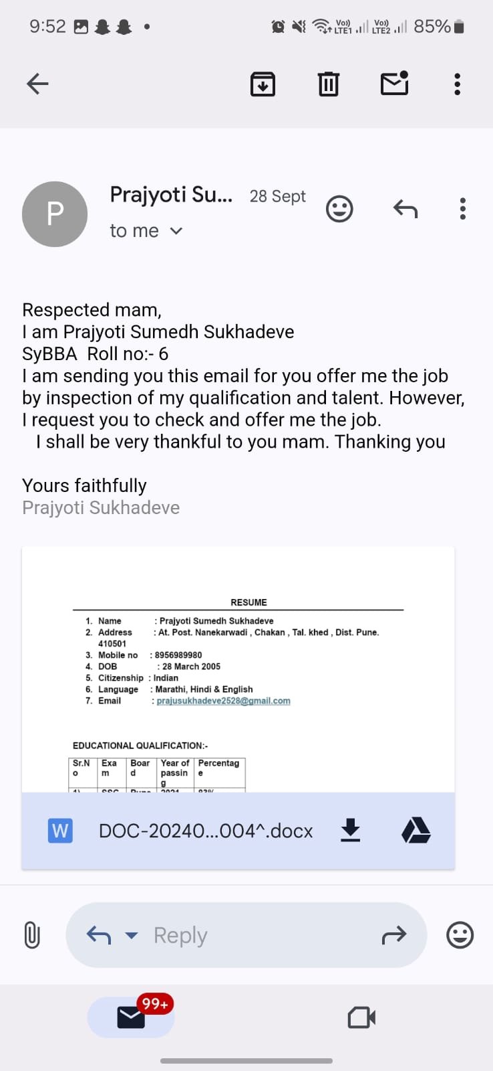

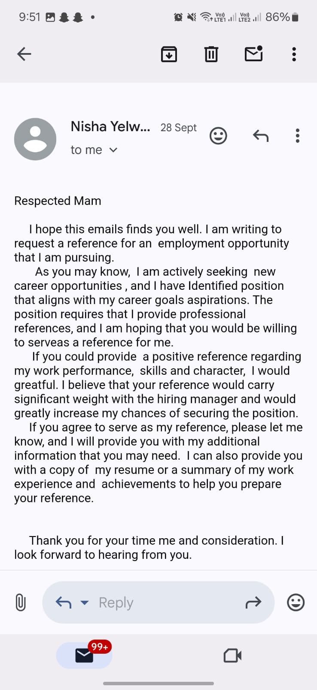

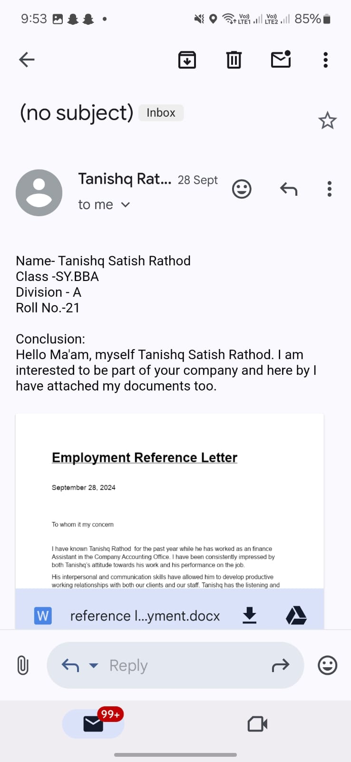

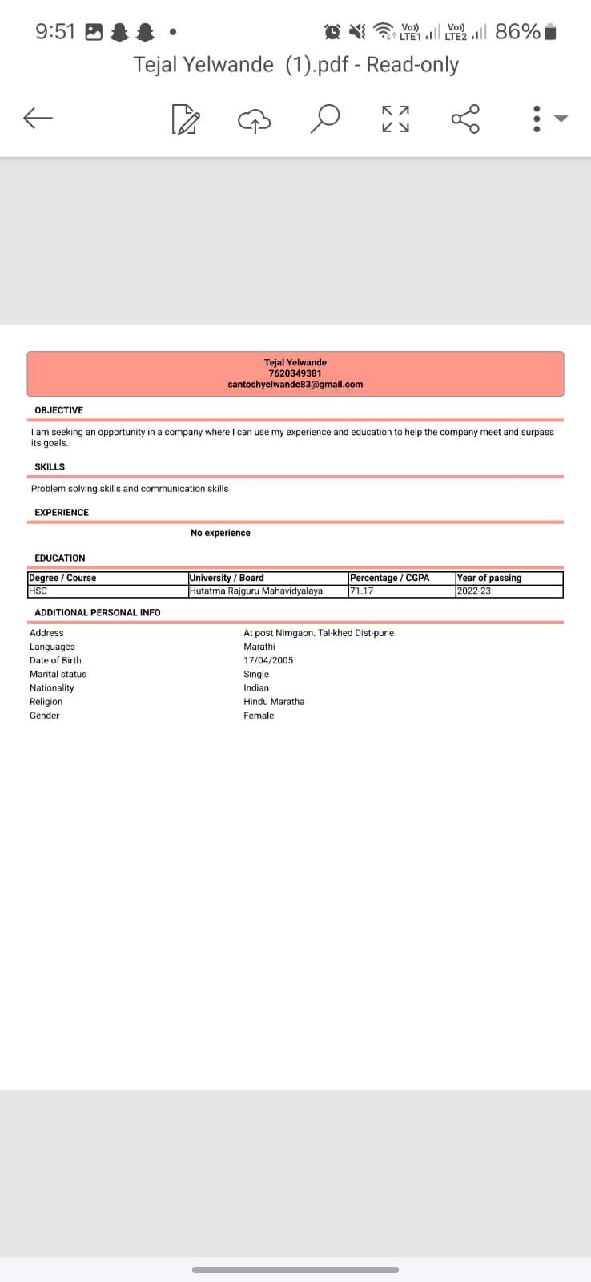

**Attendance of student:-**

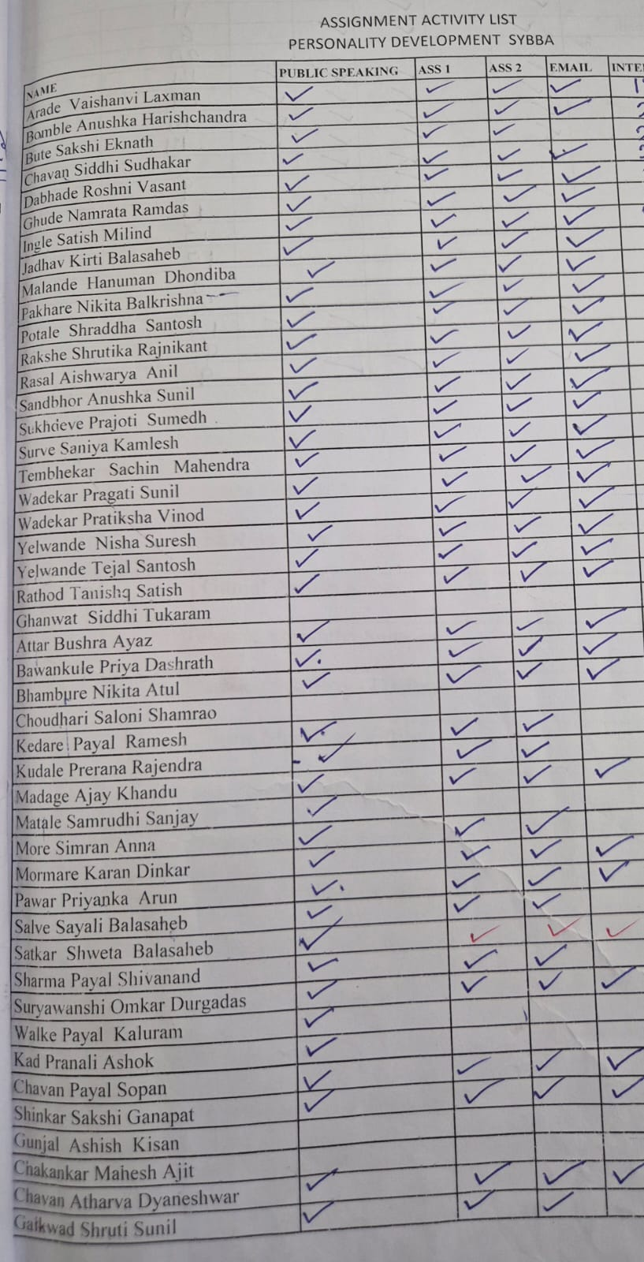

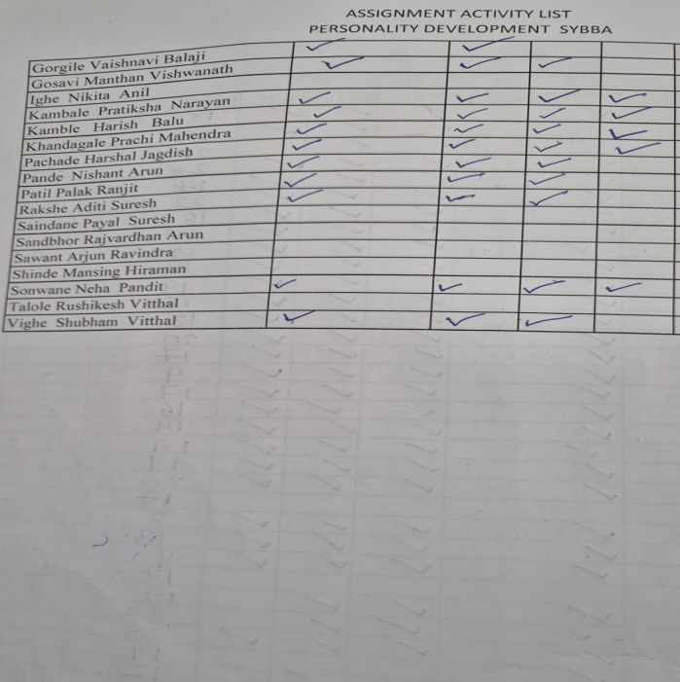

DR. P.P.OSWAL

HOD of BBA