TIMETABLE

DEPARTMENT OF COMMERCE ACADEMIC YEAR 2024-25

CLASS : F.Y.B.COM (DIV-A)

|  |  |  |  |  |  |  |
| --- | --- | --- | --- | --- | --- | --- |
| TIME | MON | TUES | WED | THUS | FRI | SAT |
| 7:30-8:20 | ENG  (VBK) | ENG  (VBK) | MOM  (URJ) | MOM  (URJ) | MOM  (URJ) | MOM  (URJ) |
| 8:20-9:10 | A/C  (HSC) | A/C  (HSC) | EVS  (JAG) | EVS  (JAG) | OE - MAR | ECO  (SVD) |
|  |  |  |  |  |  |  |
| 9:20-10:10 | B A/C  TSD | A/C  (HSC) | OE - MAR | ECO  (SVD) | A/C  (HSC) | B A/C  TSD |
| 10:10-11:00 |  | ECO  (SVD) |  |  | ECO  (SVD) |  |
| 11:00-11:50 |  |  |  |  |  |  |

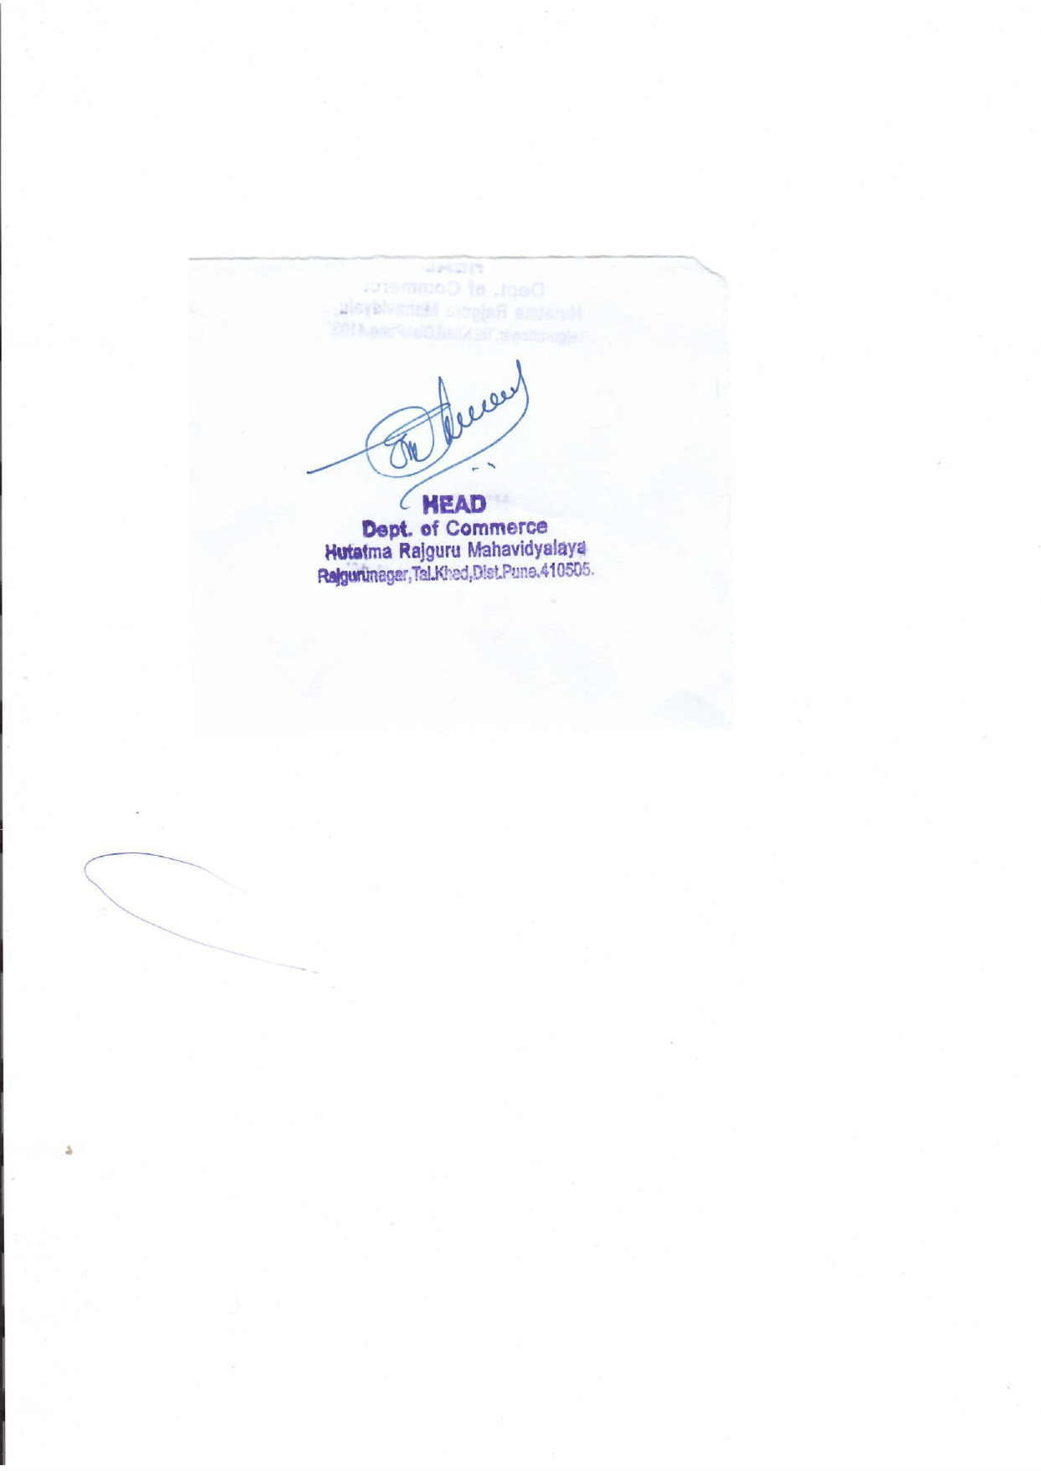 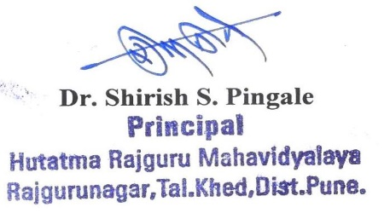

TIMETABLE

DEPARTMENT OF COMMERCE ACADEMIC YEAR 2024-25

CLASS : F.Y.B.COM (DIV-B)

|  |  |  |  |  |  |  |
| --- | --- | --- | --- | --- | --- | --- |
| TIME | MON | TUES | WED | THUS | FRI | SAT |
| 7:30-8:20 | B A/C  (RYS) | B A/C  (RYS) | BF  (TRH) | BF  (TRH) | BF  (TRH) | BF  (TRH) |
| 8:20-9:10 | ECO  (BAW) | EVS  (JAG) | ECO  (BAW) | ECO  (BAW) | EVS  (JAG) | ECO  (BAW) |
|  |  |  |  |  |  |  |
| 9:20-10:10 | A/C  (TVB) | A/C  (TVB) | A/C  (TVB) | A/C  (TVB) | ENG  (LBK) | OE  POL. SCI. |
| 10:10- 11;00 | ENG  (LBK) | OE  POL. SCI. |  |  |  |  |
| 11:00-11:50 |  |  |  |  |  |  |

 

TIMETABLE

DEPARTMENT OF COMMERCE

ACADEMIC YEAR 2024-25

CLASS: F.Y.B.COM (DIV-C)

|  |  |  |  |  |  |  |
| --- | --- | --- | --- | --- | --- | --- |
| TIME | MON | TUES | WED | THUS | FRI | SAT |
| 7:30-8:20 | A/C  (HSC) | A/C  (HSC) | CWA  (RYS) | CWA  (RYS) | CWA  (RYS) | CWA  (RYS) |
| 8:20-9:10 | ECO  (VSW) | ECO  (VSW) | A/C  (HSC) | A/C  (HSC) | ENG  (VBK) | ENG  (VBK) |
|  |  |  |  |  |  |  |
| 9:20-10:10 | OE  STATS | B A/C  (RYS) | ECO  (VSW) | OE  STATS | EVS  (RYS) | B A/C  (RYS) |
| 10:10-11:00 |  |  | EVS  (RYS) |  | ECO  (VSW) |  |
| 11:00-11:50 |  |  |  |  |  |  |

 

TIMETABLE

DEPARTMENT OF COMMERCE

ACADEMIC YEAR 2024-25

CLASS : F.Y.B.COM (DIV-D)

|  |  |  |  |  |  |  |
| --- | --- | --- | --- | --- | --- | --- |
| TIME | MON | TUES | WED | THUS | FRI | SAT |
| 7:30-8:20 | A/C  (PPO) | IKS | CWA  (GMD) | CWA  (GMD) | CWA  (GMD) | CWA  (GMD) |
| 8:20-9:10 | ENG  (VBK) | B A/C  (GMD) | ENG  (VBK) | EVS  (RYS) | EVS  (RYS) | A/C  (PPO) |
|  |  |  |  |  |  |  |
| 9:20-10:10 | OE  MATHS | A/C  (PPO) | OE  MATHS |  |  |  |
| 10:10-11:00 | B A/C  (GMD) | ECO  (ASK) | ECO  (ASK) | ECO  (ASK) | A/C  (PPO) | ECO  (ASK) |
| 11:00-11:50 |  |  |  |  |  |  |

 

TIMETABLE

DEPARTMENT OF COMMERCE

ACADEMIC YEAR 2024-25

CLASS : S.Y.B.COM (DIV-A)

|  |  |  |  |  |  |  |
| --- | --- | --- | --- | --- | --- | --- |
| TIME | MON | TUES | WED | THUS | FRI | SAT |
| 7:30-8:20 | A/C  (JAG) | A/C  (JAG) | C-LAW  (JAG) | C-LAW  (JAG) | C-LAW  (JAG) | C-LAW  (JAG) |
| 8:20-9:10 | BC  (TSD) | BC  (TSD) | BC  (TSD) | BC  (TSD) | BM  (TSD) | A/C  (JAG) |
|  |  |  |  |  |  |  |
| 9:20-10:10 | A/C  (JAG) | BM  (TSD) | BM  (TSD) | BM  (TSD) | ECO  (VSW) | ECO  (VSW) |
| 10:10-11:00 | ECO  (VSW) | BA-1  (URJ) | BA-1  (URJ) | ECO  (VSW) | EVS  (RSP) | BA-1  (URJ) |
| 11:00-11:50 | BA-1  (URJ) |  |  | EVS  (RSP) |  |  |

 

TIMETABLE

DEPARTMENT OF COMMERCE

ACADEMIC YEAR 2024-25

CLASS : S.Y.B.COM (DIV-B)

|  |  |  |  |  |  |  |
| --- | --- | --- | --- | --- | --- | --- |
| TIME | MON | TUES | WED | THUS | FRI | SAT |
| 7:30-8:20 | 1. LAW   (URJ) | BM  (KDS) |  | BM  (KDS) | EVS  (RSP) | BM  (KDS) |
| 8:20-9:10 | ECO  (SVD) | C-LAW  (URJ) | BC  (RYS) | ECO  (SVD) | A/C  (RNK) | BC  (RYS) |
|  |  |  |  |  |  |  |
| 9:20-10:10 | A/C  (RNK) | A/C  (RNK) | C-LAW  (URJ) | C-LAW  (URJ) | ECO  (SVD) | ECO  (SVD) |
| 10:10-11:00 | BC  (RYS) | CWA  (JAG) | CWA  (JAG) | A/C  (RNK) | BM  (KDS) | CWA  (JAG) |
| 11:00-11:50 |  | BC  (RYS) | EVS  (RSP) |  | CWA  (JAG) |  |

 

TIMETABLE

DEPARTMENT OF COMMERCE

ACADEMIC YEAR 2024-25

CLASS : S.Y.B.COM (DIV-C)

|  |  |  |  |  |  |  |
| --- | --- | --- | --- | --- | --- | --- |
| TIME | MON | TUES | WED | THUS | FRI | SAT |
| 7:30-8:20 | BC  (RNK) | BC  (RNK) | BC  (RNK) | BC  (RNK) | ECO  (RSS) | C-LAW  (PBP) |
| 8:20-9:10 | BM  (PSN) | BM  (PSN) | A/C  (GMD) | A/C  (GMD) | A/C  (GMD) | A/C  (GMD) |
|  |  |  |  |  |  |  |
| 9:20-10:10 | EVS  (RSP) | ECO  (RSS) | BM  (PSN) | BM  (PSN) | EVS  (RSP) | C-LAW  (PBP) |
| 10:10-11:00 | ECO  (RSS) | CWA  (GMD) | CWA  (GMD) | C-LAW  (PBP) | C-LAW  (PBP) | CWA  (GMD) |
| 11:00-11:50 | CWA  (GMD) |  |  |  |  | ECO  (RSS) |

 

TIMETABLE

DEPARTMENT OF COMMERCE

ACADEMIC YEAR 2024-25

CLASS : T.Y.B.COM (DIV-A)

|  |  |  |  |  |  |  |
| --- | --- | --- | --- | --- | --- | --- |
| TIME | MON | TUES | WED | THUS | FRI | SAT |
| 7:30-8:20 | A/C  (KDS) | ECO  (SVD) | A/C  (KDS) | 1. LAW   (HSC) | ECO  (SVD) | M-LAW  (HSC) |
| 8:20-9:10 | AUDIT  (PP0) | AUDIT  (PP0) | AUDIT  (PP0) | AUDIT  (PP0) | MLAW  (HSC) | BA-II  (TRH) |
|  |  |  |  |  |  |  |
| 9:20-10:10 | BA-III  (HSC) | A/C  (KDS) | M-LAW  (HSC) | A/C  (KDS) | BA-II  (TRH) | BA-III  (HSC) |
| 10:10-11:00 | BA-II  (TRH) | BA-II  (TRH) | ECO  (SVD) | BA-III  (HSC) | BA-III  (HSC) | ECO  (SVD) |
| 11:00-11:50 |  |  |  |  |  |  |

 

TIMETABLE

DEPARTMENT OF COMMERCE

ACADEMIC YEAR 2024-25

CLASS : T.Y.B.COM (DIV-B)

|  |  |  |  |  |  |  |
| --- | --- | --- | --- | --- | --- | --- |
| TIME | MON | TUES | WED | THUS | FRI | SAT |
| 7:30-8:20 | ECO  (VSW) | AUDIT  (PPO) | AUDIT  (PPO) | AUDIT  (PPO) | A/C  (KDS) | AUDIT  (PPO) |
| 8:20-9:10 | M-LAW  (KDS) | CWA-III  (RYS) | M-LAW  (KDS) | M-LAW  (KDS) | A/C  (KDS) | CWA II  (RNK) |
|  |  |  |  |  |  |  |
| 9:20-10:10 | CWA-III  (RYS) | ECO  (VSW) | A/C  (KDS) | ECO  (VSW) | CWA II  (RNK) | M-LAW  (KDS) |
| 10:10-11:00 | CWA II  (RNK) | CWA II  (RNK) | A/C  (KDS) | CWA-III  (RYS) | CWA-III  (RYS) | ECO  (VSW) |
| 11:00-11:50 |  |  |  |  |  |  |

 

TIMETABLE

DEPARTMENT OF COMMERCE

ACADEMIC YEAR 2024-25

CLASS: T.Y.B.COM (DIV-C)

|  |  |  |  |  |  |  |
| --- | --- | --- | --- | --- | --- | --- |
| TIME | MON | TUES | WED | THUS | FRI | SAT |
| 7:30-8:20 | AUDIT  (PPO) | ECO  (RSS) | ECO  (RSS) | ECO  (RSS) | M-LAW  (RNK) | M-LAW  (RNK) |
| 8:20-9:10 | M-LAW  (RNK) | M-LAW  (RNK) | A/C  (RNK) | A/C  (RNK) | ECO  (RSS) | CWA II  (TBV) |
|  |  |  |  |  |  |  |
| 9:20-10:10 | CWA III  (GMD) | AUDIT  (PPO) | A/C  (RNK) | A/C  (RNK) | CWA II  (TBV) | CWA III  (GMD) |
| 10:10-11:00 | CWA II  (TBV) | CWA II  (TBV) | AUDIT  (PPO) | CWA III  (GMD) | CWA III  (GMD) | AUDIT  (PPO) |
| 11:00-11:50 |  |  |  |  |  |  |

 