**K.T.S.P.MANDAL’S**

**HUTATMA RAJGURU MAHAVIDYALAYA**

RAJGURUNAGAR, TAL-KHED, DIST-PUNE 410501

**BBA DEPARTMENT (2024-25)**

A log sheet with the following details of program

|  |  |  |
| --- | --- | --- |
| Sr. No | Item | Particulars |
| 1 | Date | 5th September |
| 2 | Name of Event | **Teachers Day Celebration** |
| 3 | Venue | CLASSROOM |
| 4 | Time | Class timings |
| 5 | Duration of the program | 1 Day |
| 6 | Expense | - |
| 7 | Source of Financial Assistance | - |
| 8 | Names of resource persons | - |
| 9 | Name of coordinator | DR. P.P.OSWAL |
| 10 | Number of participants | All Students |
| 11 | Copy of the program | - |
| 12 | Curricular/Co-Curricular/Extra-Curricular | Extra-Curricular |
| 13 | Activity belongs to Which Criteria of NAAC | - |

Date:- 5th September, 2024

**Report**

We celebrate Teachers day every year throughout the country on 5th September. Students express their gratitude and appreciation for their teachers on this day. This day is dedicated to Dr.Sarvepalli Radhakrishnan-second President of India. The great academic philosopher and one of the most well-known diplomats, scholar, president of India and above all a teacher. As a tribute to this great teacher, his birthday has been observed as teachers' day.

A celebration conducted at our department by our students on 5th September- 2024. The whole function was planned by students. We decided that, the responsibility of teaching is taken up by the students as an appreciation for their teachers.

As per the Indian culture, we always start our work with prayer. Total number of participates in teacher's day are 7 Students has prepared timetable of lectures from 08:20 a.m. to 12:00 p.m. Students went to class to deliver lectures on the ongoing semester subjects.

On this day, our teaching was started as usual on 08:20 am. All the students in role of teachers who had no lectures they had seated in staff room. All other non-participated students were also studying seriously without making any noise or mischief. All participated students were appreciated by giving rose as our token of love.

The event was concluded with a formal vote of thanks.

Dr.P.P.Oswal

HOD-BBA

**Photos:-**

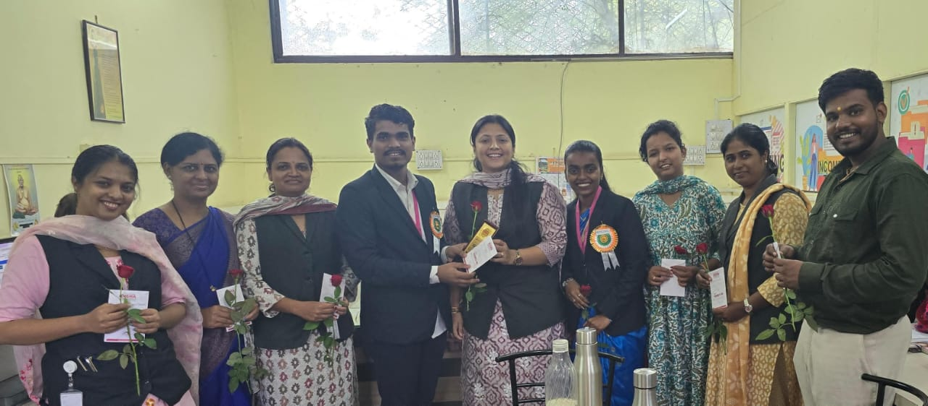

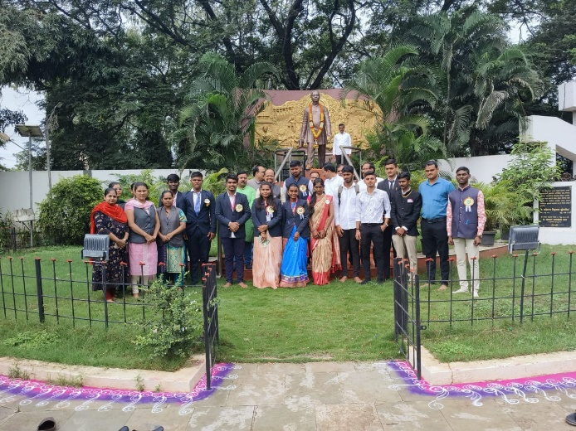

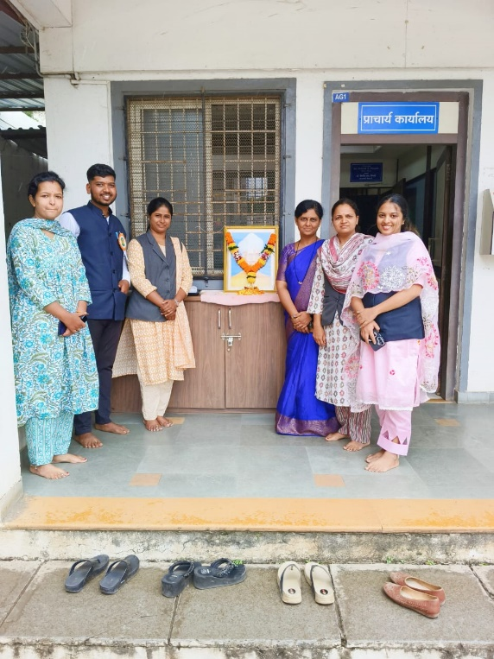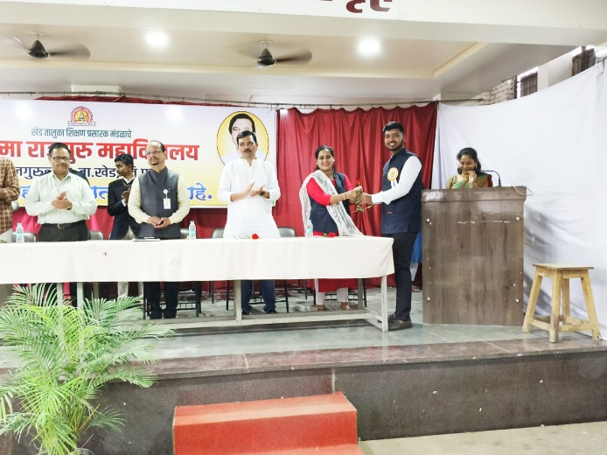

**Attendance of student:-**

|  |  |  |
| --- | --- | --- |
| Roll No. | Student Name | P/A |
| 1 | Bute Sakshi Eknath | P |
| 2 | Sawant Arjun Ravindra | P |
| 3 | Jadhav Kirti Balasaheb | P |
| 4 | Ingle Satish Milind | P |
| 5 | Malande Hanuman Dhondiba | P |
| 6 | Sukhdeve Prajoti Sumedh | P |
| 7 | Wadekar Pragati Sunil | P |
| 8 | Choudhari Saloni Shamrao | A |
| 9 | Ghude Namrata Ramdas | P |
| 10 | Kudale Prerana Rajendra | P |
| 11 | Arade Vaishanvi Laxman | P |
| 12 | Pawar Priyanka Arun | A |
| 13 | Chavan Payal Sopan | A |
| 14 | Saindane Payal Suresh | P |
| 15 | Rasal Aishwarya Anil | P |
| 16 | Sandbhor Anushka Sunil | P |
| 17 | Pakhare Nikita Balkrishna | P |
| 18 | Tembhekar Sachin Mahendra | P |
| 19 | Kad Pranali Ashok | P |
| 20 | Khandagale Prachi Mahendra | P |
| 21 | Rathod Tanishq Satish | P |
| 22 | Bomble Anushka Harishchandra | P |
| 23 | Ghanwat Siddhi Tukaram | P |
| 24 | Rakshe Shrutika Rajnikant | P |
| 25 | Satkar Shweta Balasaheb | A |
| 26 | Suryawanshi Omkar Durgadas | P |
| 27 | Shinkar Sakshi Ganapat | P |
| 28 | Ighe Nikita Anil | A |
| 29 | Dabhade Roshni Vasant | P |
| 30 | Mormare Karan Dinkar | P |
| 31 | Surve Saniya Kamlesh | P |
| 32 | Pachade Harshal Jagdish | A |
| 33 | Shinde Mansing Hiraman | P |
| 34 | Sonwane Neha Pandit | P |
| 35 | Chavan Siddhi Sudhakar | P |
| 36 | Gaikwad Shruti Sunil | P |
| 37 | Gosavi Manthan Vishwanath | P |
| 38 | Kambale Pratiksha Narayan | P |
| 39 | Kamble Harish Balu | P |
| 40 | Attar Bushra Ayaz | A |
| 41 | Madage Ajay Khandu | P |
| 42 | Matale Samrudhi Sanjay | P |
| 43 | Sandbhor Rajvardhan Arun | P |
| 44 | Talole Rushikesh Vitthal | P |
| 45 | Walke Payal Kaluram | P |
| 46 | Kedare Payal Ramesh | A |
| 47 | Chakankar Mahesh Ajit | P |
| 48 | Gorgile Vaishnavi Balaji | P |
| 49 | Bhambure Nikita Atul | P |
| 50 | More Simran Anna | P |
| 51 | Sharma Payal Shivanand | P |
| 52 | Gunjal Ashish Kisan | P |
| 53 | Potale Shraddha Santosh | P |
| 54 | Bawankule Priya Dashrath | A |
| 55 | Vighe Shubham Vitthal | P |
| 56 | Yelwande Nisha Suresh | P |
| 57 | Yelwande Tejal Santosh | P |
| 58 | Chavan Atharva Dyaneshwar | P |
| 59 | Rakshe Aditi Suresh | P |
| 60 | Pande Nishant Arun | P |
| 61 | Patil Palak Ranjit | P |
| 62 | Wadekar Pratiksha Vinod | P |
| 63 | Salve Sayali Balasaheb | A |

Dr.P.P.Oswal

HOD-BBA