**K.T.S.P.MANDAL’S**

**HUTATMA RAJGURU MAHAVIDYALAYA**

RAJGURUNAGAR, TAL-KHED, DIST-PUNE 410501

**BBA DEPARTMENT (2023-24)**

A log sheet with the following details of program

|  |  |  |
| --- | --- | --- |
| Sr. No | Item | Particulars |
| 1 | Date | 5th September, 2023 |
| 2 | Name of Event | **Teachers’ Day Celebration** |
| 3 | Venue | College Auditorium |
| 4 | Time | 10.00Pm to 03.30 P.M. |
| 5 | Duration of the programme | 1 Day |
| 6 | Expense | - |
| 7 | Source of Financial Assistance | - |
| 8 | Names of resource persons | - |
| 9 | Name of coordinator | DR. P.P.OSWAL |
| 10 | Number of participants | Students |
| 11 | Copy of the program | - |
| 12 | Curricular/Co-Curricular/Extra-Curricular | Extra-Curricular |
| 13 | Activity belongs to Which Criteria of NAAC | - |

Date: - 5th September, 2023

**Report**

On 5th September, 2023 (Tuesday), the Hutatma Rajguru Mahavidhyalaya College organized Teachers’ Day celebrations. The function took place in the auditorium of the college. The students of various departments, along with the help of the Student’s Union, organised a function for the teachers. Like every year, this year also our college celebrated Teachers’ Day on September 5 with fervor and zeal. The event was organised to acknowledge the dedication and hard work of the teachers.

The Principal gave a speech on Dr. Radha krishnan and the role of teachers in shaping the society. The committee president congratulated the teachers and motivated the students to become a good person and a good teacher.

Students expressed their gratitude, regard, and respect towards their teachers on that day. They presented various cultural activities like speeches, poems and songs to express their feelings. The activities of the students were appreciated by all the teachers.

The event was concluded with a formal vote of thanks.

Dr.P.P.Oswal

Head of Department

**Photos:-**

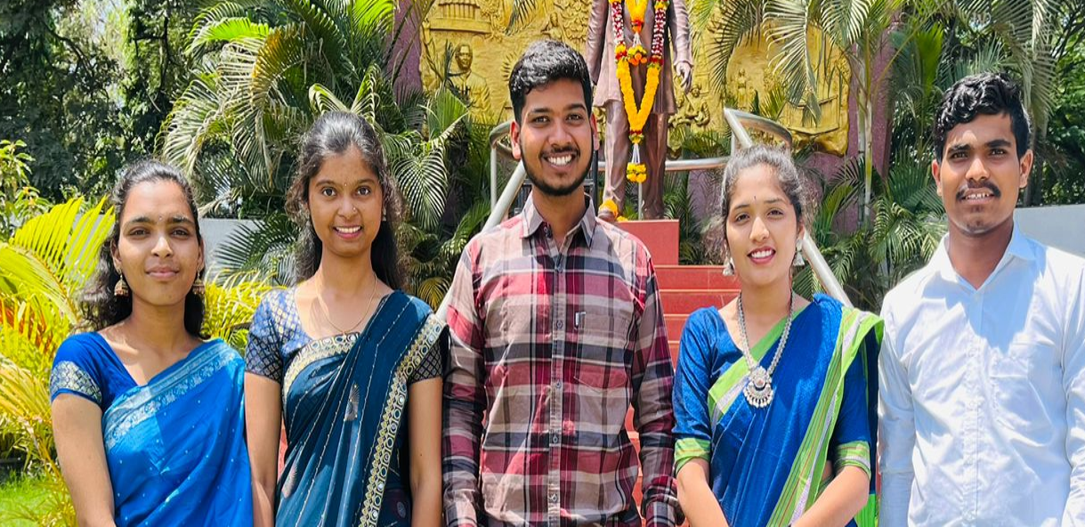

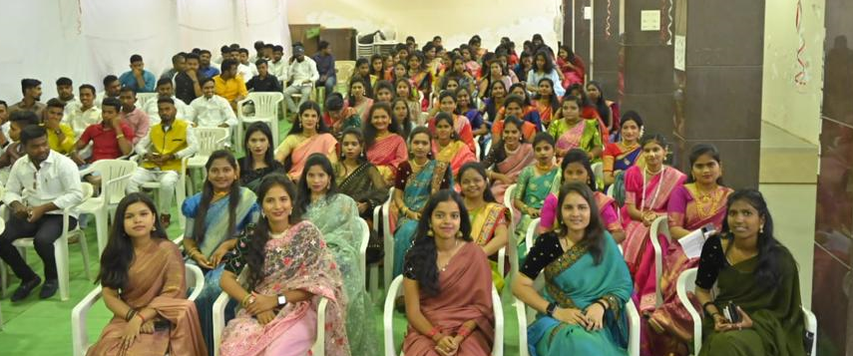

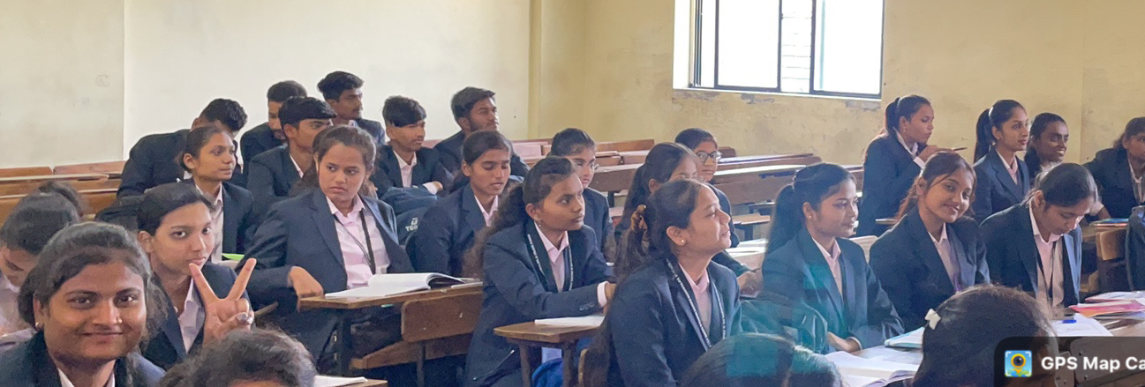

**Attendance of student:-**

DR. P.P.OSWAL

HOD of BBA depart.