**K.T.S.P.MANDAL’S**

**HUTATMA RAJGURU MAHAVIDYALAYA**

RAJGURUNAGAR, TAL-KHED, DIST-PUNE 410501

**BBA DEPARTMENT (2024-25)**

A log sheet with the following details of program

|  |  |  |
| --- | --- | --- |
| Sr. No | Item | Particulars |
| 1 | Date | 5th Oct 2024 |
| 2 | Name of Event | **Retail Shop Field Visit** |
| 3 | Venue | Retail Shop |
| 4 | Time | 12pm to 2.30 pm |
| 5 | Duration of the program | 1 Day |
| 6 | Expense | - |
| 7 | Source of Financial Assistance | - |
| 8 | Names of resource persons | Prof. Y. R. Semlani |
| 9 | Name of coordinator | DR. P.P.OSWAL |
| 10 | Number of participants | 20 Students |
| 11 | Copy of the program | - |
| 12 | Curricular/Co-Curricular/Extra-Curricular | Extra-Curricular |
| 13 | Activity belongs to Which Criteria of NAAC | - |



Date:- 5th Oct , 2024

**Report**

**OBJECTIVES:** Students of S.Y.BBA learnt about retailing in India.

Marketing: Basic knowledge about how the retail shop works, product placement in shop, shop layout, marketing of products, customer flow according to geographical location, pricing decisions, categories of products etc.   
  
 prof.y.r.semlani arranged a field trip for students of the SY BBA for the detail study of retail shop working. A group of 20 students participated in this effort to provide retail exposure to students.

The halt was at amrutlal sohanraj & company located at Rajgurunagar. Students got an exposure to this supermarket; they got an opportunity to see different assortments of goods sold by this mega retailer. They also got to observe the layout and the store décor which is a little different from many retailers in and around.

They also observed the leased departments outside the store. they also got detail study about food license.

The students unanimously agreed that it was a fun learning experience for them. they clicked lots of pictures with different types of products. At lasts the field visit ended by vote of thanks to the owner of shop for supporting and coordinating with students.

After the field visit the students were given refreshments and informal discussion was carry forward between teacher & students about the marketing strategy. The students left the at 2.30 p.m.

Dr. P.P.Oswal

HOD- BBA

**Photos:-**

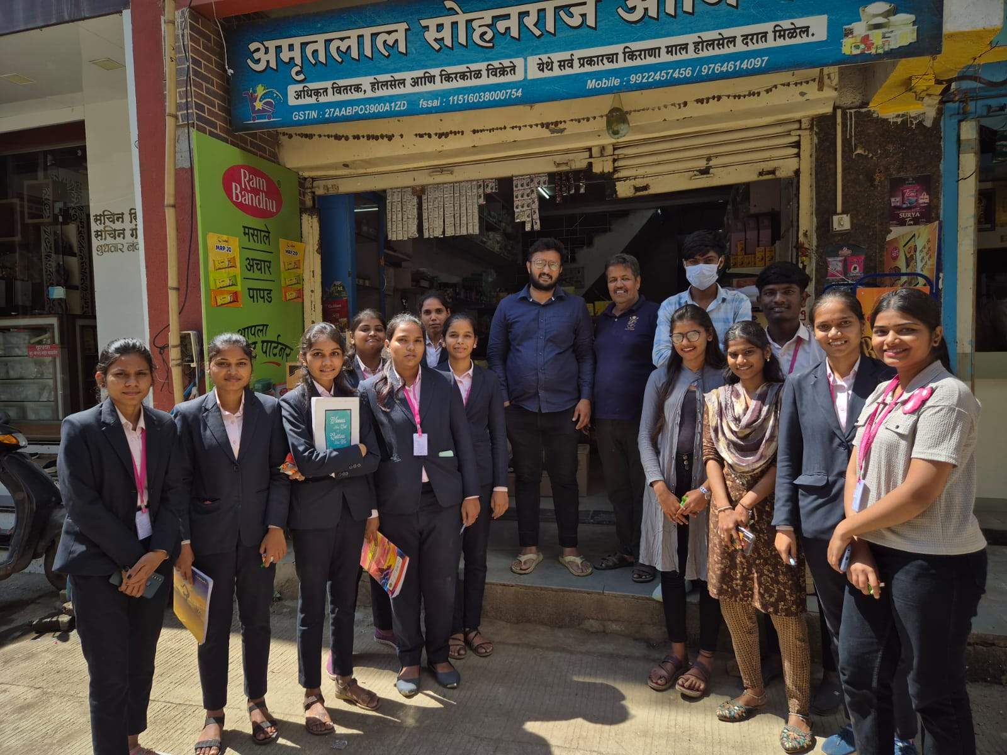

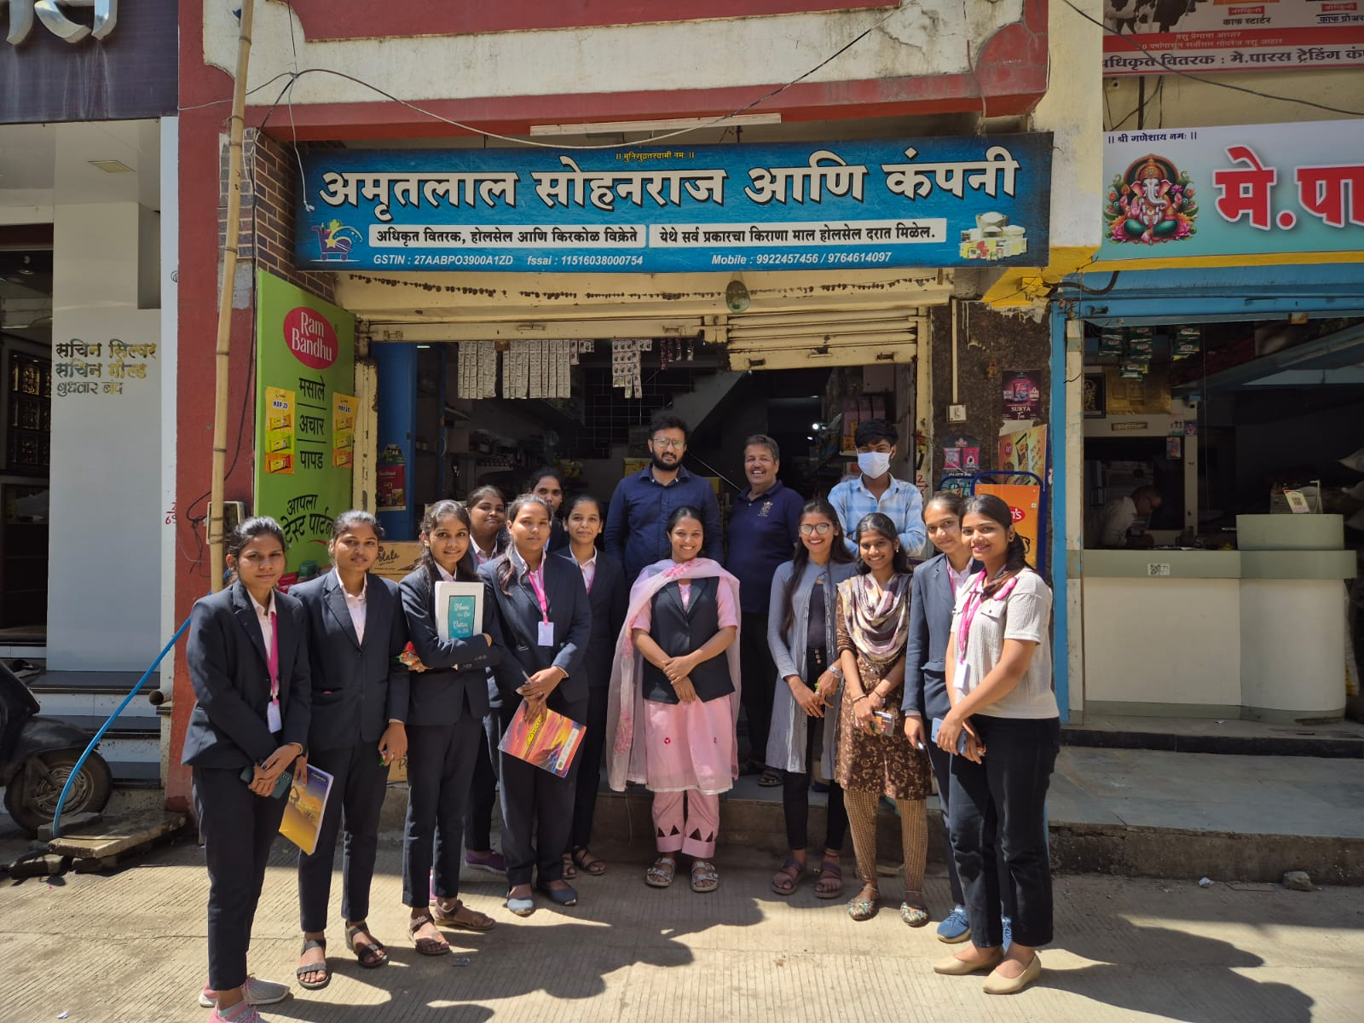

**Attendance of student:-**



DR. P.P.OSWAL

HOD-BBA