**K.T.S.P.MANDAL’S**

**HUTATMA RAJGURU MAHAVIDYALAYA**

RAJGURUNAGAR, TAL-KHED, DIST-PUNE 410501

**BBA DEPARTMENT (2023-24)**

A log sheet with the following details of program

|  |  |  |
| --- | --- | --- |
| Sr. No | Item | Particulars |
| 1 | Date | 3 AUGUST, 2023 |
| 2 | Name of Event | **“INDUCTION PROGRAM FOR BBA STUDENTS”** |
| 3 | Venue | Hutatma Rajguru Mahavidyalaya |
| 4 | Time | 11.00 AM to 2.00 P.M. |
| 5 | Duration of the program | 1 Day |
| 6 | Expense | - |
| 7 | Source of Financial Assistance | - |
| 8 | Names of resource persons | DR. P.P.OSWAL |
| 9 | Name of coordinator | DR. P.P.OSWAL |
| 10 | Number of participants | students |
| 11 | Copy of the programme | - |
| 12 | Curricular/Co-Curricular/Extra-Curricular | Curricular |
| 13 | Activity belongs to Which Criteria of NAAC | - |

Date:- 3rd AUGUST, 2023

**Report**

After high school, moving to college is the most anticipated phase in the life of a student. One prominent point of comparison between college life & school life that everyone would agree with is; college gives a sense of freedom to students. In school, students follow the instruction of teachers & parents, but, in college, one likes to take charge of his/her life. Well, with freedom comes responsibility. This is the one life lesson that colleges aim to inculcate in students apart from course work. Through various training & programs, the college administration indirectly teaches students to become responsible for their life. However, the first step that a college takes towards this is through the induction program. Yes, the day that most students believe makes no sense. Well, it does. It is so important that the education ministry of India has made it mandatory. In this report, we will tell you all the reasons why it holds a lot of importance for a fresher.

1. Life Lessons For The Future: Induction programs usually have a session from experts who can impart life lessons. Listening to someone with experience of life can fill students with enthusiasm & energy to take-on this new step of life.

2. Add-On Information: Colleges offer a variety of additional courses that are mentioned in the brochure, but, are generally ignored by the students. During an induction program, the faculty introduces these add-on programs that students can join.

3. Familiarization with Department: As a student, you will spend 2-4 years of your life as part of a specific department in the college. Getting acquainted with department heads in advance can be very vital for students. Getting to know who the professors are, where will classes be held, at what timings, and where the laboratories are can ensure that you do not enter college at day one with a blank mind!

4. Meet Your Mates: To enter a class with friends on day one of college can be a blissful feeling. An induction program can help you meet & interact with all your batch mates and make friends

Dr P.P.OSWAL also extended a warm welcome to all present and stressed on the importance of learning management skills and developing a futuristic orientation.

After explaining the introduction of BBA, and details about the all the subjects of all semester and specialization, we also gave an overview of the examination process and credit patterns.

The success and smooth conduct of induction program is an evidence of the management skills and initiative taking abilities of our first BBA Batch 2023-24.

DR .P.P.OSWAL

HOD of BBA

**Photos:-**

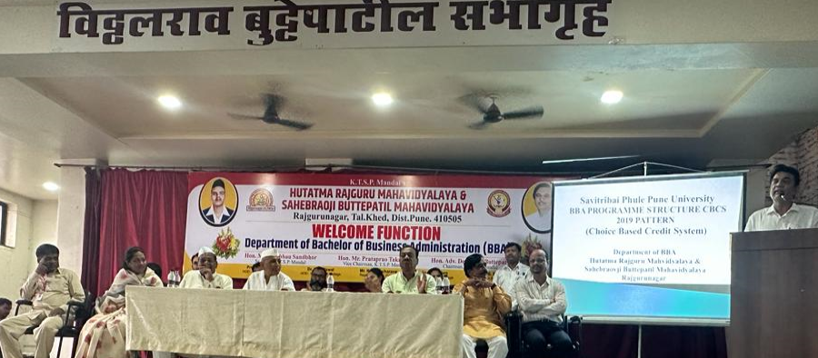

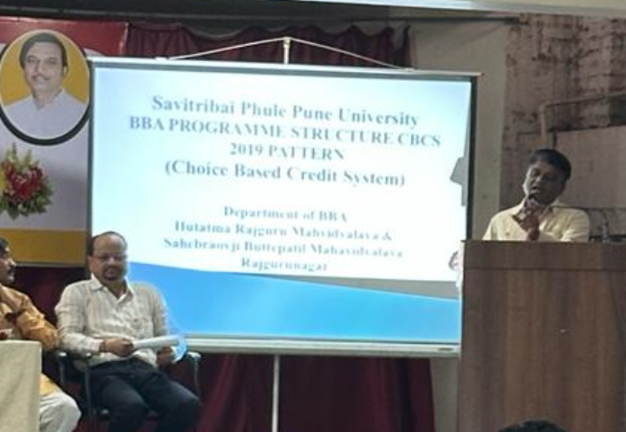

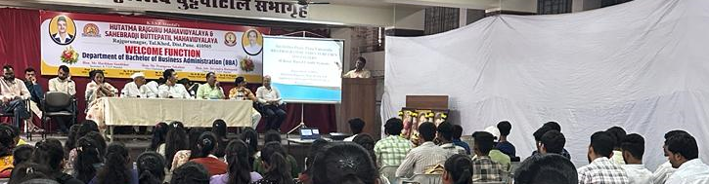

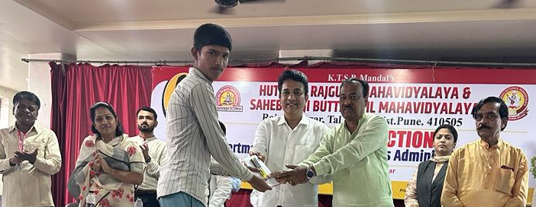

**Attendance of student:-**

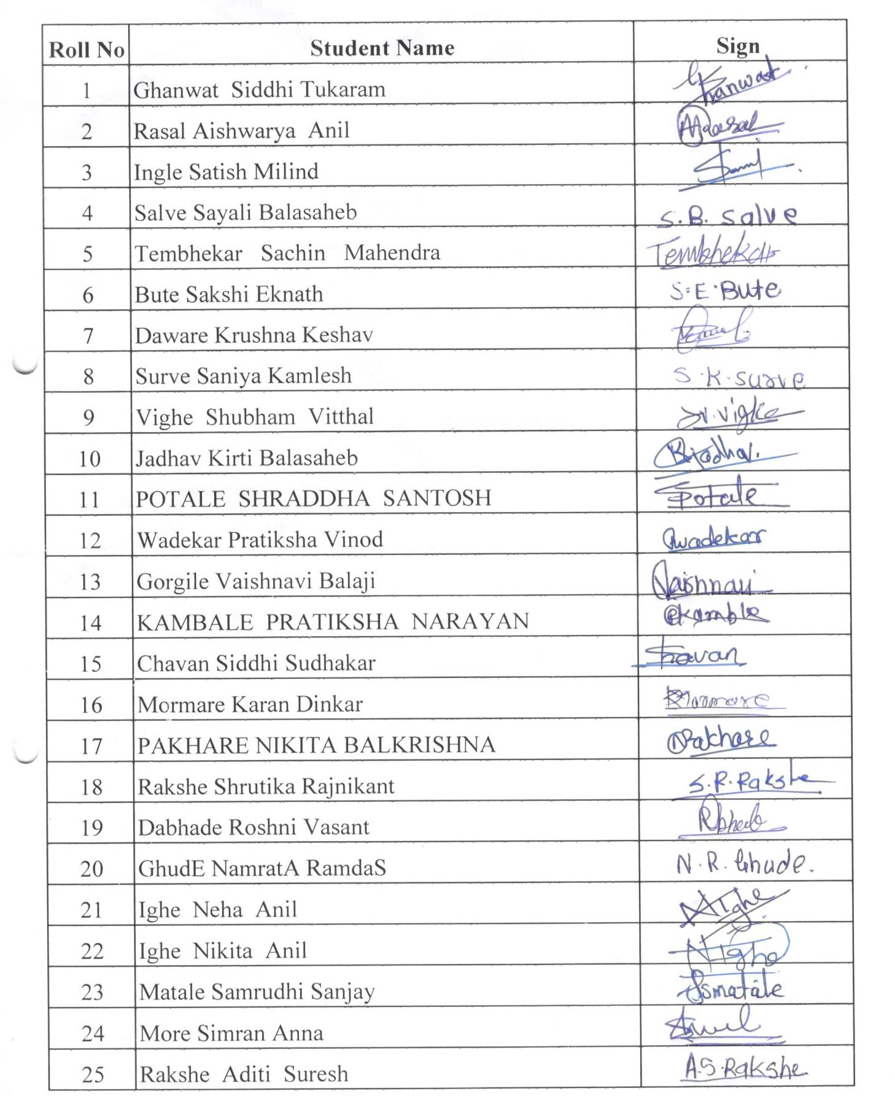

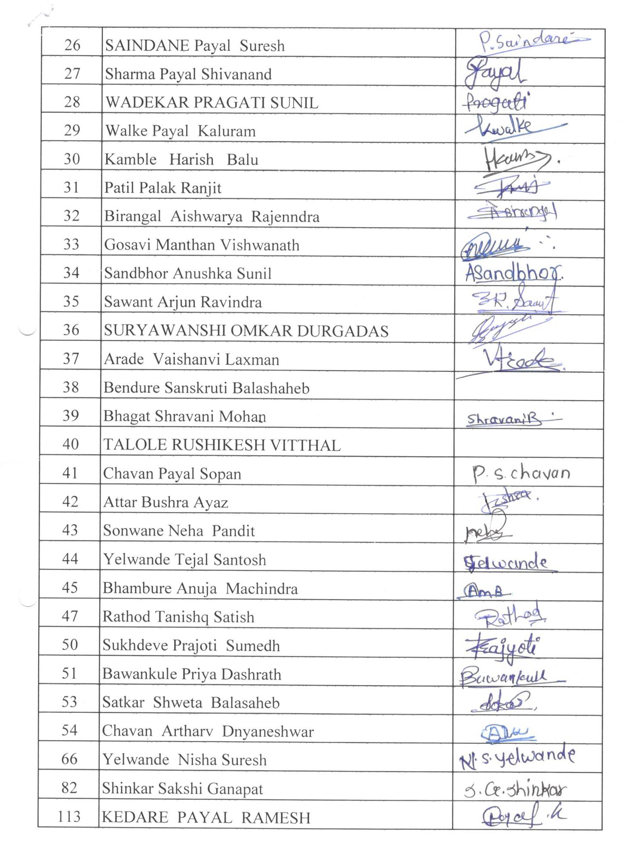

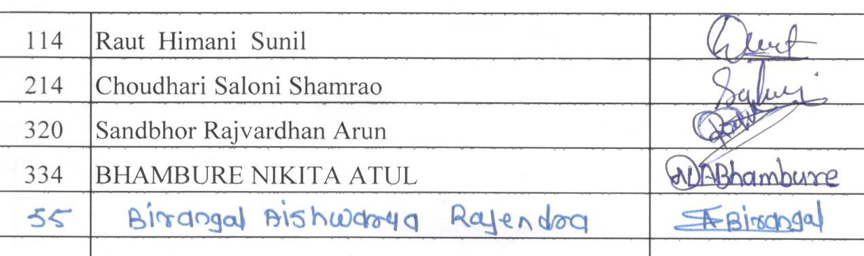

Dr.P.P.Oswal

Head of Department