**K.T.S.P.MANDAL’S**

**HUTATMA RAJGURU MAHAVIDYALAYA**

RAJGURUNAGAR, TAL-KHED, DIST-PUNE 410501

**BBA DEPARTMENT (2024-25)**

A log sheet with the following details of program

|  |  |  |
| --- | --- | --- |
| Sr. No | Item | Particulars |
| 1 | Date | 22 July |
| 2 | Name of Event | **Guru Purnima Celebration** |
| 3 | Venue | CLASSROOM |
| 4 | Time | Class timings |
| 5 | Duration of the program | 1 Day |
| 6 | Expense | - |
| 7 | Source of Financial Assistance | - |
| 8 | Names of resource persons | - |
| 9 | Name of coordinator | Dr. P.P.Oswal |
| 10 | Number of participants | All Students |
| 11 | Copy of the program | - |
| 12 | Curricular/Co-Curricular/Extra-Curricular | Extra-Curricular |
| 13 | Activity belongs to Which Criteria of NAAC | - |

Date: - 22 July, 2024

**Report**

The festival of Guru Purnima was celebrated in BBA department on 22/07/2024. The event was organized by students. It was a memorable event that showcased the deep reverence and gratitude of the students towards their teachers and the event was anchored by students. The function began with lightening the lamp of goddess Saraswati followed the felicitation of teachers by the students. Each student presented a beautiful bouquet of flowers to their respective teachers as a token of appreciation for their guidance and support. Following the felicitation, several students were given the opportunity to deliver speeches. They shared their thoughts and experience, expressing their gratitude towards the teachers who had played a significant role in shaping their lives and academic journeys. Students have arranged funny games for teachers in this programed.

Dr.P.P.Oswal HOD of BBA department acknowledges the importance of Guru Purnima and emphasized the role of teachers in molding the future of the students. As the program drew to a close, a vote of thanks was extended by student of SYBBA to all the attendance.

The event was concluded with a formal vote of thanks.

DR. P.P.OSWAL

HOD-BBA

**Photos:-**

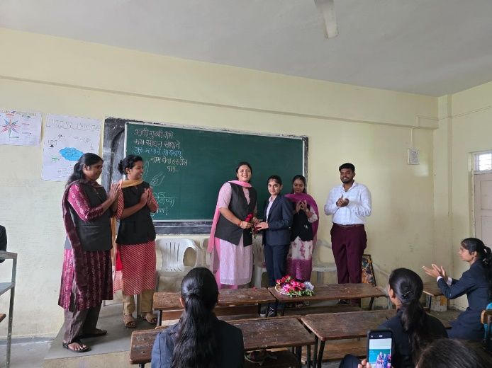

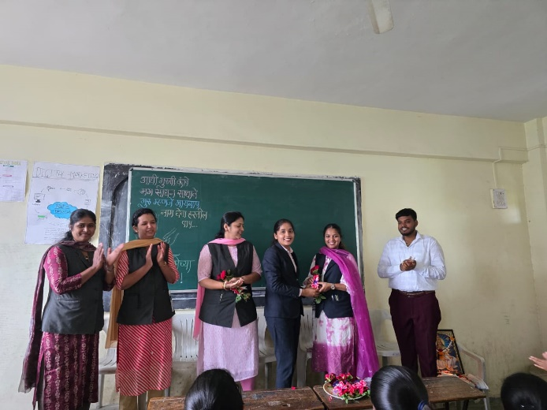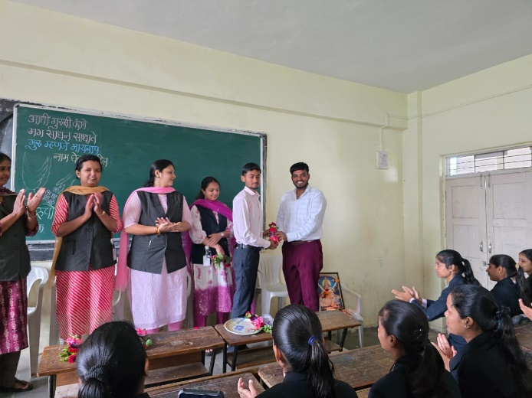

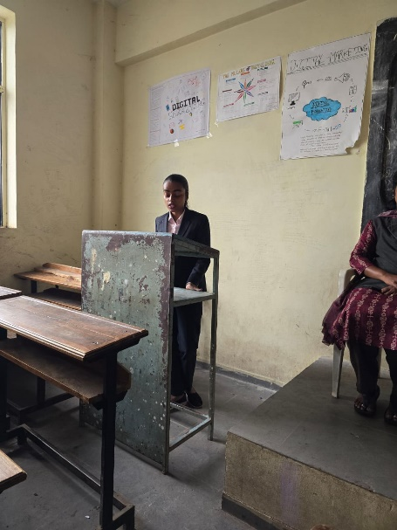

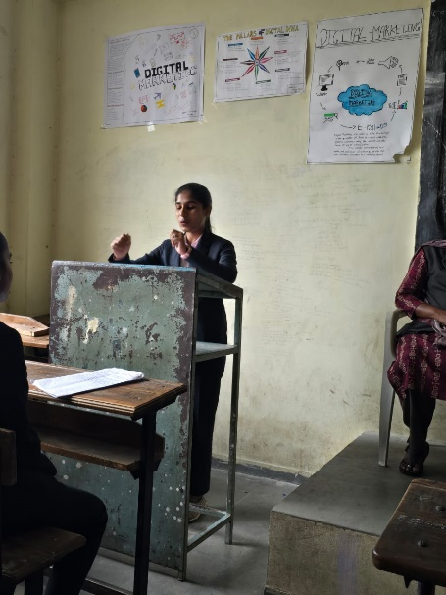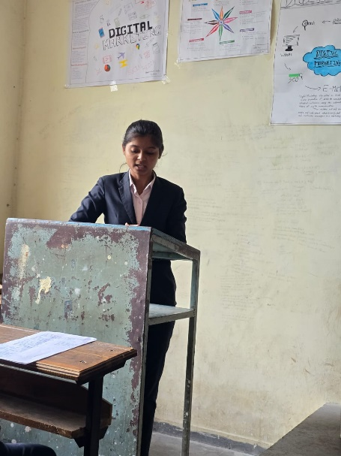

**Attendance of student:-**

|  |  |  |
| --- | --- | --- |
| Roll No. | Student Name | P/A |
| 1 | Bute Sakshi Eknath | P |
| 2 | Sawant Arjun Ravindra | P |
| 3 | Jadhav Kirti Balasaheb | P |
| 4 | Ingle Satish Milind | A |
| 5 | Malande Hanuman Dhondiba | P |
| 6 | Sukhdeve Prajoti Sumedh | P |
| 7 | Wadekar Pragati Sunil | P |
| 8 | Choudhari Saloni Shamrao | P |
| 9 | Ghude Namrata Ramdas | P |
| 10 | Kudale Prerana Rajendra | P |
| 11 | Arade Vaishanvi Laxman | P |
| 12 | Pawar Priyanka Arun | P |
| 13 | Chavan Payal Sopan | A |
| 14 | Saindane Payal Suresh | P |
| 15 | Rasal Aishwarya Anil | P |
| 16 | Sandbhor Anushka Sunil | P |
| 17 | Pakhare Nikita Balkrishna | A |
| 18 | Tembhekar Sachin Mahendra | P |
| 19 | Kad Pranali Ashok | P |
| 20 | Khandagale Prachi Mahendra | A |
| 21 | Rathod Tanishq Satish | P |
| 22 | Bomble Anushka Harishchandra | P |
| 23 | Ghanwat Siddhi Tukaram | P |
| 24 | Rakshe Shrutika Rajnikant | P |
| 25 | Satkar Shweta Balasaheb | P |
| 26 | Suryawanshi Omkar Durgadas | P |
| 27 | Shinkar Sakshi Ganapat | P |
| 28 | Ighe Nikita Anil | A |
| 29 | Dabhade Roshni Vasant | P |
| 30 | Mormare Karan Dinkar | P |
| 31 | Surve Saniya Kamlesh | P |
| 32 | Pachade Harshal Jagdish | P |
| 33 | Shinde Mansing Hiraman | A |
| 34 | Sonwane Neha Pandit | P |
| 35 | Chavan Siddhi Sudhakar | P |
| 36 | Gaikwad Shruti Sunil | P |
| 37 | Gosavi Manthan Vishwanath | P |
| 38 | Kambale Pratiksha Narayan | A |
| 39 | Kamble Harish Balu | P |
| 40 | Attar Bushra Ayaz | A |
| 41 | Madage Ajay Khandu | P |
| 42 | Matale Samrudhi Sanjay | P |
| 43 | Sandbhor Rajvardhan Arun | P |
| 44 | Talole Rushikesh Vitthal | P |
| 45 | Walke Payal Kaluram | P |
| 46 | Kedare Payal Ramesh | P |
| 47 | Chakankar Mahesh Ajit | A |
| 48 | Gorgile Vaishnavi Balaji | P |
| 49 | Bhambure Nikita Atul | P |
| 50 | More Simran Anna | A |
| 51 | Sharma Payal Shivanand | P |
| 52 | Gunjal Ashish Kisan | P |
| 53 | Potale Shraddha Santosh | P |
| 54 | Bawankule Priya Dashrath | P |
| 55 | Vighe Shubham Vitthal | P |
| 56 | Yelwande Nisha Suresh | P |
| 57 | Yelwande Tejal Santosh | P |
| 58 | Chavan Atharva Dyaneshwar | P |
| 59 | Rakshe Aditi Suresh | P |
| 60 | Pande Nishant Arun | P |
| 61 | Patil Palak Ranjit | P |
| 62 | Wadekar Pratiksha Vinod | P |
| 63 | Salve Sayali Balasaheb | A |

Dr.P.P.Oswal

HOD -BBA