K.T.S.P. Mandal’s

**Hutatma Rajguru Mahavidyalaya, Rajgurunagar**

Department of Mathematics

Future Plan

* To promote the use of ICT tools such as GeoGebra, MATLAB, and Python for mathematical computations and visualization.
* To attend regular workshops and seminars to enhance the teaching pedagogy of faculty members.
* To organize mathematics short-term courses, workshops, guest lectures, and inter-collegiate competitions for students.
* To publish high-quality research papers in indexed journals and participate in international conferences.

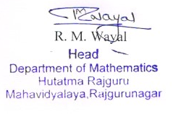

K.T.S.P. Mandal’s

**Hutatma Rajguru Mahavidyalaya, Rajgurunagar**

Department of Mathematics

List of Activities

2024-25

Term-I

* Pi Approximation day
* Quiz Competition (Two)
* Field Visit