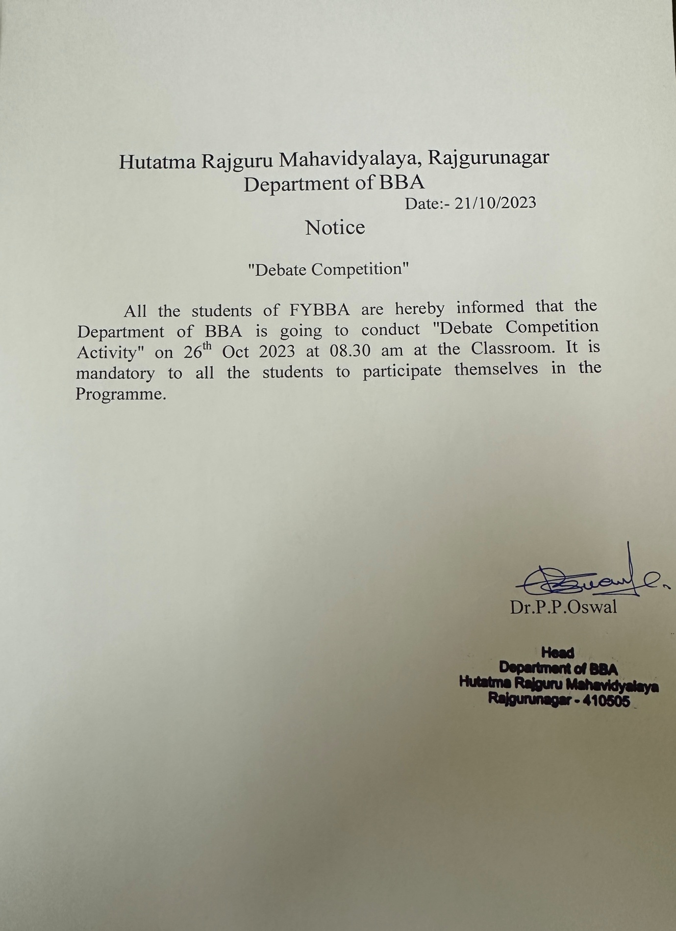

"Debate Competition Activity Report"

The Department of BBA “The Debate Competition Activity “on 26th Oct 2023. The Topic for the debate was "Social Media: Advantages and Disadvantages". Social media has changed the way we live our lives. Now, many people have become addicted to the social media. In the time of Covid-19 Pandemic people mostly stayed at home, so they become more habitual to the social media. Social media has grown tremendously in the last few years. Especially Facebook, Whatsapp, Twitter and Instagram have grown much faster and captured millions of users in just a few years. The way technology is growing, it is obvious that more and more people are going to grasp is benefits. It has brought a lot of advantages for the society. Every nation is utilizing the power of social media to enhance life and use it for the bitterness of the people. However, on the other hand it has also affected the society in the negative way. Both positive and negative aspects were discussed by the students. The positive aspect such as better connection with family and friends, quick access to information, quicker banking services, E-learning, Marketing etc. pointed out by the students. However, the negative aspects such as Addiction, Privacy, Distraction, Mental health issues, Stocking etc. were discussed. Prof. H.S.Chaudhari proposed the vote of thanks.

