**K.T.S.P.MANDAL’S**

**HUTATMA RAJGURU MAHAVIDYALAYA**

RAJGURUNAGAR, TAL-KHED, DIST-PUNE 410501

**BBA DEPARTMENT (2023-24)**

A log sheet with the following details of program

|  |  |  |
| --- | --- | --- |
| Sr. No | Item | Particulars |
| 1 | Date | 2nd Sept, 2023 |
| 2 | Name of Event | **Guest Lecture on Cyber Security** |
| 3 | Venue | BBA Classroom |
| 4 | Time | 11.00 am. |
| 5 | Duration of the program | 1 Day |
| 6 | Expense | - |
| 7 | Source of Financial Assistance | - |
| 8 | Names of resource persons | ADV. MADHURI INDORE  PSI- DHOTRE CYBER POLICE  RUSHIKESH SHINDE CYBER SECURITY SPECIALIST |
| 9 | Name of coordinator | Dr.P.P.Oswal |
| 10 | Number of participants | 50 students |
| 11 | Copy of the program | - |
| 12 | Curricular/Co-Curricular/Extra-Curricular | Extra-Curricular |
| 13 | Activity belongs to Which Criteria of NAAC | - |

Date:- 2th SEPTEMBER, 2023

**Report**

Venue: Hutatma Rajguru Mahavidyalaya

Department of BBA & Vidhyarthi Vikas Mandal organized a seminar on Cyber security and Ethical Hacking for BBA students on 2nd Sept 2023 at 10:45 am. Dr.P.P.Oswal HOD of the BBA department welcomed the speakers for the day.

The seminar began with a prayer seeking god’s blessings. ADV. MADHURI INDORE(LLB), PSI MR.DHOTRE(CYBER POLICE, PUNE) and MR. RUSHIKESH SHINDE(CYBER SECURITY SPECIALIST) were the resource persons for the seminar who were welcomed and guests were greeted. The Seminar was graced by the presence of Principal Dr. S. S. Pingale, Mr.Kails Pacharne Registrar & Prof Sandip Thorath Program Officer Vidhyarthi Vikas Mandals.

They explained various topics relating to cybercrime, cyber laws, hacking, spamming, android hacking, social media its advantages& disadvantages and gave students’ knowledge about various tools involved in hacking, demonstrated how DDOS attacks and spamming attacks are carried out. He also gave relatable real-life examples about how people have been affected by hacking and other cybercrimes. He cautioned the students and explained them about various measures they should take to safeguard themselves from such cybercrimes.

The session was indeed useful and informative for students as they gained knowledge about topics that they were not really exposed to in their curriculum.

The outcomes of this seminar on Cyber Security and Ethical Hacking was students were able to learn about types of attacks, attackers and security threats and vulnerabilities present in the computer system as well as tools and techniques to safeguard oneself in cyber space.

Dr.P.P.Oswal

**Photos:-**

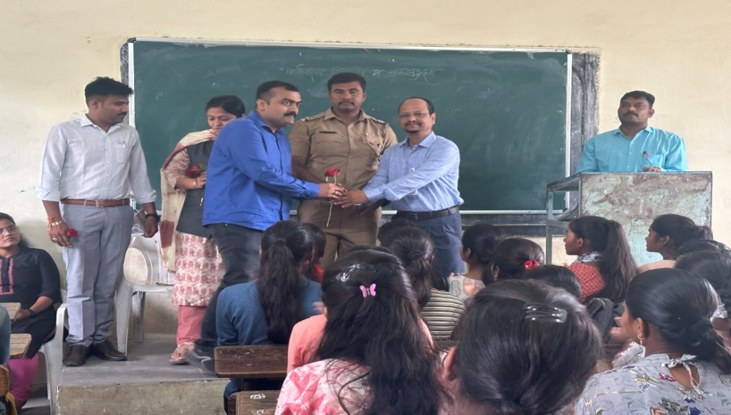

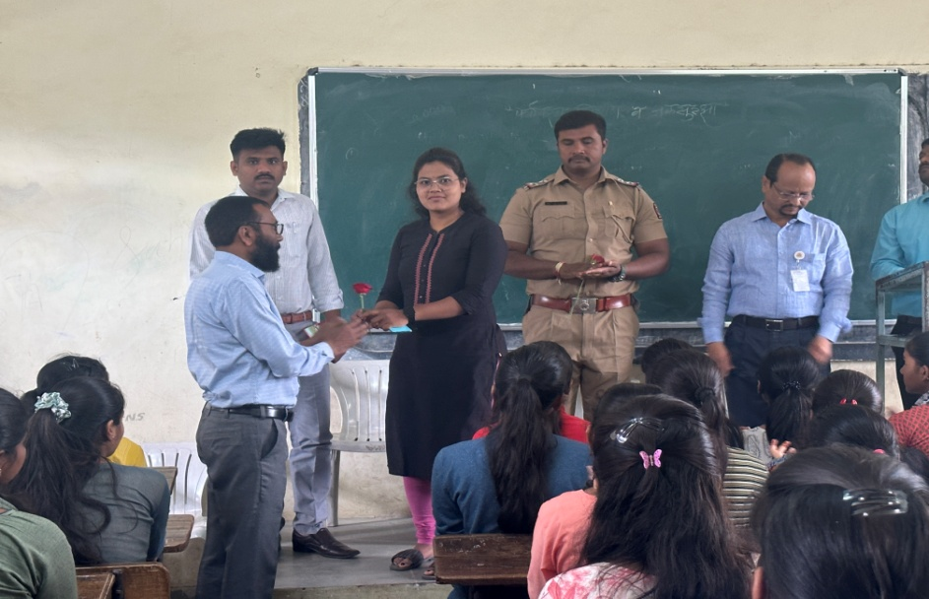

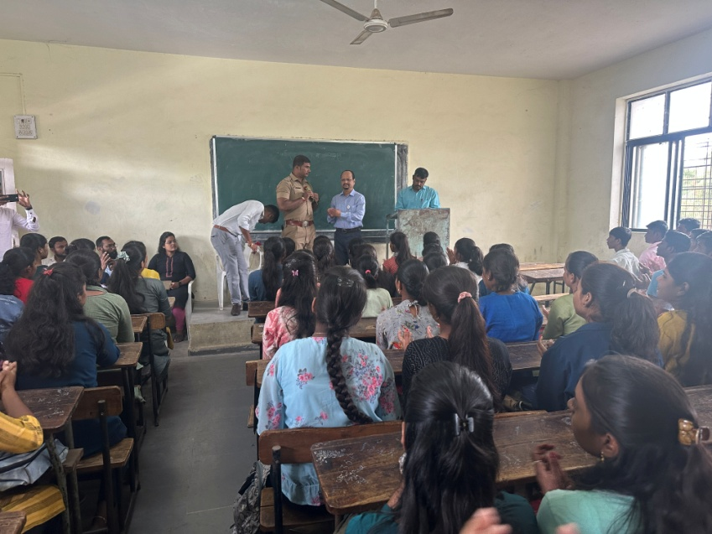

**Attendance of student:-** 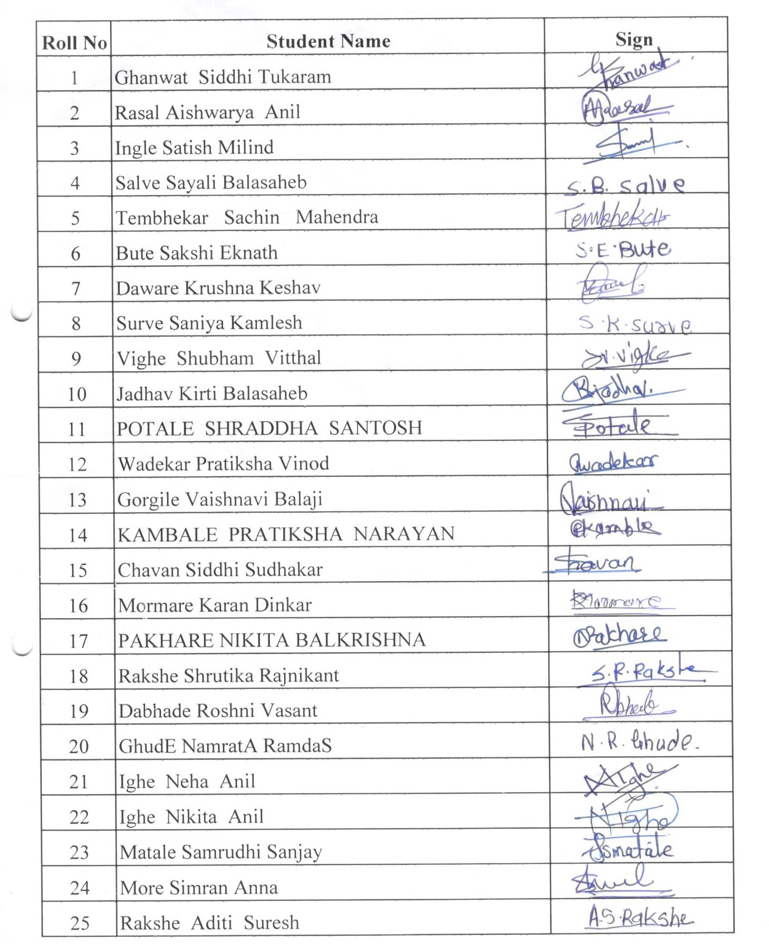

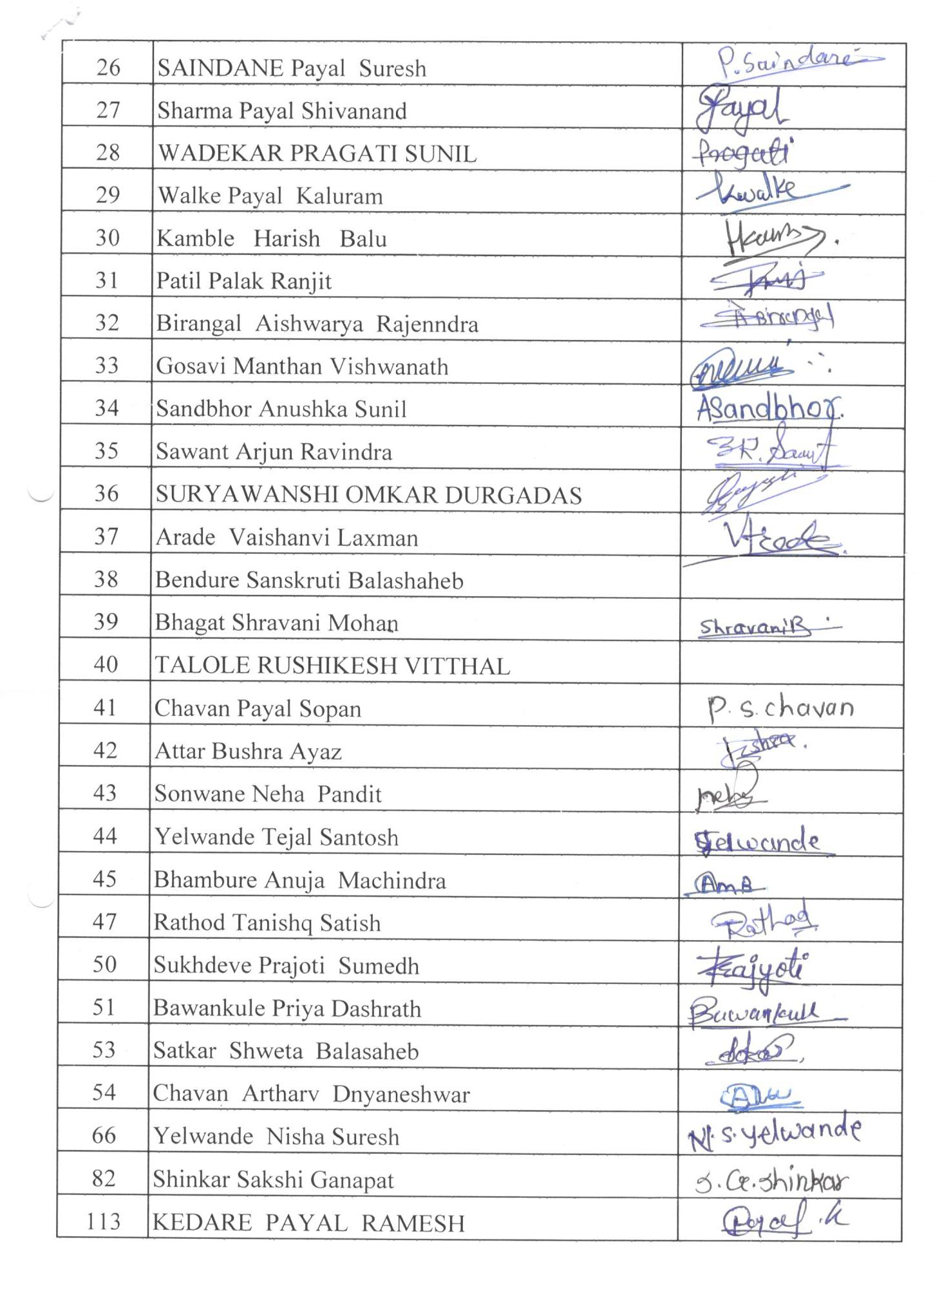

Dr.P.P.Oswal